Send Order Object
We need to use your API to send orders to the selected restaurant branch. In order to achieve this goal we prepared the following JSON object to be sent through your api as following:
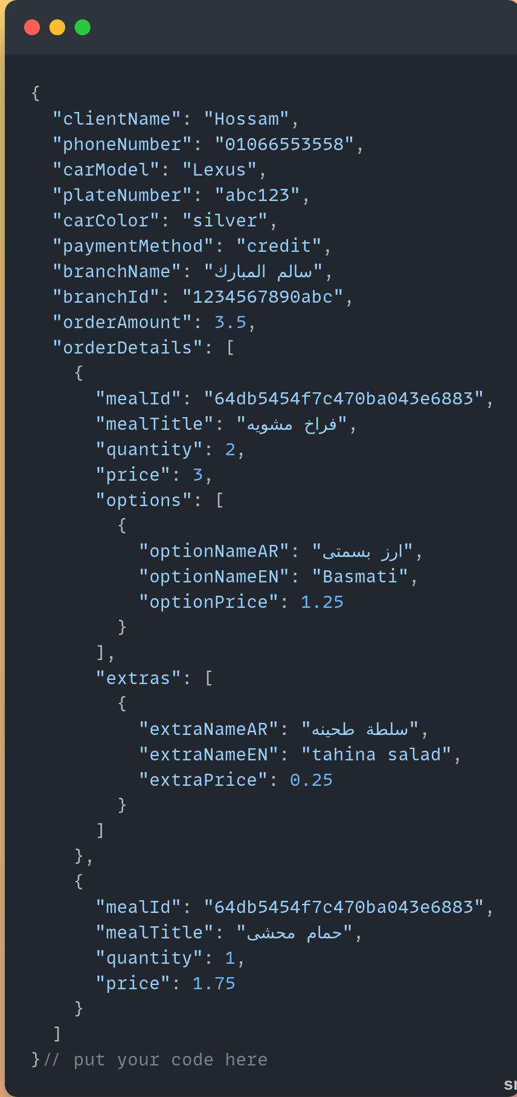
this table is to explain each key in the above object

Key Name | Value Type | Required | Description
Client Name | String | True | Customer name
Phone Number | String | True | Customer phone number
Car model | String | True | Customer car model
Plate number | String | false(optional) | Customer car plate number
Car color | String | True | Customer car color
Payment method | String | True | Payment method selected by customer (credit / cash)
Branch name | String | True | Restaurant branch name
Branch id | String | True | Restaurant branch id will be determined by our system
Order amount | Number | True | Total amount due
Order details | Array of objects | True | Array contain order items
Meal Id | String | True | Meal id assigned by our system
Meal title | String | True | Name of the meal
Quantity | Number | True | Number of ordered meal
Price | Number | True | Meal price
Options | Array of objects | False (optional) | Array contain the options of a specific meal
Option name AR | String | True (if meal has options) | The option name in Arabic language
Option name EN | String | True (if meal has options) | The option name in English
Option Price | Number | True (if meal has options) | The selected option price
Extras | Array of objects | False (optional) | Array contain the extras add to the meal
Extra name AR | String | True (if meal has extras) | Name of the added extra to the meal in Arabic
Extra name EN | String | True (if meal has options) | Name of the added extra to the meal in English
Extra price | Number | True (if meal has options) | Price of the extra

- Once the request is sent to foodics system we expect to receive a response containing the order number which will be assigned to the order by your foodics system so we can send a response to our client with containing the order details and order number

Thank you
Muscle Maker Dev Team

