**Figures**

**Albatross**

***Atherinomorus endrachtensis***

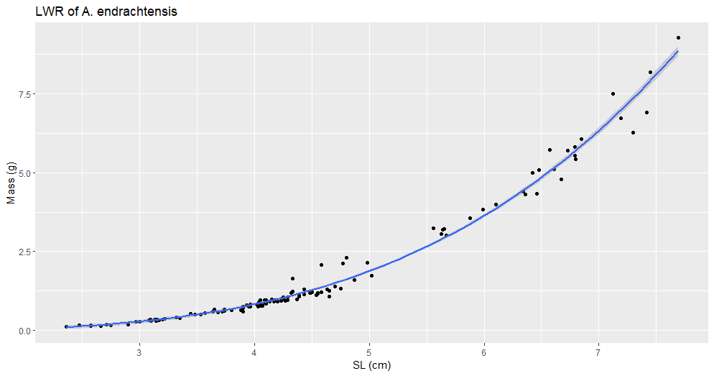

Figure #. (A_endrachtensis_LWR_SL.png). Title

Description

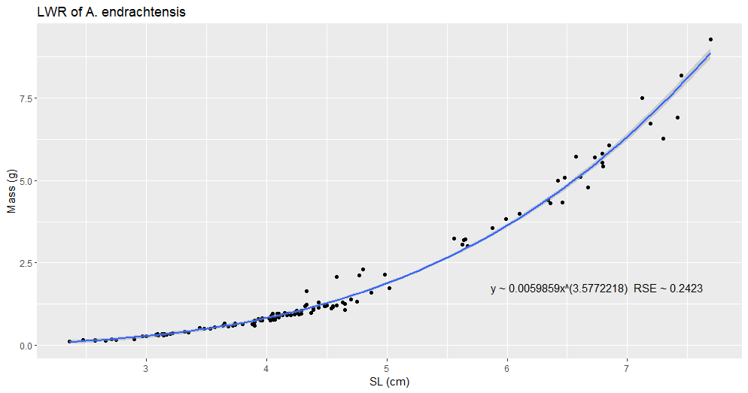

Figure #. (A_endrachtensis_LWR_SL.png). Title

Description

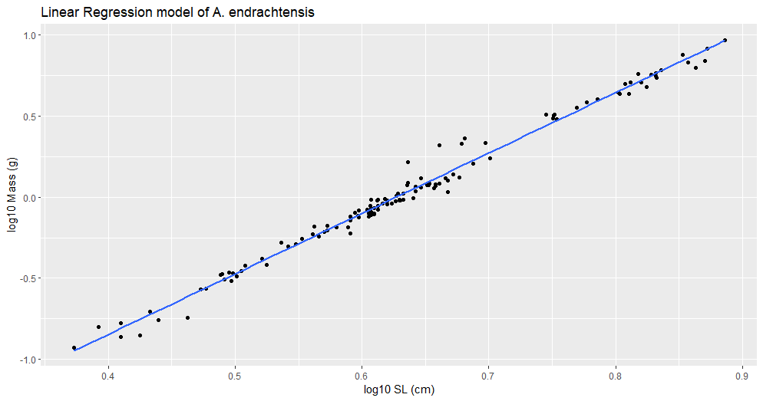

Figure #. (A_endrachtensis_lm.png). Title

Description

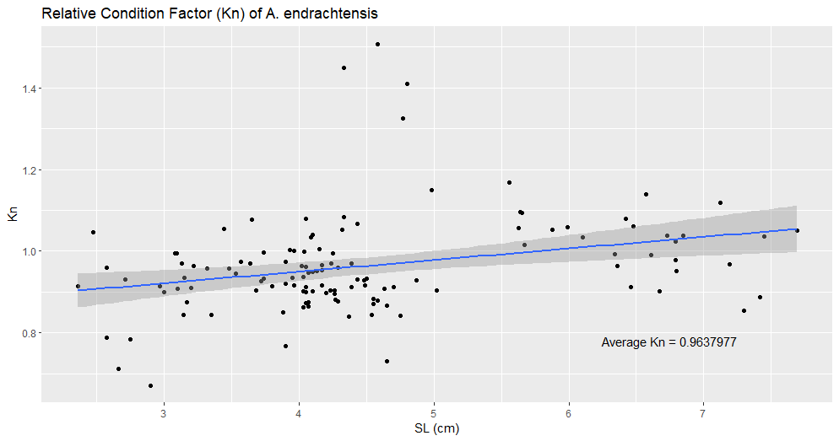

Figure #. (A_endrachtensis_kn.png). Title

Description