**Figures**

**Albatross**

***Ambassis interrupta***

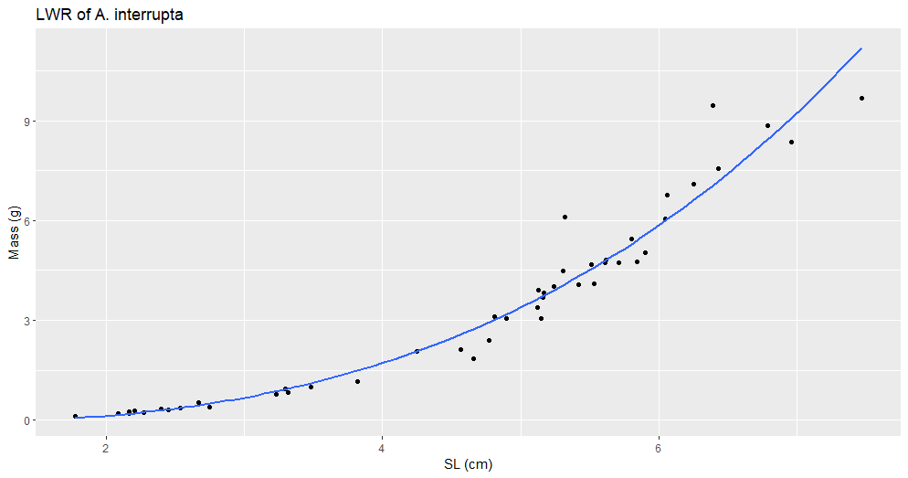

Figure #. (A_interrupta_LWR_SL.png). Title

Description

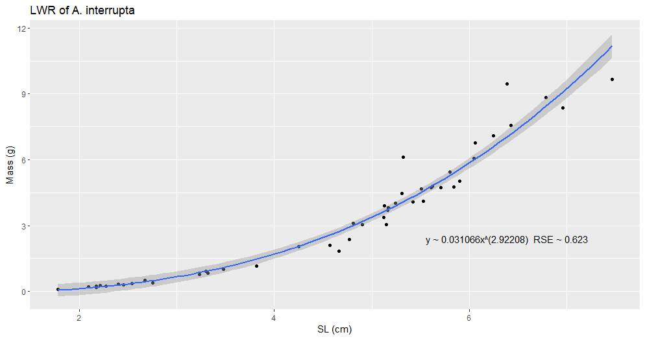

Figure #. (A_interrupta_LWR_SL_2.png). Title

Description

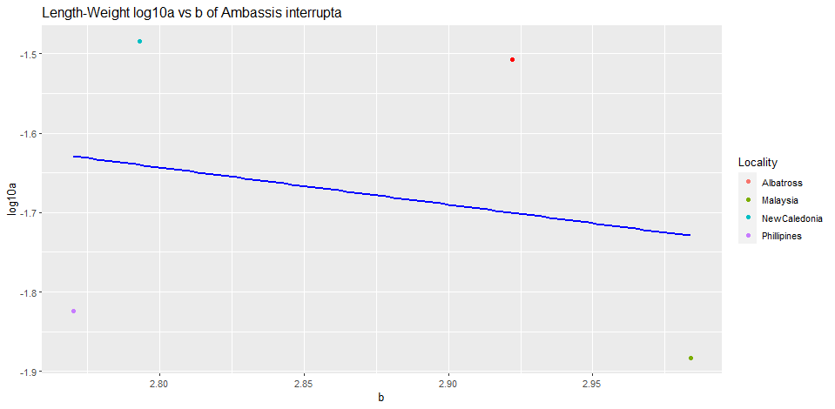

Figure #. (A_interrupta_log10a_b). Title

Description

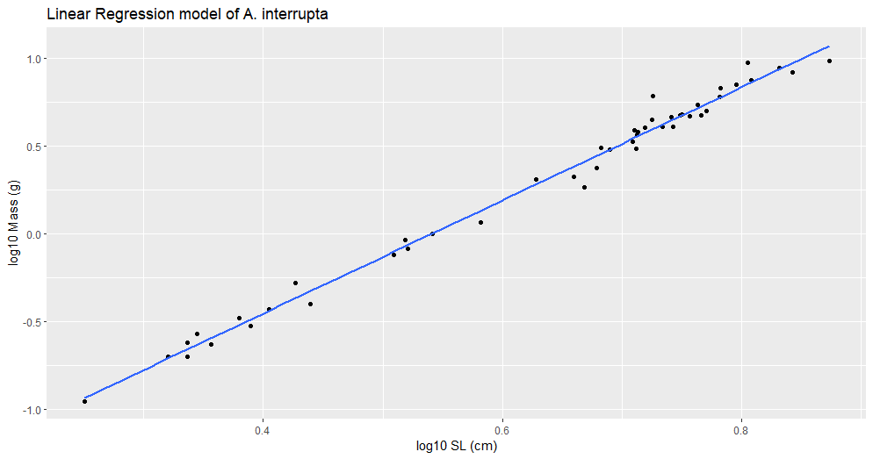

Figure #. (A_interrupta_lm.png). Title

Description

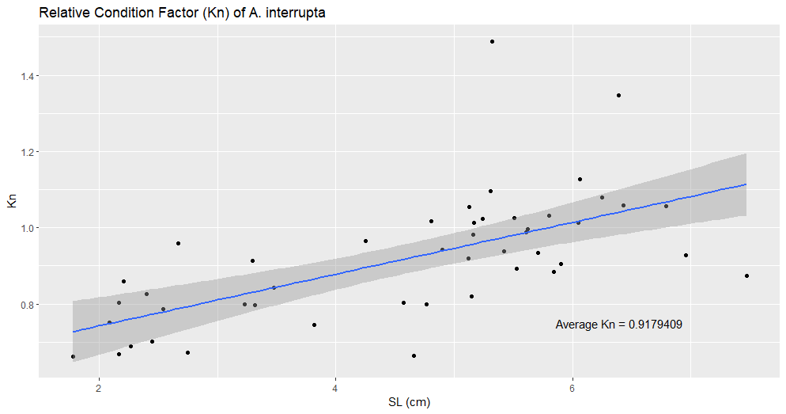

Figure #. (A_interrupta_kn.png). Title

Description