**Figures**

**Albatross**

***Doboatherina duodecimalis***

Figure #. (D_duodecimalis_LWR_SL.png). Title

Description

Figure #. (D_duodecimalis_LWR_SL_2.png). Title

Description

Figure #. (D_duodecimalis_lm.png). Title

Description

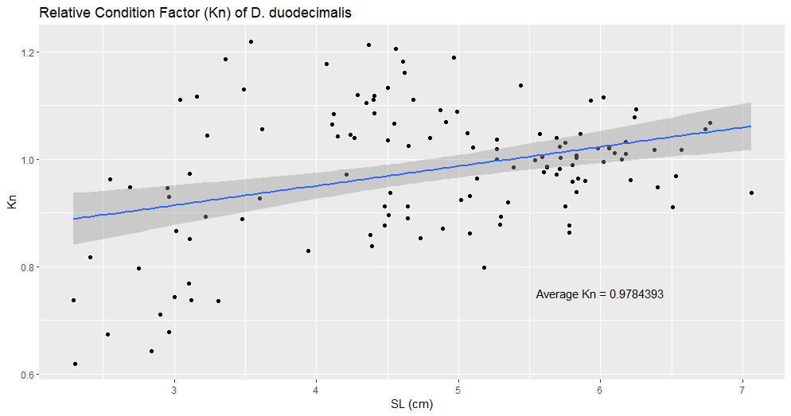

Figure #. (D_duodecimalis_kn.png). Title

Description

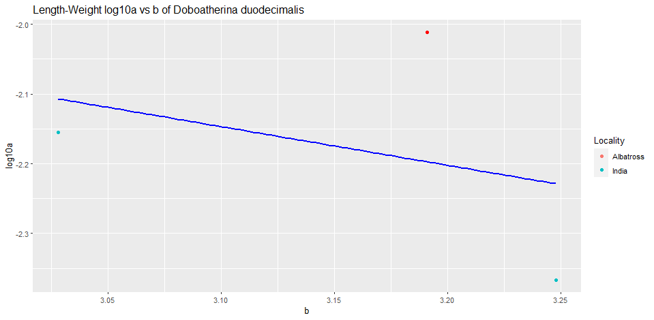

Figure #. (D_duodecimalis_log10a_b). Title

Description