**Figures**

**Albatross**

***Glossogobius giuris***

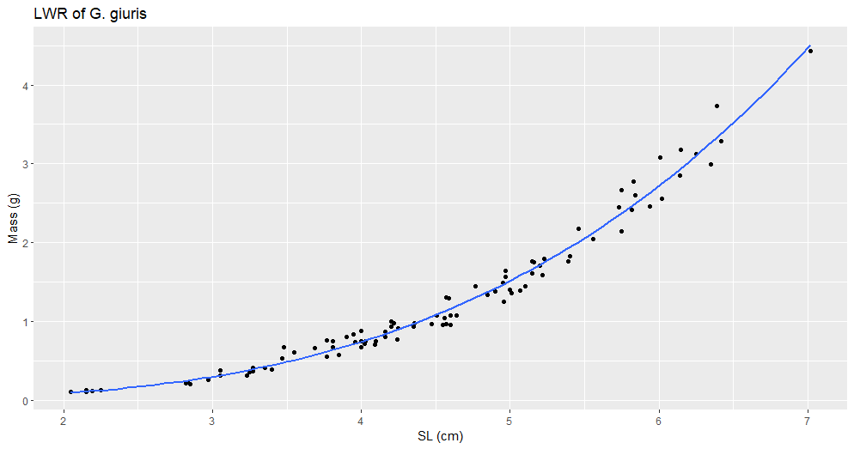

Figure #. (G_giuris_LWR_SL.png). Title

Description

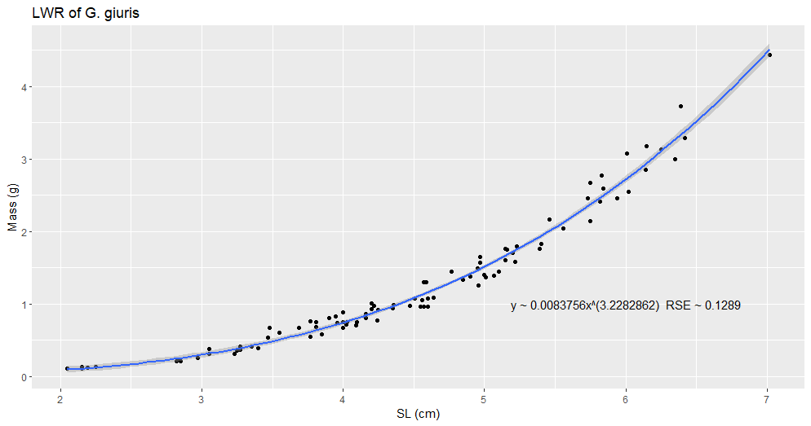

Figure #. (G_giuris_LWR_SL_2.png). Title

Description

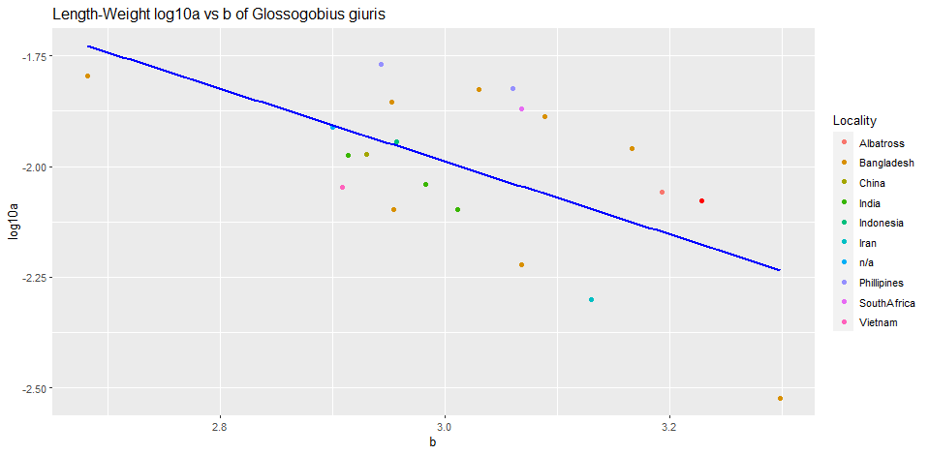

Figure #. (G_giuris_log10a_b). Title

Description

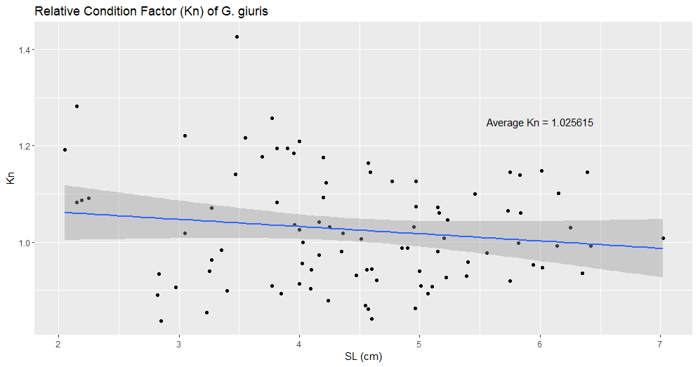

Figure #. (G_giuris_kn.png). Title

Description

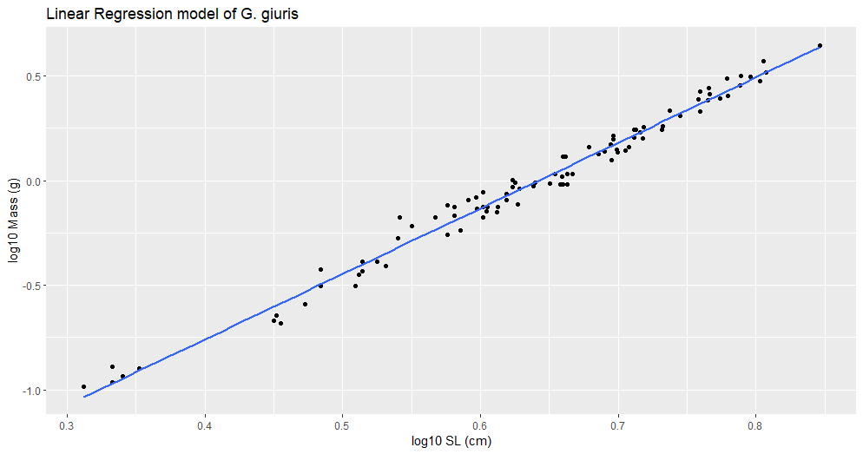

Figure #. (G_giuris_lm.png). Title

Description