**Figures**

**Albatross**

**Genus Comparison**

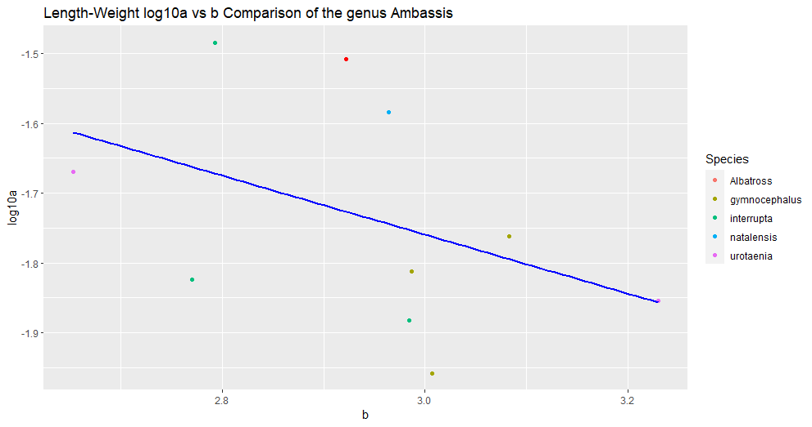

Figure #. (Ambassis_log10a_b_genus_comparison.png). Title

Description

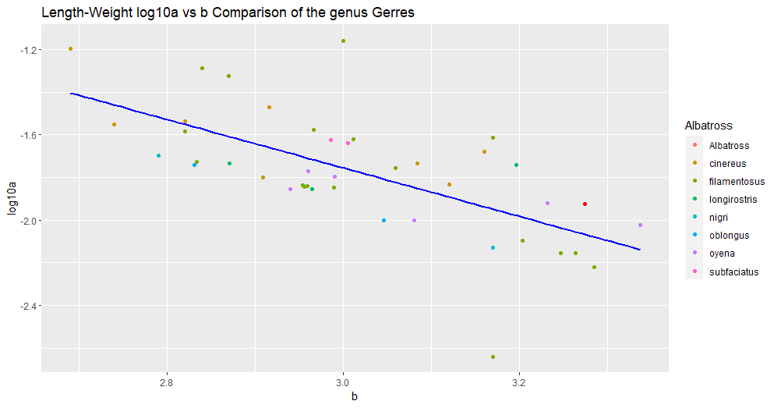

Figure #. (G_oyena_log10a_b_genus_comparison.png). Title

Description

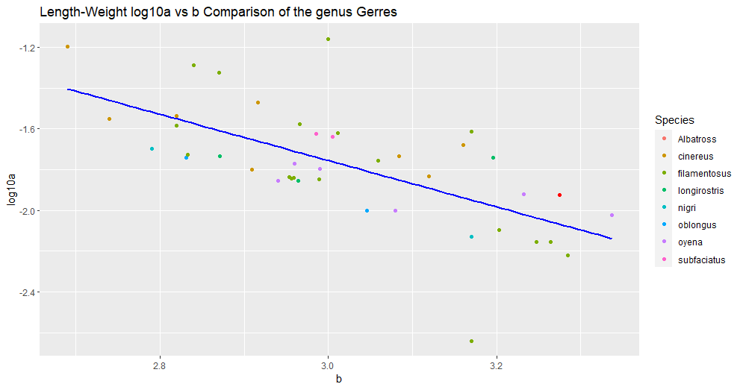

Figure #. (Gerres_log10a_b_genus_comparison.png). Title

Description

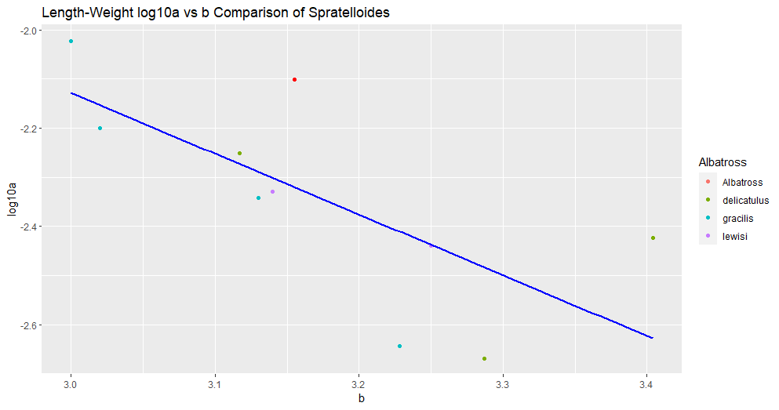

Figure #. (S_delicatulus_log10a_b_genus_comparison.png). Title

Description

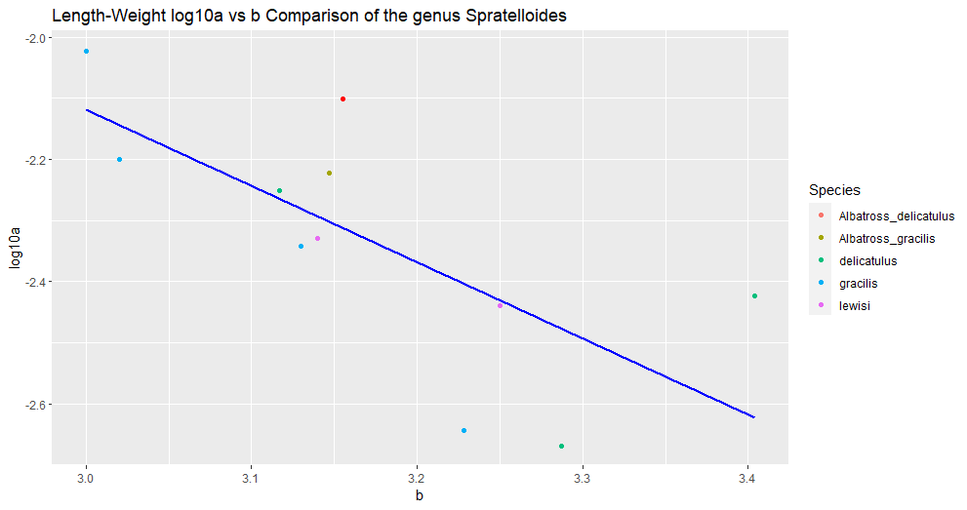

Figure #. (Sprat_log10a_b_genus_comparison.png). Title

Description