**Figures**

**Albatross**

***Kuhlia marginata***

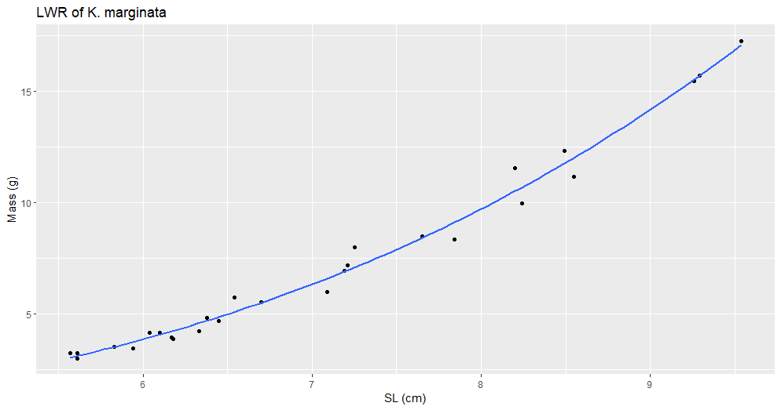

Figure #. (K_marginata_LWR_SL.png). Title

Description

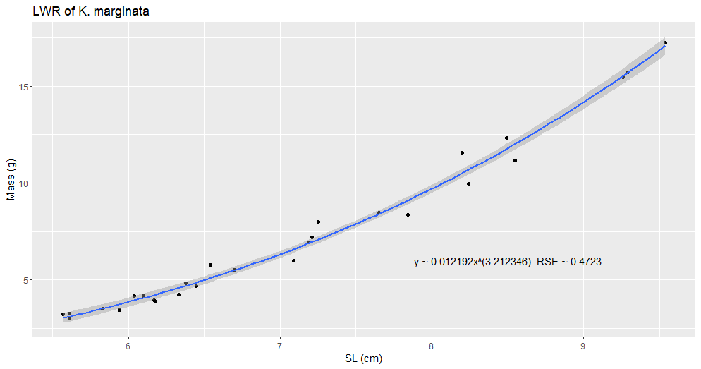

Figure #. (K_marginata_LWR_SL_2.png). Title

Description

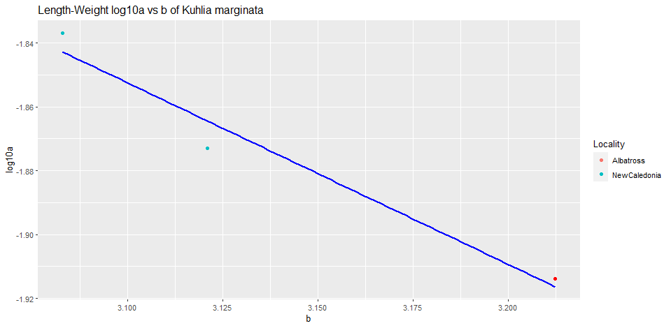

Figure #. (K_marginata_log10a_b). Title

Description

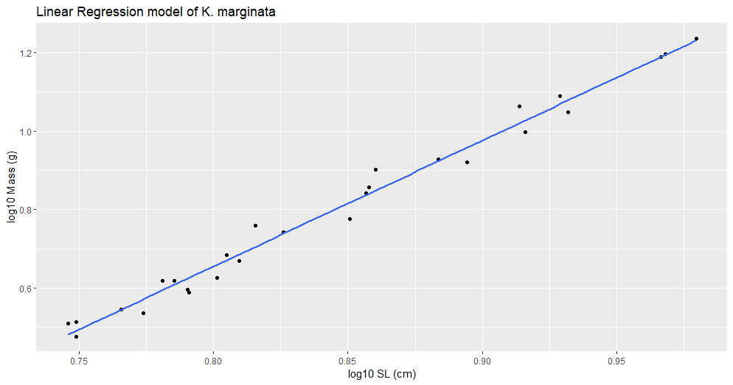

Figure #. (K_marginata_lm.png). Title

Description

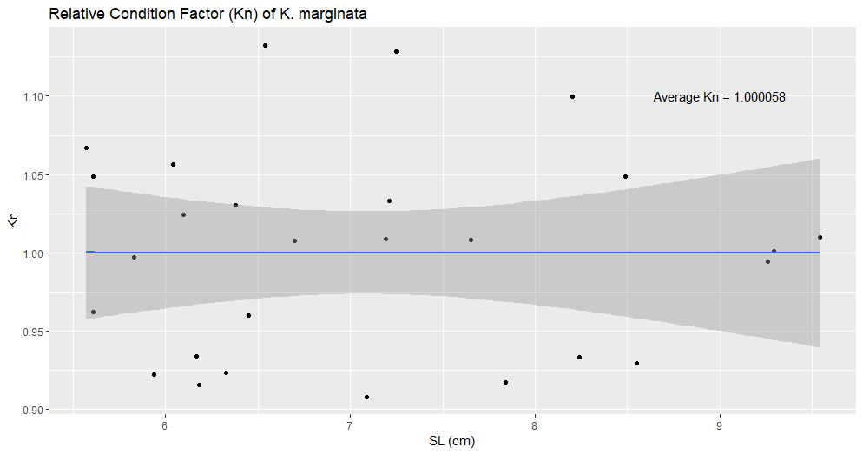

Figure #. (K_marginata_kn.png). Title

Description