**Figures**

**Ablatross**

***Photopectoralis bindus***

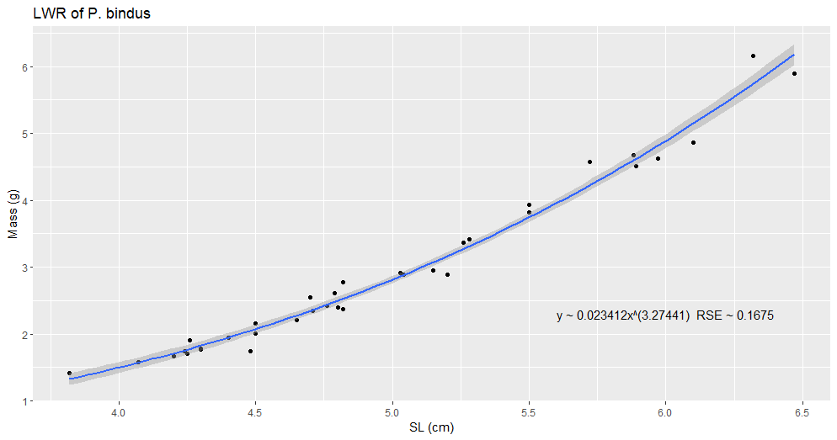

Figure 5a. Length-weight Relationship of *Photopectoralis bindus* (Valenciennes, 1835) (P_bindus_LWR_SL_2.png).

Description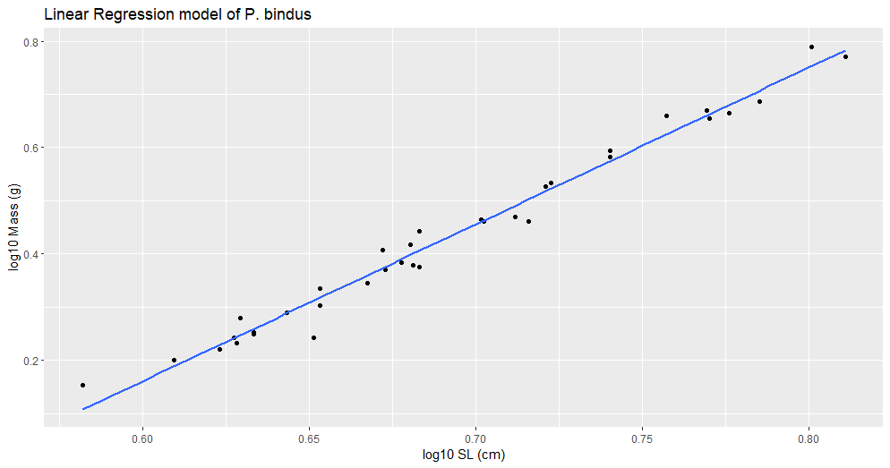Figure 5b. Linear Regression model of *Photopectoralis bindus* (Valenciennes, 1835) (P_bindus_log10a_b).

Linear regression analysis of standard length (SL) and mass (g), showing that the predictive relationship between length and weight is strong.

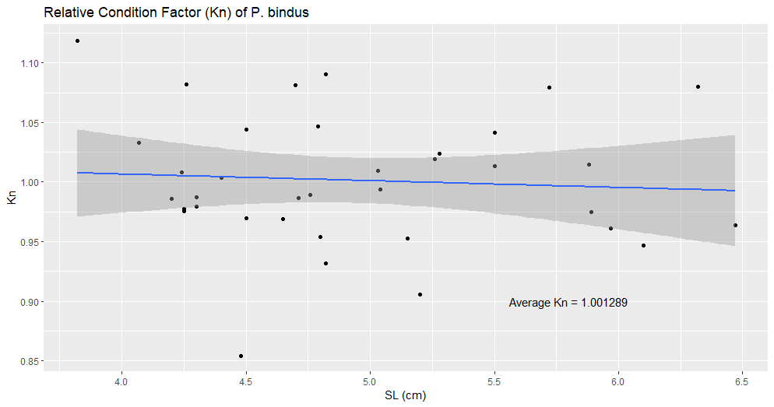

Figure 5c. Relative Condition Factor (Kn) of *Photopectoralis bindus* (Valenciennes, 1835) (P_bindus_kn.png).

Relationship between Le Cren’s (Kn = observed weight (w) / expected weight (W)) relative condition factor (Kn) and standard length (SL) (Le Cren, 1951). SL is used to highlight its relationship to Kn, which could be influenced by the increased loss of fluids by larger individuals while stored in ethanol.Chart, scatter chart

Figure 5d. Comparison of the Length-weight Relationship of *Photopectoralis bindus* (Valenciennes, 1835) between Locality/Study (P_bindus_lm.png).

Values are collected from Fishbase and are color coded based on geographic location of each available study. Studies deemed “Doubtful” by Fishbase were excluded. This study is labelled as “Albatross”, but it is important to keep in mind that they were collected by the USS Albatross from various locations in the Philippine archipelago.