**Figures**

**Albatross**

***Spratelloides delicatulus***

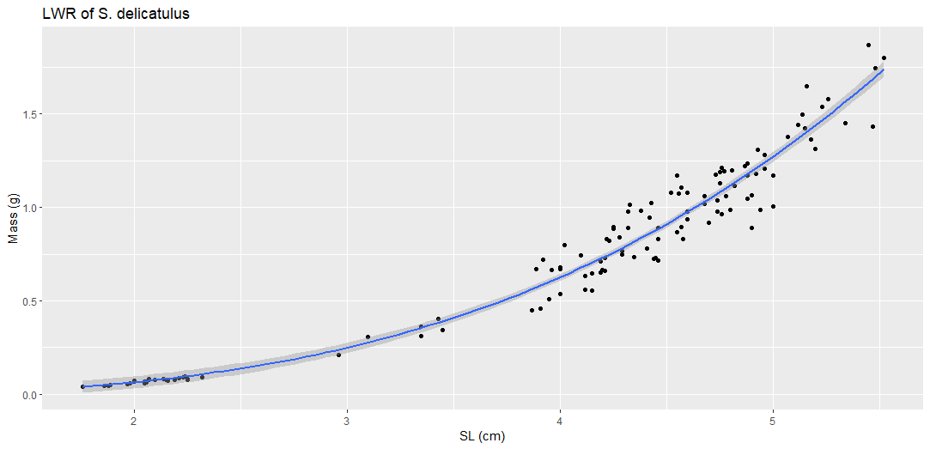

Figure #. (S_delicatulus_LWR_SL.png). Title

Description

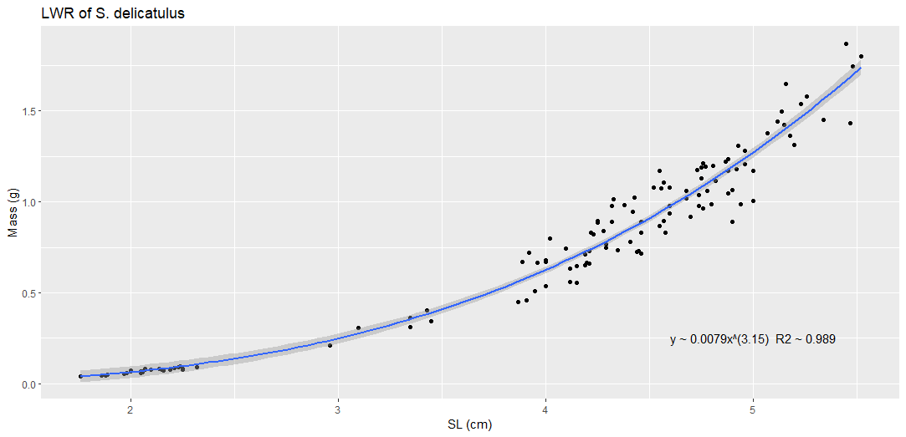

Figure #. (S_delicatulus_LWR_SL_2.png). Title

Description

Figure #. (S_delicatulus_log10a_b). Title

Description

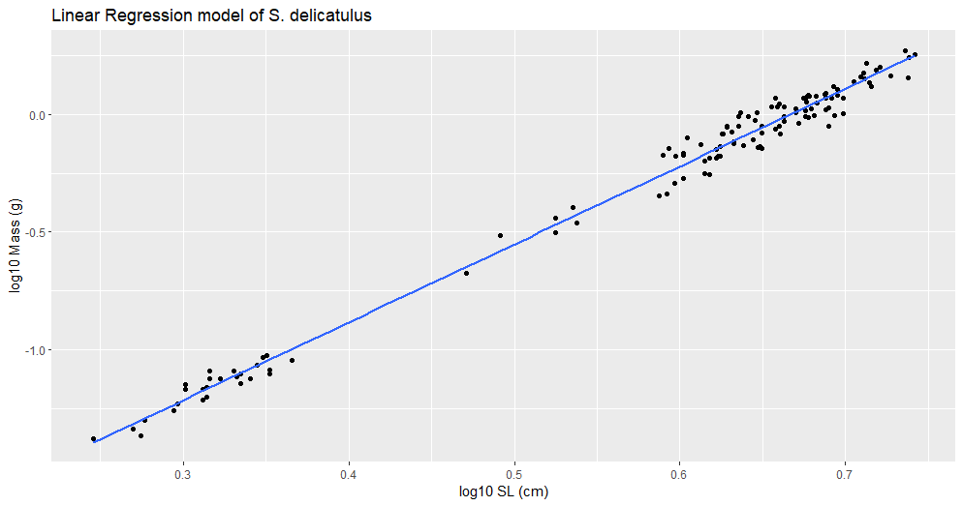

Figure #. (S_delicatulus_lm.png). Title

Description

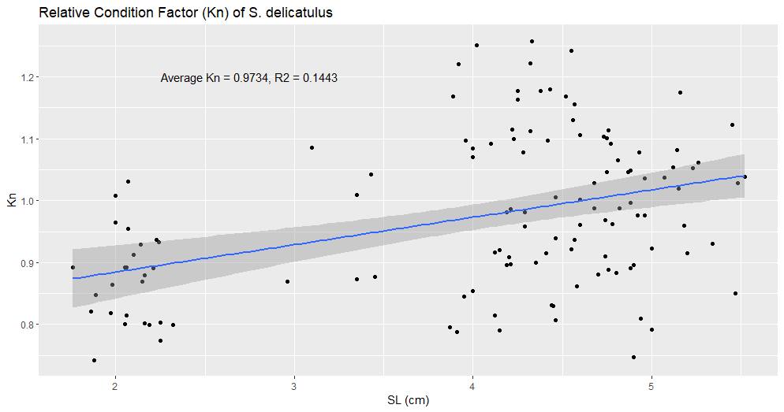

Figure #. (S_delicatulus_kn.png). Title

Description