**Figures**

**Albatross**

***Sphyraena obtusata***

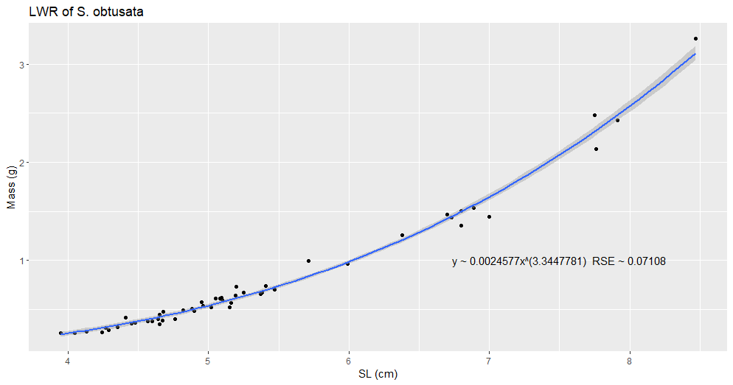

Figure 4a. Length-weight Relationship of *Sphyraena obtusata* (Cuvier, 1829) (S_obtusata_LWR_SL_2.png).

Description

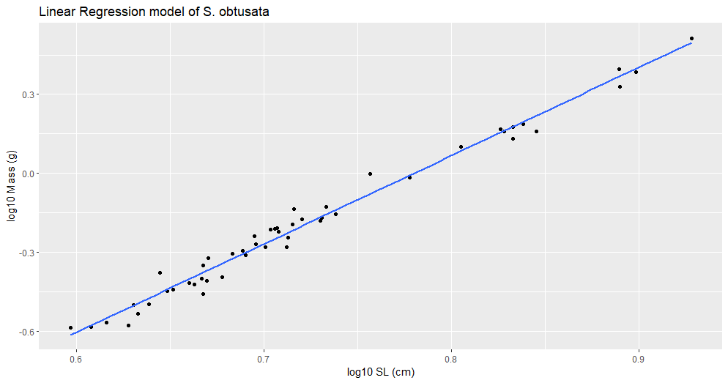

Figure 4b. Linear Regression model of *Sphyraena obtusata* (Cuvier, 1829) (S_obtusata_lm.png).

Linear regression analysis of standard length (SL) and mass (g), showing that the predictive relationship between length and weight is strong.

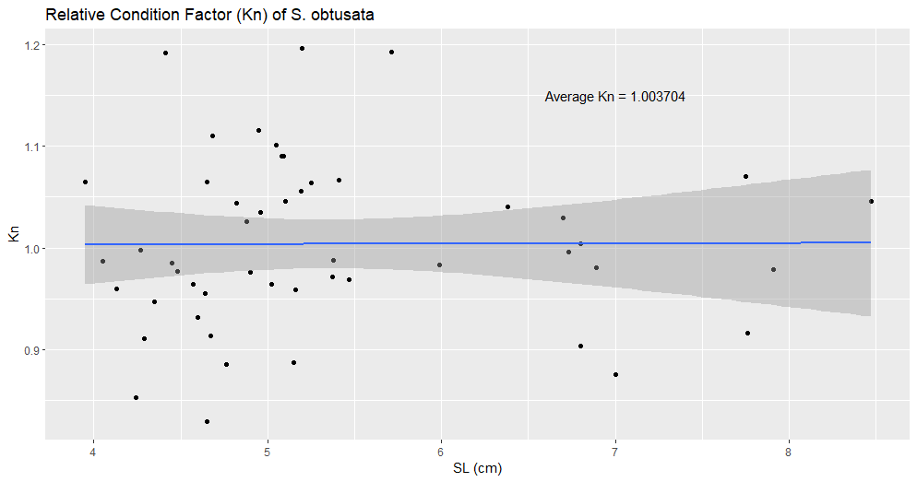

Figure 4c. Relative Condition Factor (Kn) of *Sphyraena obtusata* (Cuvier, 1829) (S_obtusata_kn.png).

Relationship between Le Cren’s (Kn = observed weight (w) / expected weight (W)) relative condition factor (Kn) and standard length (SL) (Le Cren, 1951). SL is used to highlight its relationship to Kn, which could be influenced by the increased loss of fluids by larger individuals while stored in ethanol.Chart

Figure 4d. Comparison of the Length-weight Relationship of *Sphyraena obtusata* (Cuvier, 1829) between Locality/Study (S_obtusata_log10a_b).

Values are collected from Fishbase and are color coded based on geographic location of each available study. Studies deemed “Doubtful” by Fishbase were excluded. This study is labelled as “Albatross”, but it is important to keep in mind that they were collected by the USS Albatross from various locations in the Philippine archipelago.