The Omniscient Observer:
What Happens to Time When Nothing Is Hidden?
Gabriel Giani Moreno
Companion note — February 2026
Abstract
We take the unified Page–Wootters formula $ρ_{S}(t)={Tr}_{E}[⟨t|_{C}|Ψ⟩⟨Ψ||t⟩_{C}]/p(t)$ and ask: what happens if the observer has total access to all degrees of freedom — if the observer is, operationally, “God”? We show analytically and numerically that the formula remains perfectly valid but produces a universe with no arrow of time (Level 1), no dynamics (Level 2), and ultimately no time at all (Level 3). Progressive restriction of the observer’s access monotonically increases the emergent arrow, confirming the central thesis: time is not a property of the universe, but a property of ignorance. All results are obtained from the same code and the same formula used in the main paper, with no modifications.
Keywords: Page–Wootters; omniscient observer; arrow of time; information; atemporality; emergence.
This note is a companion to the paper “The Observer as a Local Breakdown of Atemporality” and uses the same codebase available at https://github.com/gabgiani/paw-toymodel.

The Question
The central formula of the Page–Wootters (PaW) framework is:
$$ρ_{S}(t) = \frac{{Tr}_{E}​\left[⟨t|_{C} |Ψ⟩⟨Ψ| |t⟩_{C}\right]}{p(t)}.$$
This single expression produces three pillars of the problem of time:
- Quantum dynamics: from the projection $⟨t|_{C}$ onto clock states.
- Thermodynamic arrow: from the partial trace ${Tr}_{E}$ over inaccessible environmental degrees of freedom.
- Observer-dependent time: from the fact that $C$ is a local physical subsystem, not a global parameter.
A natural question arises: what if the observer has no limitations? What if the observer can see every qubit, every degree of freedom, every correlation in the universe — including the clock itself? Does the formula break? Does time still emerge?
This note answers that question numerically and analytically, using the exact same formula and the exact same code as the main paper.

Three Levels of Omniscience
We define three progressively stronger notions of “total access” and test the formula at each level.

Level 1: God Uses a Clock but Sees Everything
Setup. The observer conditions on a physical clock $C$ (projection $⟨t|_{C}$ is performed), but has complete access to the environment $E$. Operationally, this means $n_{env}=0$: there are no hidden degrees of freedom. The partial trace ${Tr}_{E}$ acts as the identity.
Prediction. Since ${Tr}_{E}=I$, the conditional state $ρ_{S}(k)$ remains pure at every tick. The von Neumann entropy satisfies $S_{eff}(k)=0$ for all $k$. Dynamics exist (the projection $⟨k|_{C}$ still generates a temporal sequence), but the dynamics are fully reversible. No information is lost, no arrow emerges.
Numerical result.
- $⟨σ_{z}⟩_{k}$ oscillates as $cos(ωk dt)$ with machine-precision agreement (max deviation $∼4×{10}^{−16}$).
- $S_{eff}(k)=0$ at every tick (maximum value $2.6×{10}^{−15}$, consistent with floating-point zero).
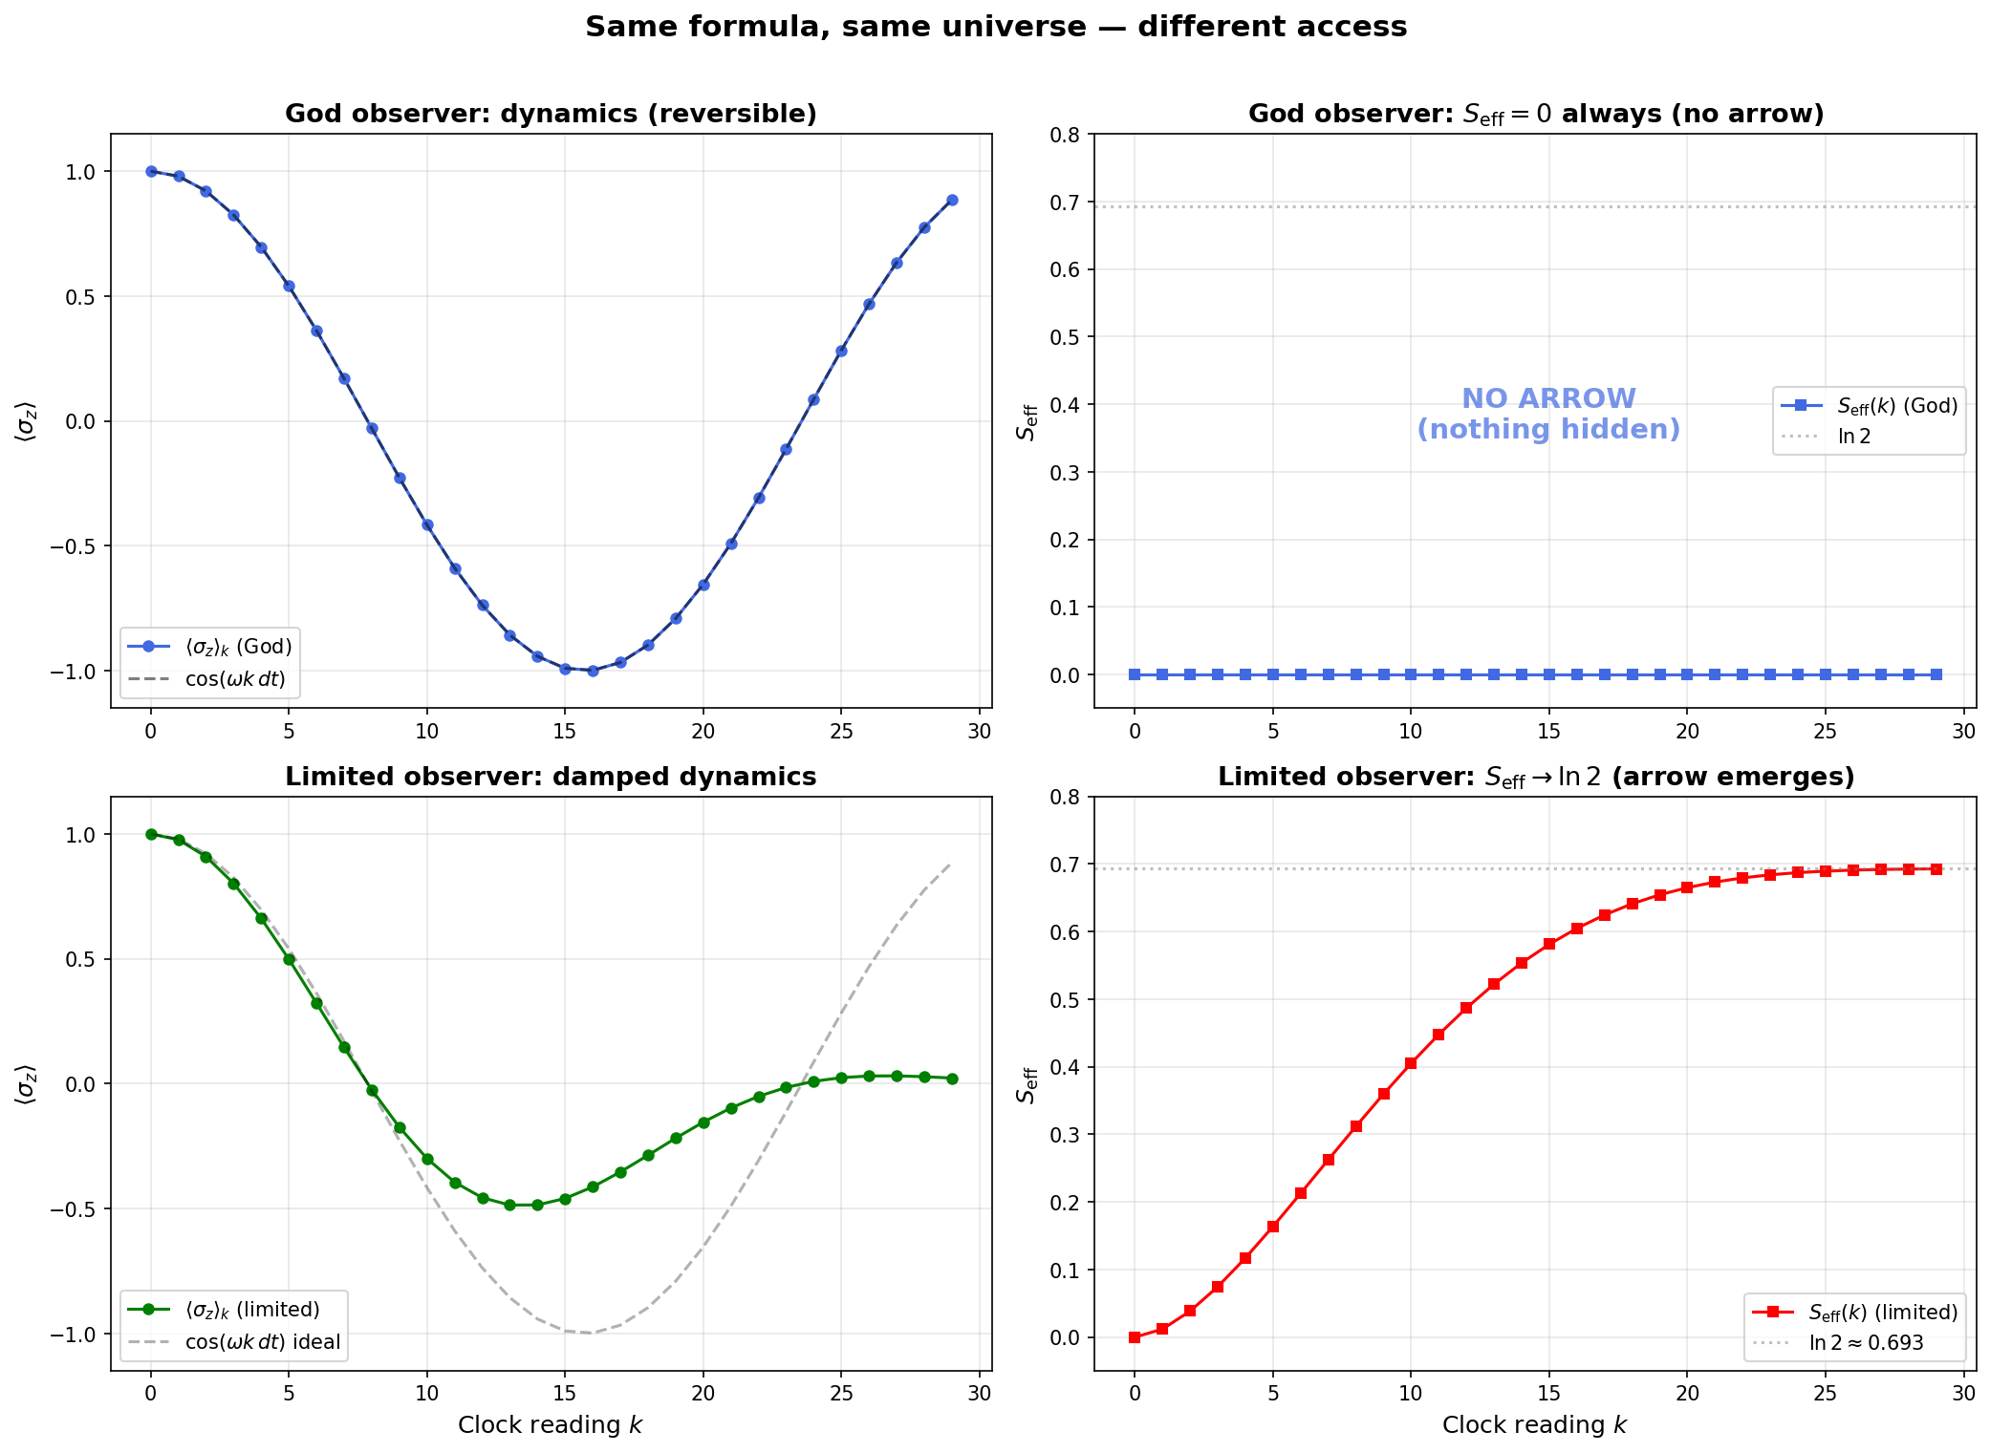
Top row: God observer ($n_{env}=0$) — dynamics are clean and reversible, $S_{eff}≡0$. Bottom row: limited observer ($n_{env}=4$) — oscillations damp, $S_{eff}→ln2$. Same formula, same universe, different access.
Interpretation. An omniscient observer who uses a clock can still count (there is a sequence: $k=0,1,2,…$), but the sequence is perfectly reversible. There is no distinction between forward and backward. Time exists as a coordinate label, but the arrow of time does not exist. God can “run the movie backwards” with no loss of information.
This is precisely what the formula predicts: the arrow comes from ${Tr}_{E}$, and when there is nothing to trace out, the arrow vanishes.

Level 2: God Sees Everything, Including the Clock
Setup. The observer does not condition on any clock reading. Instead, the observer has direct access to the full global state $|Ψ⟩$. No projection $⟨t|_{C}$ is performed. No partial trace ${Tr}_{E}$ is performed.
Prediction. Without the projection $⟨t|_{C}$, there is no map $t↦ρ_{S}(t)$, and therefore no dynamics. The system observable $⟨σ_{z}⟩$ is not a function of time — it is a single number obtained from the global state. Specifically:
$$⟨σ_{z}⟩_{global}=Tr​\left[σ_{z}⋅{Tr}_{CE}​\left(|Ψ⟩⟨Ψ|\right)\right].$$
This is one static value, not a time series.
Numerical result.
- The global state $|Ψ⟩$ is pure: $S_{vn}(|Ψ⟩⟨Ψ|)=5.2×{10}^{−13}≈0$ (machine precision).
- $⟨σ_{z}⟩_{global}=0.0365$ — a single frozen number.
- $S_{vn}(ρ_{S}^{global})=0.6683$ — the system appears mixed because clock and environment are entangled with it in $|Ψ⟩$, but this entropy is static.
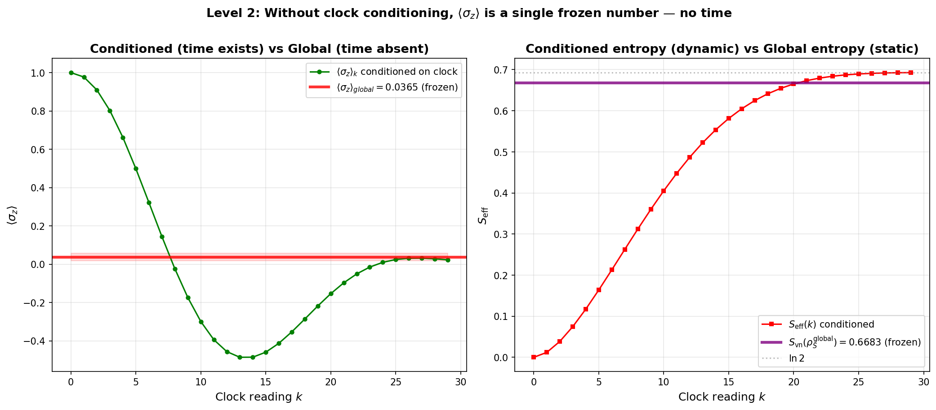
Left: conditioned $⟨σ_{z}⟩_{k}$ (green, dynamic) vs. global $⟨σ_{z}⟩$ (red line, frozen). Right: conditioned $S_{eff}(k)$ (growing) vs. global $S_{vn}$ (purple line, static). Without clock conditioning, all temporal structure disappears.
Interpretation. Dynamics are entirely an artifact of conditioning on a clock. Without the projection $⟨t|_{C}$, the system has no “before” or “after” — only a single, static state. The formula does not produce $ρ_{S}(t)$ because the operation that creates the time variable $t$ (the clock projection) is not performed. For an observer who sees $|Ψ⟩$ directly, time does not exist.
This validates the core ontological claim of the framework: time is not discovered by the observer — it is constructed by the observer through the act of conditioning on a physical clock.

Level 3: The Universe as a Pure Atemporal Object
Setup. We examine the global state $|Ψ⟩$ itself, without any observer.
Result.
- $|Ψ⟩$ has norm 1 (a single vector in Hilbert space).
- $\hat{C}|Ψ⟩=0$ by construction (the Wheeler–DeWitt constraint).
- The von Neumann entropy of the global state is exactly zero: it is a pure state.
Interpretation. The universe, seen “from outside” (if such a perspective were meaningful), is a single timeless mathematical object. It has no history, no arrow, no experience. It simply is. This is postulate P0 in its purest form: global atemporality. Every temporal feature — dynamics, irreversibility, the sense of “now” — arises only when a subsystem (the observer) performs the operations of conditioning and tracing.
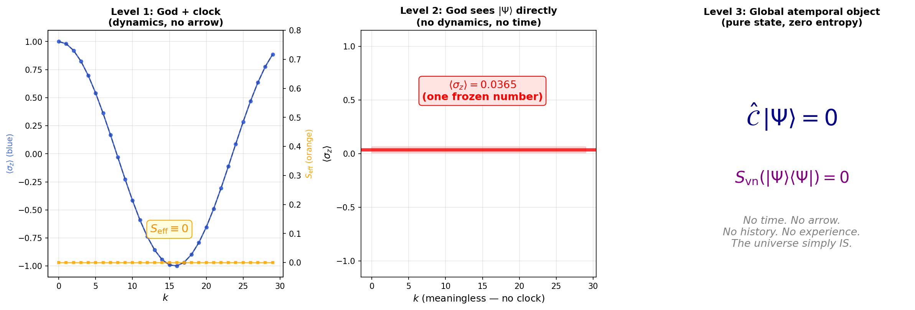
The three levels of omniscience. Left: God with a clock sees reversible dynamics but no arrow ($S_{eff}=0$). Center: God without a clock sees a frozen number ($⟨σ_{z}⟩=0.0365$), no dynamics. Right: the global state $|Ψ⟩$ with $\hat{C}|Ψ⟩=0$ is a pure atemporal object.

Progressive Blindness: The Arrow as a Function of Ignorance
To make the connection between ignorance and the arrow of time quantitative, we run the same formula with progressively larger environments, from $n_{env}=0$ (God) to $n_{env}=6$ (64 hidden qubits).
Progressive blindness: final effective entropy as a function of the number of hidden qubits. The arrow of time grows monotonically with the observer’s ignorance.
$n_{env}$ | $d_{E}=2^{n_{env}}$ | $S_{eff}^{final}$ | Arrow?
0 (God) | 1 | 0.000000 | NO
1 | 2 | 0.611144 | YES
2 | 4 | 0.680377 | YES
3 | 8 | 0.691118 | YES
4 | 16 | 0.692824 | YES
5 | 32 | 0.693096 | YES
6 | 64 | 0.693139 | YES
$∞$ | $∞$ | $ln2=0.693147…$ | YES
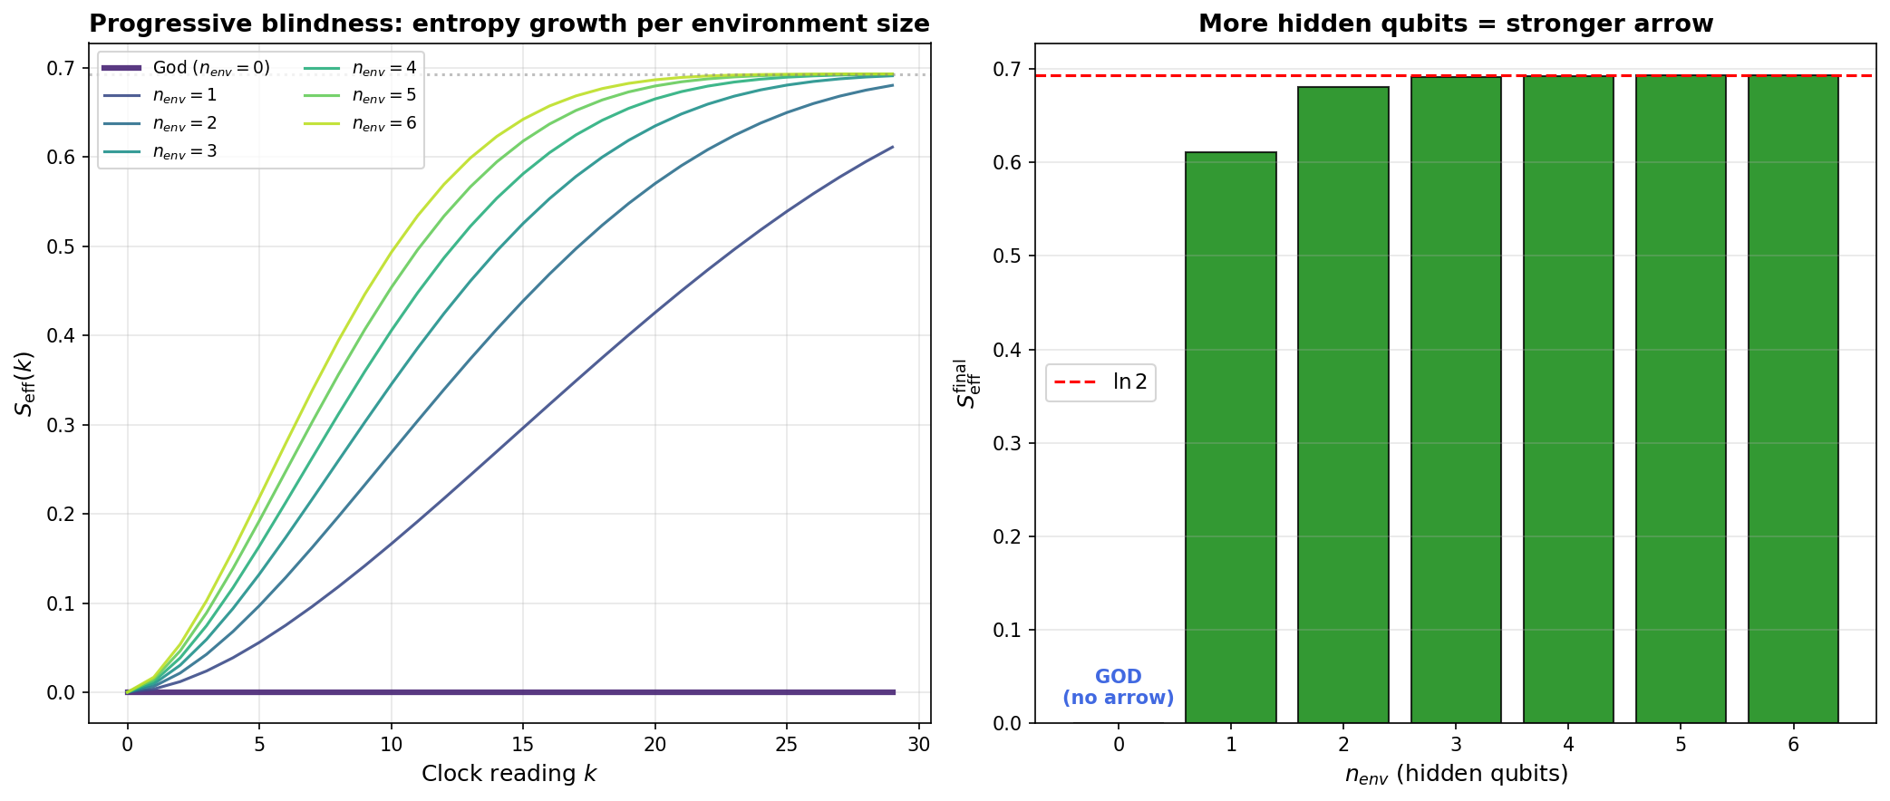
Left: entropy growth curves $S_{eff}(k)$ for each environment size; the God curve ($n_{env}=0$, thick) is identically zero. Right: final $S_{eff}$ as a function of $n_{env}$; the arrow converges to $ln2$ as ignorance increases.
The convergence is striking:
- At $n_{env}=0$: $S_{eff}=0$ exactly. No arrow. No irreversibility.
- At $n_{env}=1$: a single hidden qubit is enough to generate $S_{eff}=0.611$, already 88% of the maximum. One qubit of ignorance creates most of the arrow.
- At $n_{env}≥4$: $S_{eff}→ln2$ to three decimal places. The arrow is essentially saturated.
This produces a precise quantitative statement: the arrow of time is a monotonically increasing function of the observer’s ignorance. The function saturates at $ln2$ (the maximum entropy of a qubit) as the effective environment dimension grows.

Why the Formula Doesn’t Break
A natural concern is whether the formula “fails” or becomes ill-defined for the God observer. It does not. The formula [eq:formula] is mathematically valid for any value of $n_{env}$, including zero:
- When $n_{env}=0$: ${Tr}_{E}$ reduces to the identity, $ρ_{S}(k)$ is pure, $S_{eff}=0$. The formula returns clean, reversible quantum dynamics.
- When $n_{env}>0$: ${Tr}_{E}$ generates irreversibility by discarding correlations. The formula returns damped dynamics with growing entropy.
- When no clock conditioning is performed: the formula simply is not applied. Without $⟨t|_{C}$, there is no time variable $t$, and no $ρ_{S}(t)$ is constructed.
The key insight is that the formula does not assume limited access — it parameterizes it. The observer’s level of ignorance is encoded in which degrees of freedom fall inside $E$ (traced out) versus $S$ (kept). The formula is equally valid for God ($E=⌀$) and for a laboratory observer ($E=$ everything outside the lab). What changes is the output: the nature of the emergent temporal description.

Theological and Philosophical Implications
While this framework makes no claims about theology, the results have an interesting resonance with several classical philosophical and theological intuitions about the relationship between omniscience and temporality:
- Boethius (6th century): In The Consolation of Philosophy, Boethius argued that God sees all of time simultaneously — past, present, and future are coexistent for God. This is formally analogous to Level 2: an observer who accesses $|Ψ⟩$ directly sees a static, atemporal object with no “before” or “after.”
- Augustine (4th century): In the Confessions, Augustine proposed that time is a feature of creation, not of the Creator. Before creation, there was no time. In our framework: time is a feature of conditioned descriptions under partial access, not of the global state $|Ψ⟩$. The global state “exists” without time.
- Block Universe (Eternalism): The predominant interpretation in relativistic physics holds that past, present, and future all exist equally (the “block universe”). Our framework goes further: the block universe itself is an observer-dependent construction. Without conditioning on a clock, there is no block — there is only $|Ψ⟩$.
- The Price of Omniscience: Perhaps the most provocative result is this: an omniscient observer does not experience time. Omniscience and temporal experience are mutually exclusive. To experience time — to feel the passage from past to future, to remember, to anticipate — requires ignorance. The arrow of time is the arrow of not knowing.

Summary
Level | Access | Dynamics? | Arrow?
1 | Clock + full environment | Yes (reversible) | No ($S_{eff}=0$)
2 | Full state $|Ψ⟩$ | No (frozen) | No (static)
3 | Pure atemporal object | No | No
Limited | Clock + partial access | Yes (damped) | Yes ($S_{eff}→ln2$)
The formula $ρ_{S}(t)={Tr}_{E}[⟨t|_{C}|Ψ⟩⟨Ψ||t⟩_{C}]/p(t)$ is valid at every level of access. What changes is the emergent physics:
- With limited access: time, dynamics, irreversibility, and the arrow — the full phenomenology of temporal experience.
- With total access: a static, reversible, atemporal universe. No history. No arrow. No time.
The conclusion is austere and precise:
Time is not a property of the universe. Time is a property of ignorance. An omniscient observer experiences no time. The arrow of time is the arrow of not knowing.

Reproducibility
All numerical results in this note are generated by the scripts test_god_observer.py and generate_god_observer_plots.py, using the same build_paw_history() and get_conditioned_observables() functions from validate_formula.py. No modifications to the core formula code were required. The complete codebase is available at:
https://github.com/gabgiani/paw-toymodel
Reference parameters: $N=30$, $dt=0.2$, $ω=1.0$, $g=0.1$, $|ϕ_{0}⟩=|0⟩$, $H_{S}=(ω/2)σ_{x}$, HSE=gj​σx(S)⊗σx(Ej).

