https://www.kaggle.com/datasets/blastchar/telco-customer-churn?resource=download

This dataset, obtained from Kaggle, contains information about a telecommunications company's customers and their churn status. The dataset includes variables such as customer ID, gender, senior citizen status, partner status, dependents, tenure, phone service, multiple lines, internet service, online security, online backup, device protection, tech support, streaming TV, streaming movies, contract type, paperless billing, payment method, monthly charges, total charges, and churn.
I selected this dataset to gain additional experience analyzing customer churn and identifying the factors that influence whether customers remain with or leave a company. Customer retention is an important business objective, and understanding churn patterns can help organizations develop strategies to improve customer satisfaction and reduce revenue loss.
The primary questions guiding this project are:
- Do customers subscribed to certain services have higher churn rates than others?
- Do customers with multiple services or subscriptions churn at a lower rate than customers with only one service?
- Which customer characteristics are most strongly associated with churn?
- What overall trends and patterns can be identified within the data?
By exploring these questions through descriptive analysis and visualization, this project aims to uncover meaningful insights into customer behavior and the factors that contribute to customer churn.
The first step in the Exploratory Data Analysis (EDA) process is loading the dataset. I used pandas.read_csv() to import the data into Google Colab and then used .head(10) to view the first ten rows of the dataset. This provided an initial look at the data structure and the values contained in each column.
Next, I checked for missing values using .isnull().sum(). The results showed that there were no null values in any of the columns. After confirming data completeness, I checked for duplicate records using .duplicated().sum(). No duplicate rows were found in the dataset.
The next step was to examine the data types of each column using .info(). This revealed that some columns were not stored using the most appropriate data types. Before performing aggregations and further analysis, it is important to ensure that each variable is assigned the correct data type.
To organize the data, I grouped the columns into binary, categorical, and numerical variables:
Binary Columns
- Gender
- SeniorCitizen
- Partner
- Dependents
- PhoneService
- PaperlessBilling
- Churn
Categorical Columns
- MultipleLines
- InternetService
- OnlineSecurity
- OnlineBackup
- DeviceProtection
- TechSupport
- StreamingTV
- StreamingMovies
- Contract
- PaymentMethod
Numerical Columns
- Tenure
- MonthlyCharges
- TotalCharges
By categorizing the variables in this way, it becomes easier to apply the appropriate preprocessing techniques, perform statistical analysis, and create visualizations that accurately represent the data.
After normalizing our data it's time to do some analysis. The first question we are looking to answer is: Do customers subscribed to certain services have higher churn rates than others?To answer this question, I calculated the churn rate for customers subscribed to each service by taking the mean of the binary Churn variable and multiplying it by 100. Comparing the churn rates across services allows us to identify which services are associated with higher customer retention and which are associated with greater customer turnover. Services with lower churn rates may provide additional value to customers, while services with higher churn rates may indicate areas where customer satisfaction or engagement could be improved.
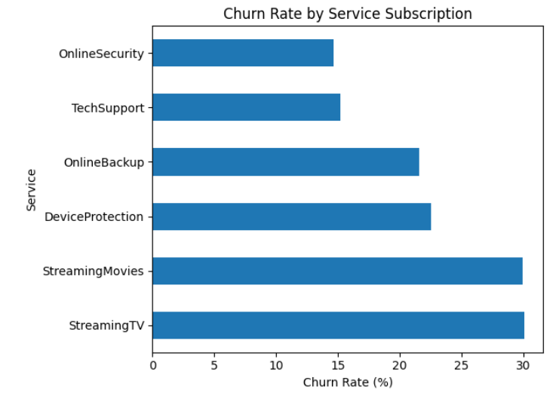
The second question we hope to answer is: Do customers with multiple services churn at a lower rate than customers with only one service? To answer this question, I first created a new binary column called MultipleServices. This column assigns a value of 0 to customers with one or fewer services and a value of 1 to customers with multiple services.
Next, I calculated the churn rate for each group by taking the mean of the binary Churn variable and multiplying it by 100 to convert it into a percentage. The results showed that customers with one or fewer services had a churn rate of 28.79%, while customers with multiple services had a churn rate of 24.67%.
Based on these findings, customers with multiple services appear to churn at a lower rate than customers with only one service. This suggests that customers who subscribe to multiple services may be more engaged with the company and therefore less likely to leave.
Next, we examined whether certain customer characteristics affect churn rates. To do this, a loop was used to calculate the churn rate for customers based on four characteristics: gender, senior citizen status, partner status, and dependent status.
The results showed that gender had very little impact on churn. Male customers had a churn rate of 26.92%, while female customers had a churn rate of 26.16%.
Senior citizen status, however, had a much stronger relationship with churn. Customers who were not senior citizens had a churn rate of 23.61%, while senior citizens had a churn rate of 41.68%, nearly double that of non-senior customers. This suggests that senior citizens are significantly more likely to leave the company.
Partner status also appeared to influence churn rates. Customers without a partner churned at a rate of 32.96%, compared to only 19.66% for customers with a partner. This may indicate that customers with partners are more likely to maintain their service subscriptions.
Finally, we examined the effect of dependents on churn. Customers with dependents had a churn rate of 15.45%, while customers without dependents had a churn rate of 31.28%. This substantial difference suggests that customers with dependents are much less likely to churn than those without dependents.
Overall, senior citizen status, partner status, and dependent status all appear to have meaningful relationships with customer churn, while gender has little to no effect.
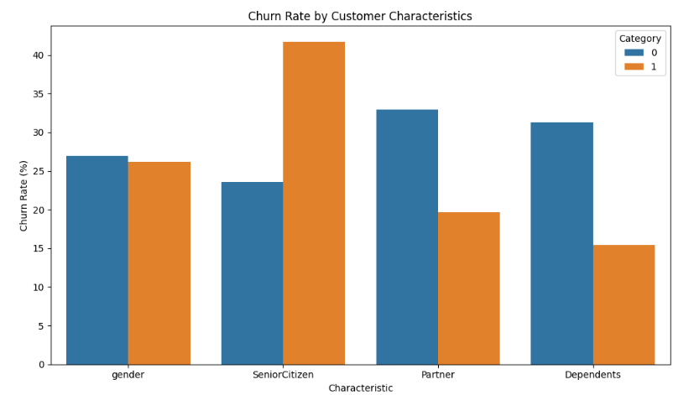
This exploratory data analysis examined customer churn patterns within a telecommunications company dataset. The analysis focused on identifying whether specific services, multiple service subscriptions, and customer characteristics were associated with higher or lower churn rates.
The results showed that customers with multiple services were less likely to churn than customers with only one service, suggesting that customers who subscribe to several services may be more engaged with the company and therefore more likely to remain customers. The analysis of customer characteristics revealed that gender had little impact on churn, while senior citizen status, partner status, and dependent status were strongly associated with customer retention. Senior citizens experienced significantly higher churn rates than non-senior customers, while customers with partners and dependents were substantially less likely to leave the company.
These findings suggest that customer demographics and service adoption patterns play an important role in predicting churn. In particular, customers who are senior citizens, do not have partners, or do not have dependents may represent higher-risk groups that could benefit from targeted retention strategies. Likewise, encouraging customers to adopt additional services may help strengthen customer engagement and reduce churn.
Overall, this analysis demonstrates how exploratory data analysis can be used to uncover meaningful business insights and identify factors that contribute to customer retention and customer loss. Future work could include building predictive machine learning models to estimate churn risk and determine which factors are the strongest predictors of customer behavior.

