During this project, we will explore different variables collected and used by banks to detect fraudulent transactions, as well as use a Random Forest model to predict whether a charge is fraudulent or not. The dataset used in this project was obtained from Kaggle and was specifically designed for student practice. It intentionally contains missing values and an imbalanced class distribution to simulate real-world data challenges.
I chose this dataset because it provides an opportunity to refresh my skills in Python and machine learning while also giving hands-on experience working with unclean data. Fraud detection is a practical real-world application of data science, making this dataset both educational and relevant.
The dataset has 7000 rows and includes the following variables: transaction amount, hour of day, weekend indicator, number of items purchased, customer age, previous transactions, distance from home, device type, network quality, first transaction indicator, store type, velocity score, and the target variable is_fraud. These features can help identify suspicious purchasing behavior and patterns commonly associated with fraudulent activity.
After loading the data, the first step was data cleaning and preprocessing. The dataset was already standardized, so the next step was to check for missing values. The dataset contained approximately 5,600 missing values distributed across 12 columns, while the is_fraud target variable was the only column without missing values.
Because of the large number of missing values, imputation techniques were used instead of deleting rows in order to preserve as much data as possible. Removing rows with missing data could have significantly reduced the dataset size and potentially removed important fraud patterns. By imputing the missing values, the dataset remained large enough to support effective analysis and machine learning model training.
For continuous numerical variables, missing values were replaced using the median of each column. The median was chosen instead of the mean because it is less sensitive to outliers, which are common in fraud detection datasets.
For discrete or categorical variables, missing values were replaced using the mode, since the mode represents the most frequently occurring category and preserves the distribution of the data.
For binary variables, missing values were filled with 0, as this was the dominant class and represented the most common outcome in those columns.
For the customer_age feature, group-based imputation was performed using store_type. Missing values were replaced with the median customer age within each store category. This method helps preserve age patterns associated with different types of stores and provides more realistic imputations than using a single overall median.
For the distance_from_home feature, group-based imputation was also applied. The data was grouped by both device_type and store_type, and missing values were replaced with the median distance calculated within each group. This approach preserves realistic behavioral patterns associated with different device and store combinations.
For the velocity_score feature, K-Nearest Neighbors (KNN) imputation was used with k = 5. KNN imputation estimates missing values based on the five most similar observations in the dataset, allowing the imputed values to reflect relationships between related variables rather than relying on a single overall statistic.
This preprocessing strategy helped maintain dataset size while producing more realistic and statistically appropriate replacements for missing data. Below is a bar graph created to show the percentage of columns that contained null values.
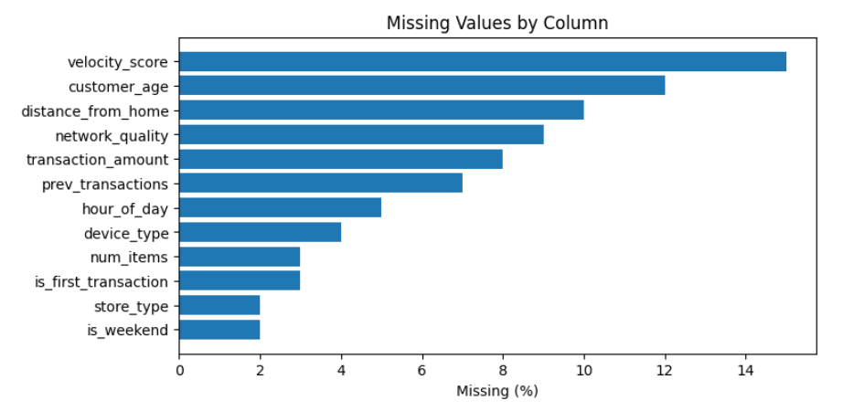
The next step in the analysis was to examine the descriptive statistics of the dataset. To accomplish this, the .describe() function in pandas was used to generate a summary table displaying the count, mean, standard deviation, minimum, quartiles, and maximum values for each numerical column. These statistics provided an overview of the distribution and spread of the data and helped identify potential outliers or unusual patterns within the variables.
In addition to the summary statistics, a count plot was created using Matplotlib and Seaborn to visualize the distribution of fraudulent and non-fraudulent transactions. This visualization made it easier to observe the class imbalance within the dataset, where non-fraudulent transactions significantly outnumber fraudulent transactions. Understanding this imbalance is important because it can impact the performance of machine learning models and influence which evaluation metrics should be prioritized during model development.
A histogram was also created to show the distribution of velocity scores in the dataset. This plot helps visualize the overall distribution pattern of the velocity score variable, including whether it follows a normal distribution or is skewed. Analyzing this distribution is useful for understanding the behavior of the feature and determining whether any transformations or additional preprocessing steps may be needed.
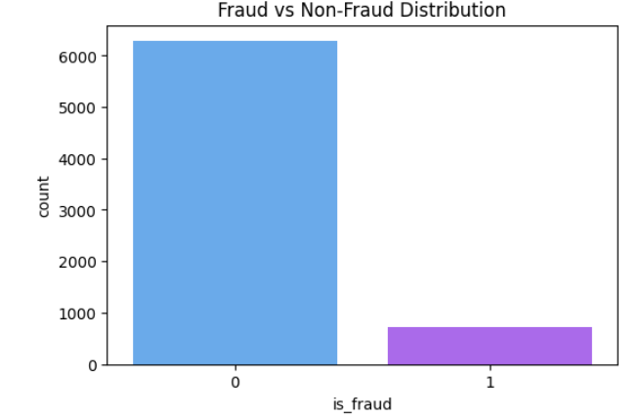
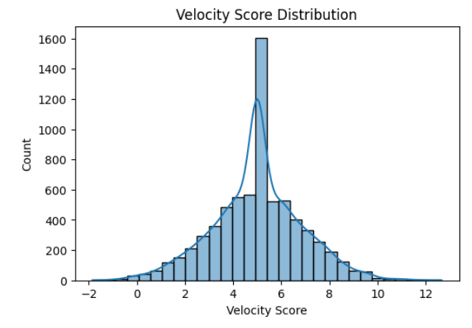
To analyse the relationships between the variables and the target variable, a scatter matrix was created using a pairplot from Seaborn. This allowed the relationships between transaction_amount, velocity_score, and distance_from_home to be visualised simultaneously in a single plot.
By examining these graphs, it is clear that there are generally weak or no strong linear relationships between the variables. This suggests that the features do not have strong direct correlations with one another.
The pairplot also provides insight into the distribution of each individual variable. As discussed earlier, velocity_score appears relatively normally distributed. In contrast, transaction_amount shows a more regular distribution, while distance_from_home is heavily right-skewed, with most values concentrated near zero and a long tail extending toward higher values.
Overall, the scatter matrix is useful for both identifying relationships between variables and understanding their underlying distributions.

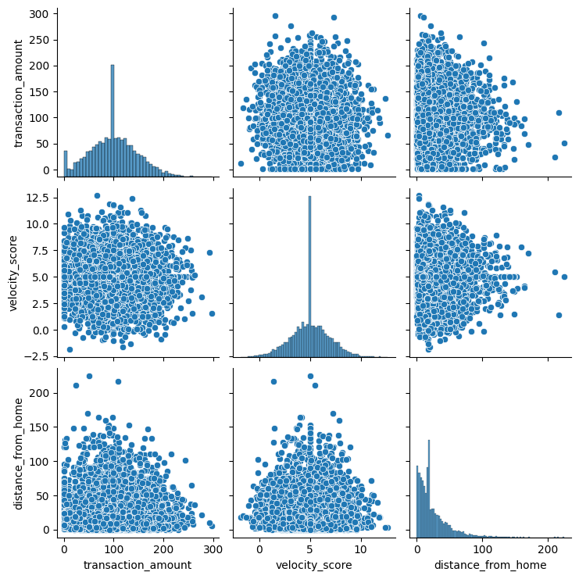
I then used the .corr() function in pandas to examine the correlation between is_fraud and the other variables in the dataset. This provides a quick overview of the linear relationships between all numerical features and the target variable.
From the results, it is clear that there is little to no correlation between any single feature and whether a transaction is fraudulent. The highest correlation coefficient observed was 0.048, which is very close to zero and indicates an extremely weak relationship.
This suggests that no individual variable strongly predicts fraud on its own. Instead, fraud detection in this dataset is likely dependent on more complex interactions between multiple variables rather than simple linear relationships. This gives the opportunity for further analysis in a future analysis.
Next, we create a train-test split. We do this by dividing the dataset into two separate groups: a training set and a testing set. The training set is used to teach the model patterns within the data, while the testing set is used to evaluate how well the model performs on unseen data. This helps ensure that the model is not simply memorizing the data and can generalize effectively to new observations. Typically, a larger portion of the data is assigned to the training set, such as 70–80%, with the remaining data used for testing. In this case 25% of the data is used for testing while the remaining 75% is used for training.
Random Forest was selected because it can handle complex nonlinear relationships and works well with mixed feature types. After running the model, we need to evaluate its performance using several metrics. The first metric examined is the accuracy score, where the model achieved 88% accuracy. While this may initially seem like a strong result, it is important to consider the imbalance in the dataset. Since most transactions are non-fraudulent, the model could predict every transaction as non-fraud and still achieve over 80% accuracy.
This is why it is important to also examine the confusion matrix. The confusion matrix shows how many predictions were correct and incorrect by comparing the model’s predicted values against the actual values. It breaks the results into true positives, true negatives, false positives, and false negatives. This provides a clearer understanding of how well the model identifies fraudulent transactions rather than relying solely on overall accuracy.
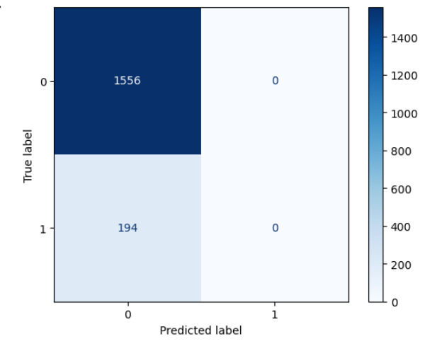
Looking at this matrix, we can see that the model predicted all transactions as negative. This means that the model failed to correctly identify any fraudulent transactions. Although the overall accuracy score appeared high, the confusion matrix reveals that the model is not effective for fraud detection because it is only predicting the majority class. In fraud detection, recall is especially important because failing to identify fraudulent transactions can result in significant financial losses. Therefore, relying solely on accuracy can be misleading when working with imbalanced datasets. These results indicate that the model still requires improvement, such as addressing the class imbalance, tuning model parameters, or evaluating additional performance metrics including precision, recall, and F1-score.
Overall, this project demonstrated the importance of data preprocessing, exploratory analysis, and careful model evaluation in fraud detection tasks. While the Random Forest model achieved high accuracy, the confusion matrix revealed that the model struggled to identify fraudulent transactions due to class imbalance. Future work could focus on improving recall through resampling techniques, parameter tuning, and alternative machine learning models. Despite these limitations, the project provided valuable experience working with real-world data challenges and machine learning workflows in Python.

