PAR Laboratory

13/09/2014 - Q1
FIRST DELIVERABLE

group: par1107
Gabriel Carrillo
Younes Zeriahi
Node architecture and memory:

1.- Draw and briefly describe the architecture of the computer in which you are doing this lab session:

To get the numbers of sockets, the cores per socket and the threads per core we use the “lscpu” command:

------------------------------------------------------------------------------------------------------------------------
Architecture: x86_64
CPU op-mode(s): 32-bit, 64-bit
Byte Order: Little Endian
CPU(s): 24
On-line CPU(s) list: 0-23
Thread(s) per core: 2
Core(s) per socket: 6
Socket(s): 2
NUMA node(s): 2
Vendor ID: GenuineIntel
CPU family: 6
Model: 44
Stepping: 2
CPU MHz: 1596.000
BogoMIPS: 4799.90
Virtualization: VT-x
L1d cache: 32K
L1i cache: 32K
L2 cache: 256K
L3 cache: 12288K
NUMA node0 CPU(s): 0,2,4,6,8,10,12,14,16,18,20,22
NUMA node1 CPU(s): 1,3,5,7,9,11,13,15,17,19,21,23
------------------------------------------------------------------------------------------------------------------------

As we can see, every node of the machine has 2 sockets, each of one has 6 cores, and each core has 2 threads. That means that every node has:
2 sockets
12 cores
24 threads

The command we used to get the cache hierarchy size and sharing is the “lstopo” command:

------------------------------------------------------------------------------------------------------------------------
Machine (24GB)
NUMANode L#0 (P#0 12GB) + Socket L#0 + L3 L#0 (12MB)
L2 L#0 (256KB) + L1 L#0 (32KB) + Core L#0
PU L#0 (P#0)
PU L#1 (P#12)
L2 L#1 (256KB) + L1 L#1 (32KB) + Core L#1
PU L#2 (P#2)
PU L#3 (P#14)
L2 L#2 (256KB) + L1 L#2 (32KB) + Core L#2
PU L#4 (P#4)
PU L#5 (P#16)
L2 L#3 (256KB) + L1 L#3 (32KB) + Core L#3
PU L#6 (P#6)
PU L#7 (P#18)
L2 L#4 (256KB) + L1 L#4 (32KB) + Core L#4
PU L#8 (P#8)
PU L#9 (P#20)
L2 L#5 (256KB) + L1 L#5 (32KB) + Core L#5
PU L#10 (P#10)
PU L#11 (P#22)
NUMANode L#1 (P#1 12GB) + Socket L#1 + L3 L#1 (12MB)
L2 L#6 (256KB) + L1 L#6 (32KB) + Core L#6
PU L#12 (P#1)
L2 L#7 (256KB) + L1 L#7 (32KB) + Core L#7
PU L#14 (P#3)
PU L#15 (P#15)
L2 L#8 (256KB) + L1 L#8 (32KB) + Core L#8
PU L#16 (P#5)
PU L#17 (P#17)
L2 L#9 (256KB) + L1 L#9 (32KB) + Core L#9
PU L#18 (P#7)
PU L#19 (P#19)
L2 L#10 (256KB) + L1 L#10 (32KB) + Core L#10
PU L#20 (P#9)
PU L#21 (P#21)
L2 L#11 (256KB) + L1 L#11 (32KB) + Core L#11
PU L#22 (P#11)
PU L#23 (P#23)
HostBridge L#0
PCIBridge
PCI 8086:10c9
Net L#0 "eth0"
PCI 8086:10c9
Net L#1 "eth2"
PCIBridge
PCI 8086:105e
Net L#2 "eth1"
PCI 8086:105e
Net L#3 "eth3"
PCIBridge
PCI 102b:0522
PCI 8086:3a20
Block L#4 "sda"
Block L#5 "sdb"
PCI 8086:3a26
Block L#6 "sr0"
PU L#13 (P#13)
------------------------------------------------------------------------------------------------------------------------

As we can see, the computer has 24GB, 12 for each node. Each node has 6 levels of cache, each one with 32KB.

For knowing the amount of main memory that the computer has, we use the “more /proc/meminfo” command:

------------------------------------------------------------------------------------------------------------------------
MemTotal: 24628820 kB
MemFree: 3260100 kB
Buffers: 180668 kB
Cached: 20480016 kB
SwapCached: 0 kB
Active: 10553492 kB
Inactive: 10159580 kB
Active(anon): 7688 kB
Inactive(anon):45080 kB
Active(file): 10545804 kB
Inactive(file): 10114500 kB
Unevictable: 128 kB
Mlocked: 128 kB
SwapTotal: 25165820 kB
SwapFree: 25165820 kB
Dirty: 212 kB
Writeback: 0 kB
AnonPages: 52520 kB
Mapped: 17088 kB
Shmem: 380 kB
Slab: 319252 kB
Sreclaimable: 253752 kB
Sunreclaim: 65500 kB
KernelStack: 2752 kB
PageTables: 3844 kB
NFS_Unstable:0 kB
Bounce: 0 kB
WritebackTmp: 0 kB
CommitLimit: 37480228 kB
Committed_AS: 310832 kB
VmallocTotal: 34359738367 kB
VmallocUsed: 339156 kB
VmallocChunk: 34346619196 kB
HardwareCorrupted: 0 kB
AnonHugePages: 0 kB
HugePages_Total: 0
HugePages_Free: 0
HugePages_Rsvd: 0
HugePages_Surp: 0
Hugepagesize: 2048 kB
DirectMap4k: 113796 kB
DirectMap2M: 7163904 kB
DirectMap1G: 17825792 kB
------------------------------------------------------------------------------------------------------------------------

As we can see, the computer has a total of 24628820 kB of main memory, 3260100 kB of which are free for us to use.

Timing sequential and parallel executions:

2.- Indicate the library header where the structure struct timeval is declared and which are its fields:

The library header is the <sys/time.h>, and it's fields are:
time_t tv_sec; /* seconds */
suseconds_t tv_usec; /* microseconds */

3.- Plot the execution time when varying the number of threads (strong scalability) and problem size (weak scalability) for pi_omp.c. Reason about the scalability of the program.

The scalability is correct because when we execute the program with strong scalability, we can see in the first graph that the curve decreases approaching zero while increasing the number of threads, and the speed-up tends to the 45 degrees line, getting wider with the increase of the number of threads.
On the other hand, when we execute the program with weak scalability, we can see that the speed-up remains almost constant with the increase of the number of threads.

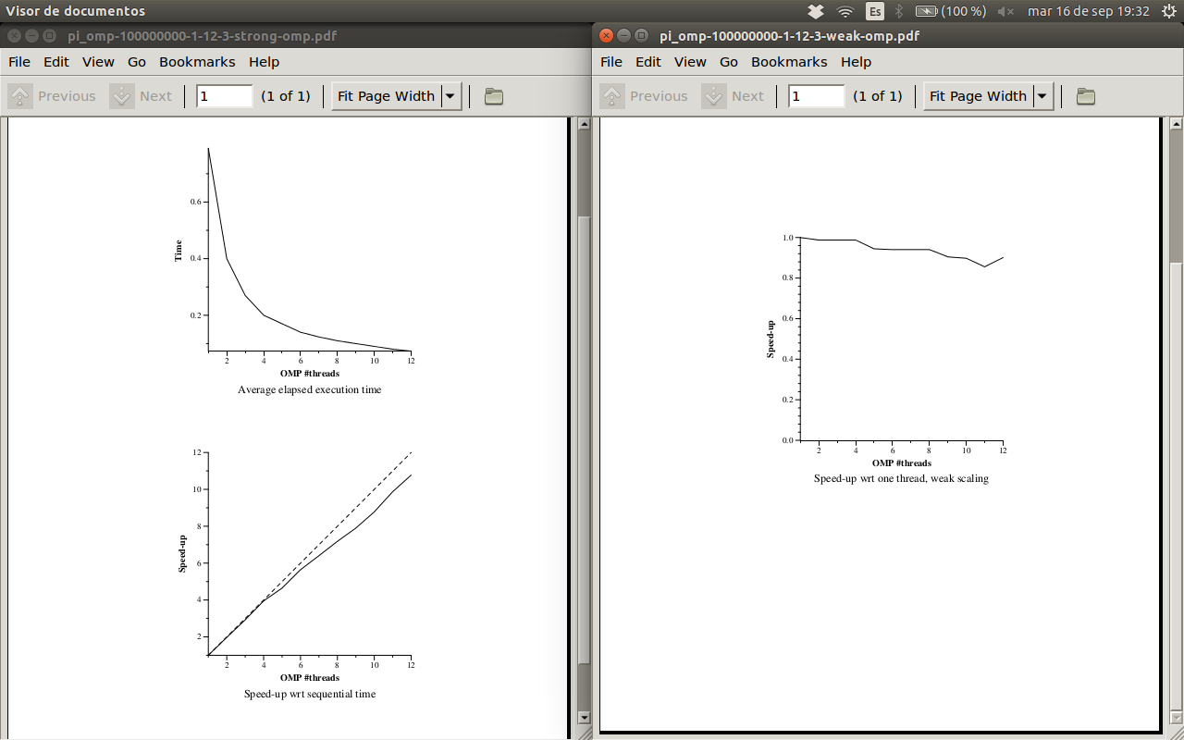

Tracing sequential and parallel executions:

4.- From the instrumented version of pi_seq.c, and using the appropiate Paraver configuration file, obtain the value of the parallel fraction ø for this programm when executed with 100.000.000 iterations:

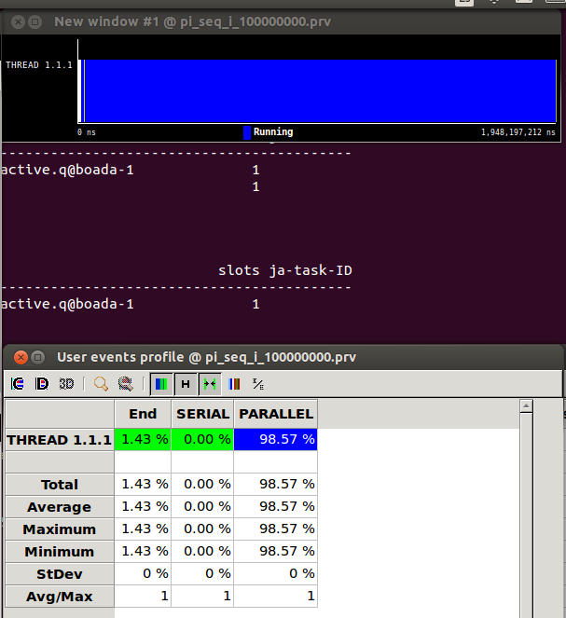

As we can see in the picture above, 98'57% of the instrumented version of pi_seq is done in parallel when we execute it with 100.000.000 iterations.

5.- From the instrumented version of pi_omp.c, and using the appropiate Paraver configuration file, show a profile of the % of time spent in the different OpenMP states ONLY during the execution of the parallel region (not considering the sequential part before and after) when using 8 threads and for 100.000.000 iterations.

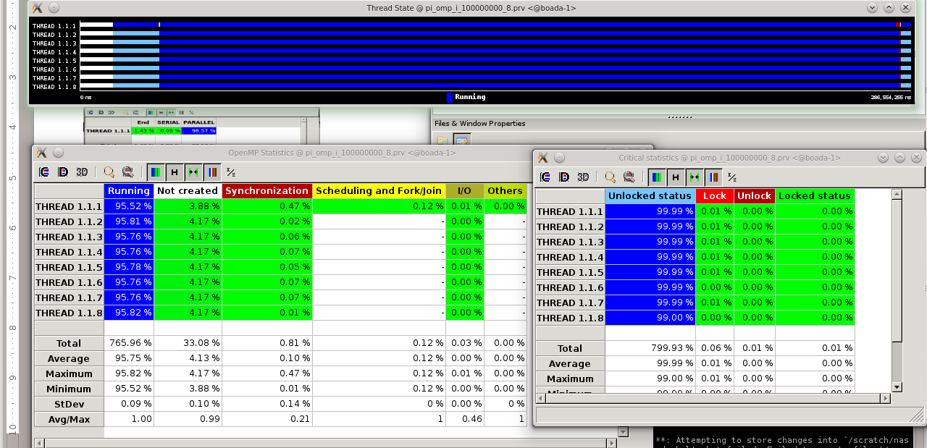
As we can see in the picture above, the average time of the processors during the parallel region using 8 processors and 100.000.000 iterations is 95'75%.
A 4'13% of the time is spent on the synchronization and the remaining 0'12% is invested in scheduling and Forking/Joining the tasks.

6.- From the instrumented versions of pi_seq.c and pi_omp.c (executed with the same number of iterations), and using the appropriate Paraver configuration files, obtain the avarage number of instructions executed and MIPS per thread during the execution of the parallel region (when using 8 threads). Are the numbers obtained coherent?

