*Link to GitHub page:* [*https://github.com/gabibergmane/social_recognition*](https://github.com/gabibergmane/social_recognition)

**Social Recognition Memory In Rhabdomys Mice Genus**

Gabi Bergmane

**Introduction**

Social recognition memory is the ability to recognise and recall familiar members of the same species1 - which is crucial for stability in a group of social animals. Social recognition memory is usually measured by exposing the test animal to a familiar (encountered in the training phase) and a novel (never encountered) mouse and measuring the time spent interacting with each conspecific. Normally, rodents prefer novelty and this is demonstrated by a longer investigation of the novel versus the familiar stimulus.2

My doctoral research project focuses on the role of the GluD1 receptor in the hippocampus and how it controls social behaviours, and one of the assays I plan to use to measure this is social recognition memory. Therefore, for this data science project, I analysed a social memory dataset to familiarise myself with its format and analysis.

**Methods**

A freely available dataset was sourced from a study investigating social recognition memory in two species of striped mouse in South Africa.3 The data included duration and latency values for social interactions between each species and a novel or familiar mouse.

Exploratory data analysis was performed in Jupyter Lab using Python 3. A correlation heatmap was generated to investigate links between the various metrics. Novel and familiar paradigms and species differences were compared using a t-test. Normality was assessed using the Shapiro-Wilk test. Data not normally distributed was assessed with the Kruskal-Wallis test. Graphs were generated using Python 3 and compiled into figures using Microsoft Powerpoint.

**Results**

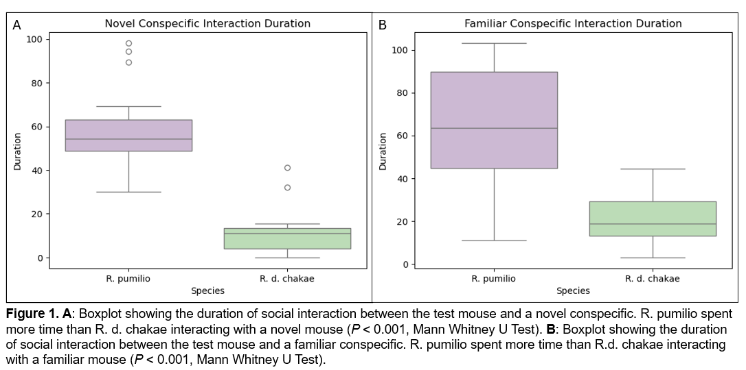***R. pumilio mice spent more time interacting with conspecifics***

Analysis of social recognition memory task performance between the two species revealed that *R. pumilio* spent significantly more time interacting with both novel and familiar conspecifics than *R.d. chakae* (Figure 1).

***No change in duration or latency of interactions with a novel or familiar conspecific***

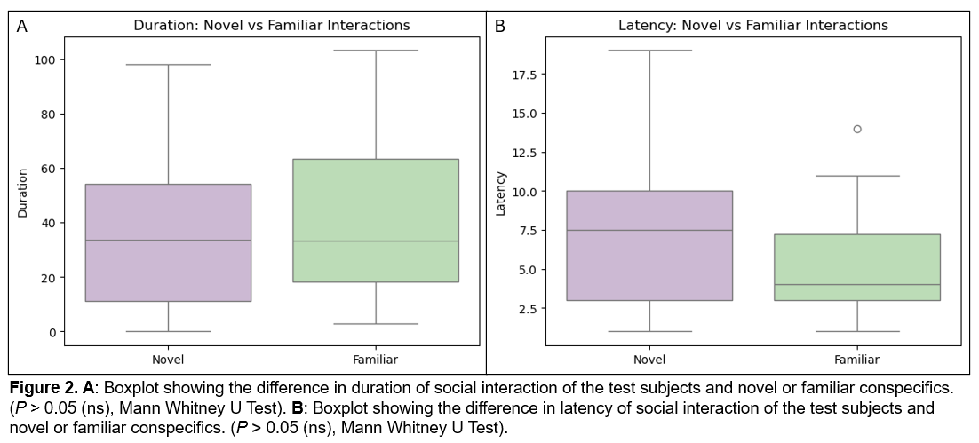

Visualisation of social memory task data showed that the mice interacted longer with familiar than with novel mice and there was more latency when interacting with novel mice, however, after applying statistical analysis, these differences were not significant (Figure 2).

**Discussion**

The results showed higher sociability in R. pumilio. This can be explained by the differing social organisation of both species: R. pumilio are group-living, while R. chakae are solitary animals.3

It was expected that the mice will spend more time investigating novel stimuli, however, my analysis showed no difference in time spent interacting with novel or familiar conspecifics. In fact, the visual representation in Figure 2 indicates that more time was spent interacting with familiar animals. This may indicate impaired social recognition memory, or rather that this test is not suitable for studying wild mice species and should be adapted for their natural social behaviours and preferences. The validity of the results may also be affected by poor data quality, e.g. lack of units for measurements.

**References**

1. Wang X., Zhan Y. Regulation of Social Recognition Memory in the Hippocampal Circuits. Front. Neural Circuits (2022). <https://doi.org/10.3389/fncir.2022.839931>
2. Cum M, Padilla-Coreano N., et. al. A systematic review and meta-analysis of how social memory is studied. Scientific Reports (2024). <https://www.nature.com/articles/s41598-024-52277-z>
3. Neves NC., Pillay N. Social recognition and short-term memory in two taxa of striped mouse with differing social systems. Journal of Experimental Zoology Part A: Ecological and Integrative Physiology (2022). <https://doi.org/10.1002/jez.2590>