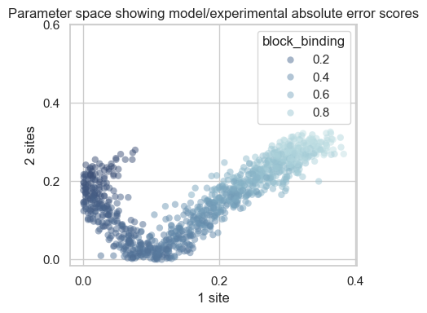

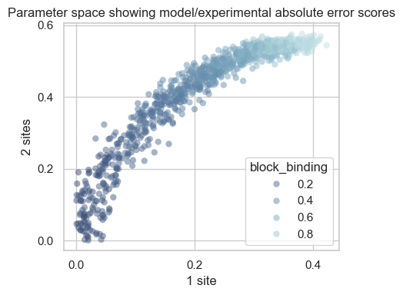

A.

B.

**Figure 1. Preliminary parameter space results testing a range of roadblock on-rates for proximity to experimental results. *A****. Independent model.* ***B****. Cooperative model.* ***N=1000 randomised points, n=10 sampled runs for median calculation in each point.***

*The x and y axes show absolute errors between model and experimental values, respectively for the exit or protein production rates as standardised medians when there is only 1 block site (x), or 2 block sites (y). Data standardised to the median rate at zero block sites. Each point represents a model run with a new block on-rate value randomised between 0 and 1; the closer a point is to (0,0), the closer the model is to the experiment.*

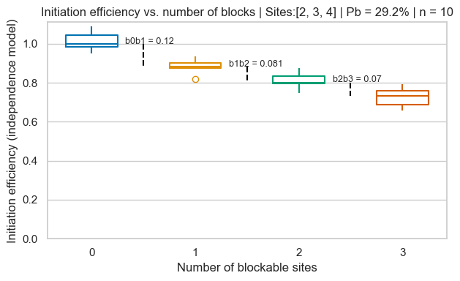

A.

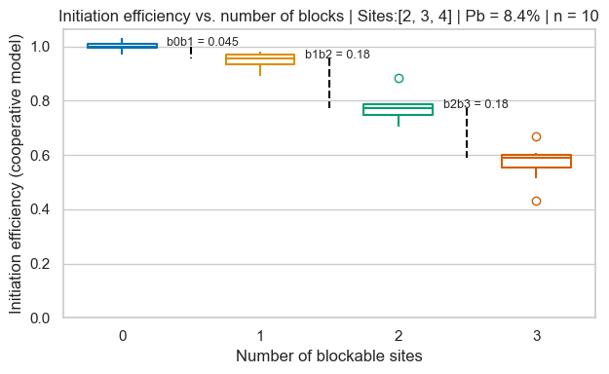

B.

**Figure 2. Model results from the best single independent and cooperative parameter sets from Figure 1.**

***A****. Independent model.* ***B****. Cooperative model.* ***n=10 sampled runs for each median calculation***

*The boxplots show standardised exit rate (proxy for initiation efficiency) data for n independent runs of the model with the best parameter set obtained in the relevant Figure 1 graphs (A or B), from 0 block sites to 3 block sites. The median exit rate at 0 block sites is the standard value. Distances between consecutive medians are printed in black (e.g. b0b1 is the distance between the median standardised rates at 0 and 1 blocks).*

*Experimental values for median standardised protein production rates from Edward’s 2021 flow cytometry experiment: m1e=0.959 (b0b1=0.041), m2e=0.741 (b1b2=0.218)*