# Worked Examples: Real Methods for Cubic Equations

This document shows two worked examples of solving cubic equations without using imaginary numbers explicitly. Instead, we rely on real trigonometric and real cube-root methods. These correspond to geometric interpretations with circles and neutral corridors.

## Example 1: Three Real Roots

Equation: x³ - 3x - 1 = 0  
  
Step 1: Depressed cubic with p=-3, q=-1.  
Step 2: Δ = (q/2)² + (p/3)³ = -0.75 < 0 ⇒ three real roots.  
Step 3: φ = arccos(-q/2 / √(-(p/3)³)) = arccos(0.5) = π/3.  
Step 4: Roots: t_k = 2√(-p/3) cos((φ+2πk)/3), k=0,1,2.  
  
Results:  
t₀ ≈ 1.879385  
t₁ ≈ -1.532089  
t₂ ≈ -0.347296  
  
All three are real solutions. No imaginary numbers were needed—the unit circle provides the missing reference.

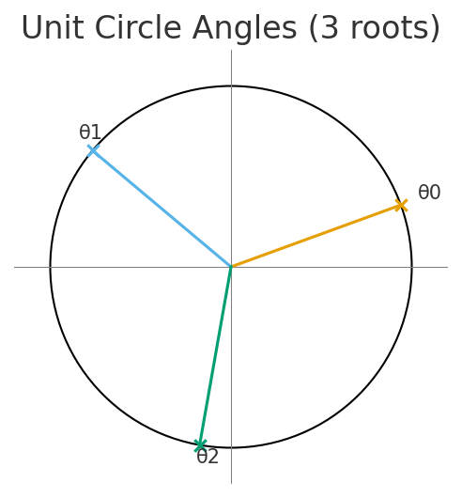

## Example 2: One Real Root

Equation: x³ + 3x + 1 = 0  
  
Step 1: Depressed cubic with p=3, q=1.  
Step 2: Δ = (q/2)² + (p/3)³ = 1.2500 > 0 ⇒ one real root.  
  
Real Cardano branch:  
x ≈ -0.322185  
  
Here, the cube roots are taken as real cube roots, even of negative numbers. This avoids introducing any imaginary values in the computation. Thus we obtain the single real root directly.

## Conclusion

These two examples demonstrate that cubic equations can be solved without using imaginary numbers explicitly:  
- When Δ < 0, the trigonometric unit-circle method works.  
- When Δ > 0, the real cube-root branch of Cardano provides the answer.  
  
This aligns with the interpretation that an inscribed circle (for the trigonometric case) or direct cube-root balancing (for the one-root case) replaces the need for imaginary steps, providing purely real geometric analogies.