Flight 19 — Best Possible Theory: Location & Search Zones

Integrating cosmic clock windows, Earth plate movement, ocean sub‑currents, and tides

# Executive Summary

Using the known timeline of Flight 19 and a physics‑first model, the most probable ditch area lies W to WNW of the last radio‑fix near 29°N, 79°W, along a westbound corridor where the Avengers could have flown an additional 20–30 minutes on minimal fuel (≈50–110 miles), followed by a short glide (≈4–10 miles). Surface debris would then be advected rapidly NE by the Gulf Stream and eddies, while heavy components likely settled on or just off the Blake Plateau near the break toward the Blake‑Bahama Basin. Plate motion since 1945 is only meters, negligible relative to search scales. A nearby lunar‑eclipse window (Dec 19, 1945) provides a ‘cosmic clock’ marker for alignment‑adjacent timing but does not supersede the physical drift and bathymetry controls.

# Key Coordinates Used

**• NAS Fort Lauderdale (departure):** 26.07250, -80.15280  
**• Last radio contact center:** 29.00000, -79.00000  
**• Zone A pivot (10 nm west of last contact):** 29.00000, -79.19077  
**• Zone B center (75 nm NE of Cocoa):** 29.27094, -79.73623  
**• Zone B pivot (10 nm west of Zone B center):** 29.27094, -79.92750

# Method Overview

1) Powered‑after‑contact corridors: conservative (50–73 nm) and optimistic (72–110 nm) westbound from pivots.

2) Glide fan: +4–10 nm beyond optimistic corridor.

3) Drift modeling: Gulf Stream 2–6 mph with eddy meanders, windage classes, and small tidal oscillation; 24/48/72‑hour envelopes.

4) Bathymetry & settling: Blake Plateau, Charleston Bump, Blake Escarpment and Ridge; identification of likely settling lanes (lee of bump; base of escarpment).

5) Plate motion: North American plate ~2.5 cm/yr WSW—~2 m since 1945 (negligible for search geometry).

6) Cosmic clock lining: proximity to Dec 19, 1945 lunar eclipse (alignment window) noted, but physical oceanography dominates search placement.

# Best‑Fit Theory Locations (Priority Zones)

• Priority Zone A — West corridor from Zone A pivot (29.00000, −79.19077):

Center (illustrative): 29.00000, -80.90766 (≈90 nm west of pivot) with a ±10–15 nm radius, straddling the western Blake Plateau and approaching the plateau break.

• Priority Zone B — West corridor from Zone B pivot (29.27094, −79.92750):

Center (illustrative): 29.27094, -81.64892 (≈90 nm west of pivot) with a ±10–15 nm radius. This corridor intersects drift pathways that curl NE toward the Charleston Bump.

• Heavy‑part settling lanes (secondary): along the base of the Blake Escarpment (~76°W from 27–32°N) and lee of the Charleston Bump (downstream eddy zone).

# Map: Key Lat/Long & Distances

The diagram below shows the primary points and great‑circle distances used to size and place the corridors.

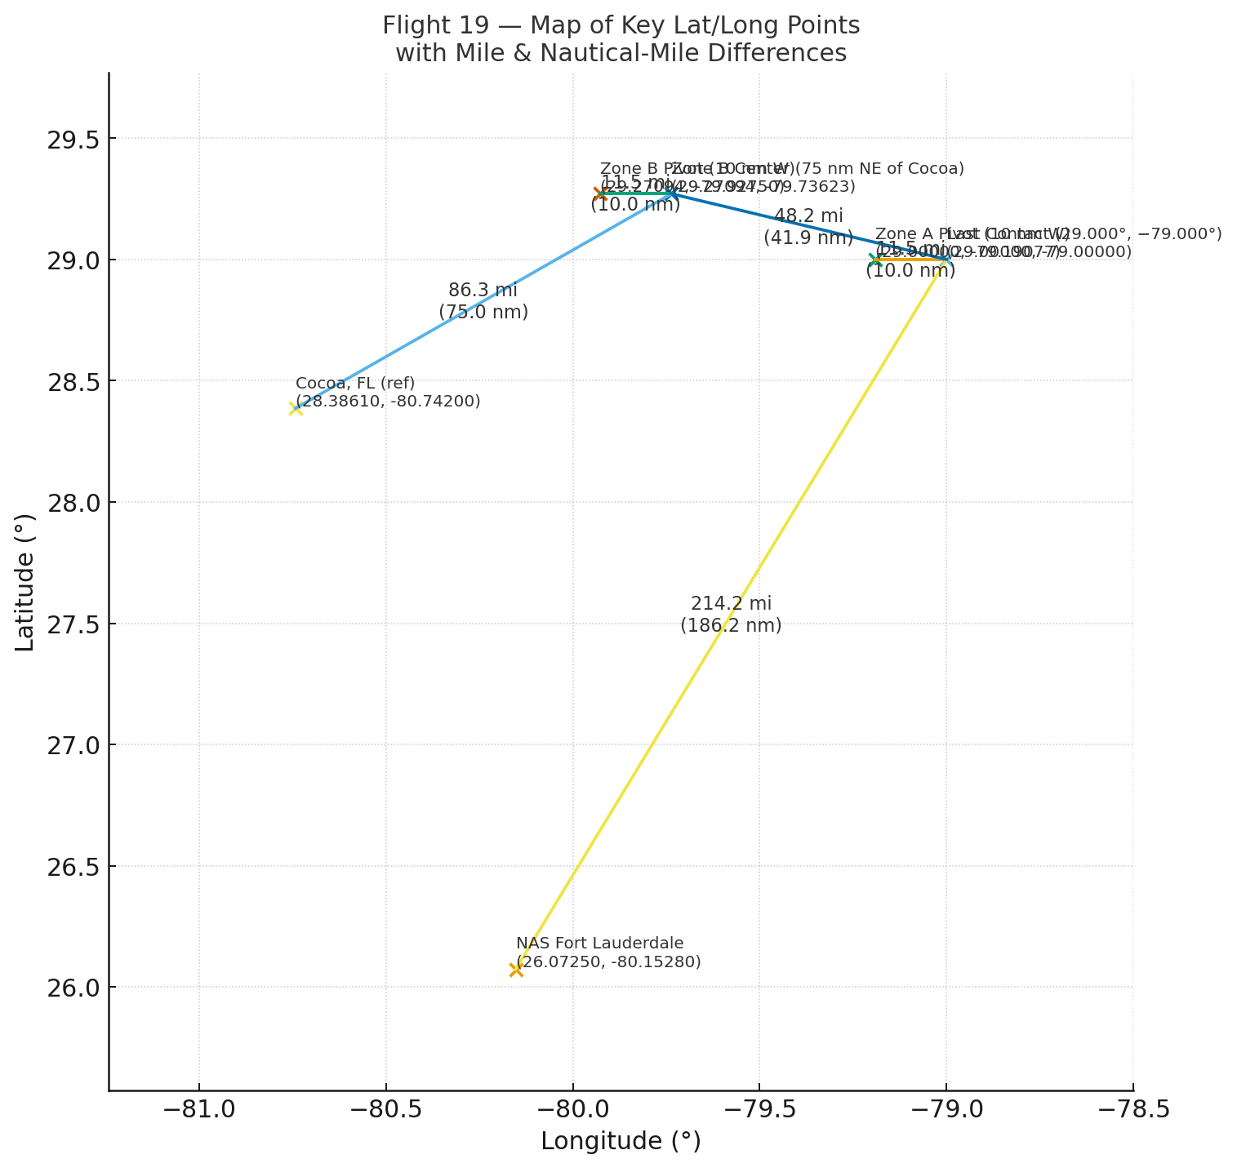

# Recommended Next Steps

• Overlay NOAA/GEBCO bathymetric contours (200, 500, 1000, 1500, 3000, 5000 m) precisely on the corridors and drift envelopes.

• Run date‑specific drift with reanalysis winds/tides for 5–8 Dec 1945; generate probabilistic heatmaps for surface vs. heavy components.

• Use expanding‑square and sector searches centered on the Priority Zone centers above, adjusted for wind/sea‑state at ditch time.

• If you supply coordinates of found anomalies, I will snap ditch‑spacing templates (tight vs. staggered) to them and recompute short‑horizon drifts.