# Master Equation with Reset Point: Unifying Time, Space, Matter, Energy, and Vibration

This document describes a conceptual master equation framework where all physical and energetic quantities—time, space, matter, energy, and vibration—are synchronized through a central equilibrium or 'reset point'. Just as living organisms return to a biological rhythm and oscillators in physics relax toward equilibrium, the universe can be modeled as oscillating fields anchored to a common reference frequency.

## 1. Reset Point Analogy

• Biological systems: circadian rhythms, heartbeats, and brain waves all synchronize to internal and external reference signals.  
• Physics: oscillators and quantum fields define a ground or vacuum state as a zero-energy reference.  
• Engineering: GPS and atomic clocks constantly resynchronize to avoid phase drift.  
By including a reset point, any master equation ensures global coherence and equilibrium.

## 2. Concept Diagram

The diagram below illustrates the reset point (center) with five outward fields representing Time, Space, Matter, Energy, and Vibration. Each field radiates from the zero state and returns periodically, maintaining equilibrium.

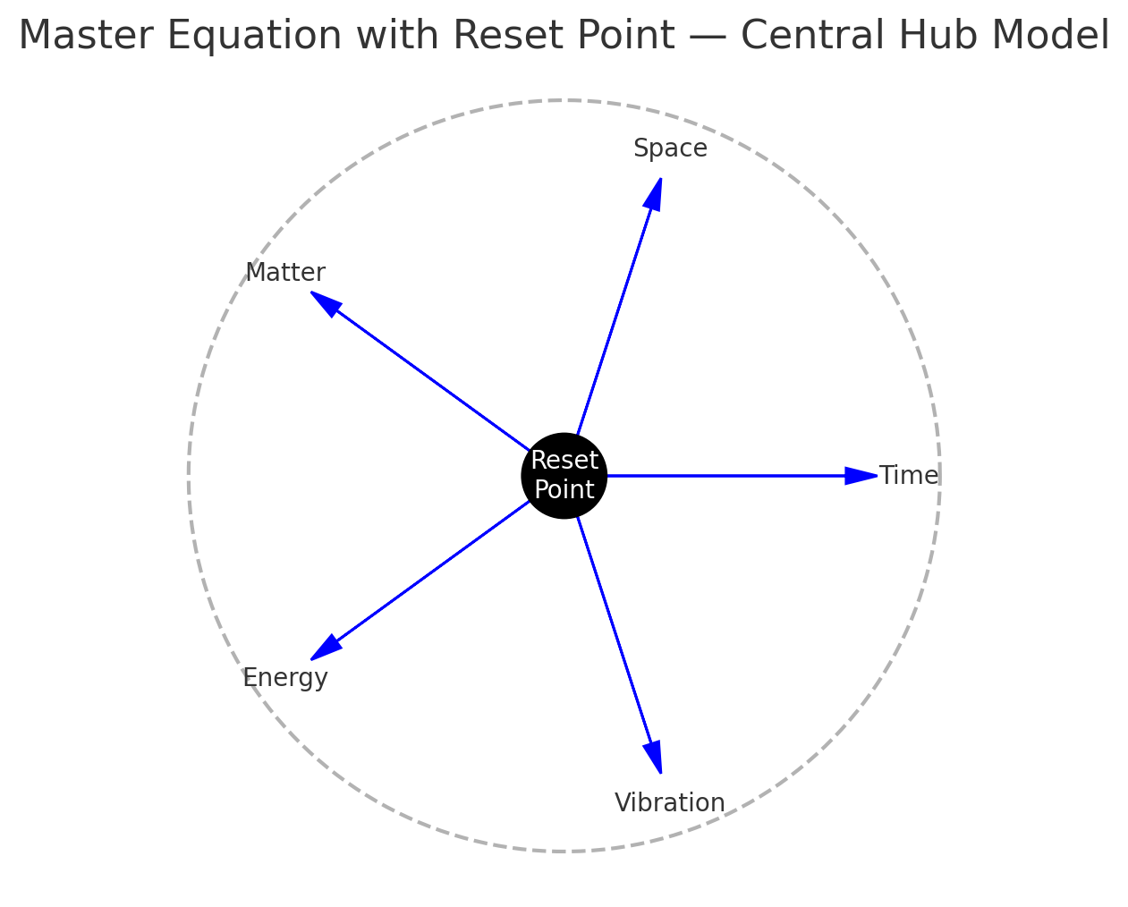

Figure 1. Reset-hub geometry showing unified fields anchored to a central reference.

## 3. Mathematical Representation

Let G(t,x) represent the unified master field combining the five domains. Define an equilibrium reference G₀ as the reset state. All physical quantities are deviations from this baseline:  
  
 ΔG(t,x) = G(t,x) − G₀  
  
The complete oscillation structure may be represented as:  
  
 G(t,x) = G₀ + ∑ₙ Aₙ e^{i(ωₙ t − kₙ x)} , where ωₙ are harmonics locked to a master frequency ω₀.  
  
G₀ ensures balance, while Aₙ and ωₙ determine the amplitude and rhythm of each domain (time, space, matter, energy, vibration).

## 4. Physical Interpretation

• Time corresponds to the fundamental rhythm of the system.  
• Space defines the geometric layout of the oscillations.  
• Matter arises from localized standing waves or resonances.  
• Energy measures the rate of change of the field relative to G₀.  
• Vibration represents the harmonics coupling all domains.  
  
The reset point serves as a universal zero: if the system drifts, it re-synchronizes just as a body adapts after jet lag.

## 5. Application to Warp Navigation

In warp-drive systems, maintaining synchronization between curvature fields and internal frequencies is vital. A reset-based master equation provides continuous phase correction—aligning local time, space, and energy densities to a cosmic reference frequency. This principle can prevent drift, turbulence, or loss of coherence within a warp corridor.

## 6. Summary

The reset point is the key stabilizing factor in any unified model. It defines the origin of time and restores balance between geometry, energy, and matter. Through cyclic synchronization, it ensures all parts of the system remain coherent, allowing the universe—or a warp engine—to function as a single rhythmic entity.