# Artificial Gravity in CST Tunnel Travel

At constant speed (192 km/s) in a CST navigation tunnel, astronauts feel artificial gravity if the path curves, because changing direction requires continuous acceleration. The tighter the curve, the stronger the g-force inside the ship.

## Principle

Centripetal acceleration for curved travel: a = v² / R

• v = 192 km/s (192,000 m/s)  
• R = tunnel curvature radius  
• a is felt as g-force inside the ship

## Examples of Onboard Gravity

|  |  |
| --- | --- |
| Target g_effective | Required curvature radius R |
| 0 g (Free fall) | Straight tunnel (R = ∞) |
| 0.1 g | ≈ 38 million km |
| 0.38 g (Mars-like) | ≈ 9.9 million km |
| 0.5 g | ≈ 7.6 million km |
| 1.0 g (Earth-like) | ≈ 3.8 million km |

## Visual Comparison

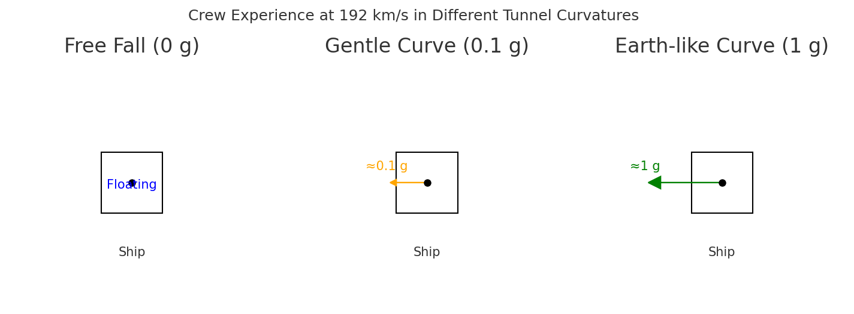

Left: Free fall (0 g) – crew floats.   
Middle: Gentle curve (~0.1 g) – light artificial gravity, similar to lunar or partial Mars gravity.   
Right: Tight curve (~1 g) – Earth-like gravity, best for long-term health.

## Conclusion

• Free fall = no gravity felt.   
• Gentle curves = light gravity (safe for shorter trips, but some health risks).   
• Earth-like curve = 1 g footward, safest for organs, bones, and long-term survival.   
  
Thus, by tuning tunnel curvature, CST navigation can provide a gravity level targeted for human health.