# Reversing Go/No-Go Geometry for Warp-Drive Earth Exit

This document refines the earlier draft by stating conceptual Go/No-Go conditions for classical re-entry, formulating reversed conditions for a low-force warp emergence from Earth, and including both the original re-entry diagram and a new reversed diagram for launch corridors. These relations are engineering intuition tools, not full aerodynamic/thermodynamic re-entry models.

## 1. Original Re-Entry Go/No-Go Conditions (Conceptual)

Let R_E be Earth’s mean radius, h the altitude, v the vehicle speed, and θ the flight‑path angle relative to local horizontal at the atmospheric interface. A compact inequality capturing whether the trajectory penetrates the atmosphere at a viable slope is:  
 • Go: v² · sin²(θ) > 2 g (R_E + h)  
 • No-Go: v² · sin²(θ) ≤ 2 g (R_E + h)  
Operational guidance solves full 3‑DoF dynamics including drag, lift, heating, winds, and control.

### Figure A — Classical Go/No-Go Zones (Re‑Entry)

Reference diagram retained from the previous draft.

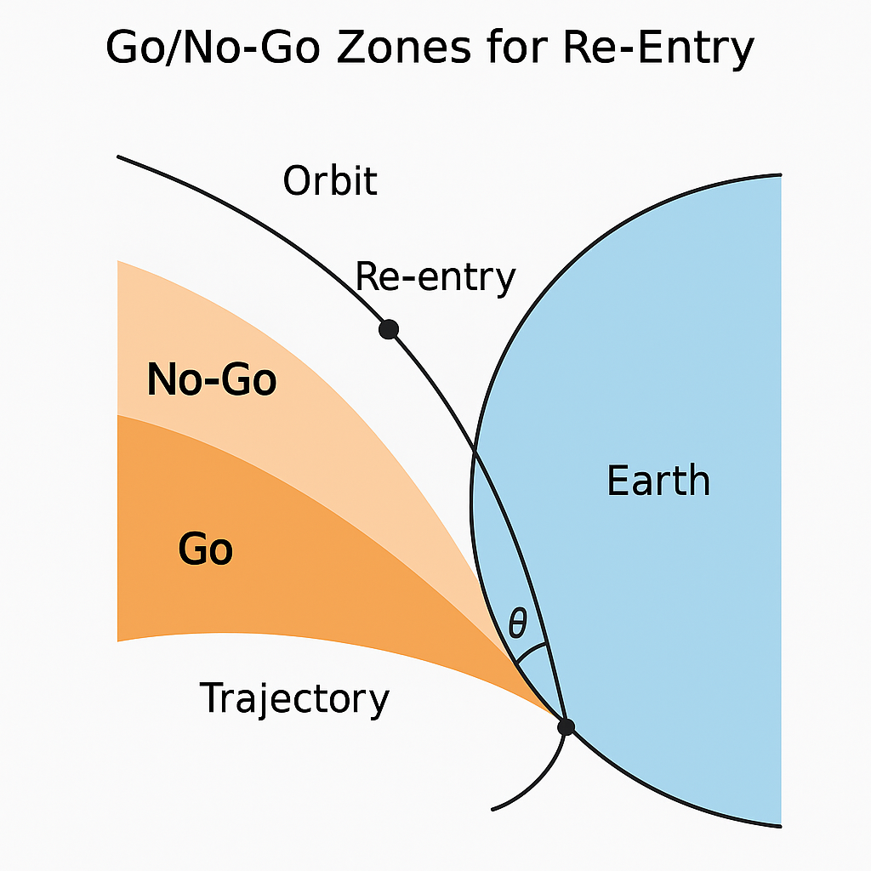

## 2. Reversed Conditions for Warp‑Drive Earth Exit

Reverse the question: instead of whether a trajectory enters the atmosphere safely, determine whether a space‑time curvature (warp bubble) can detach from the gravity well along a stable, low‑force corridor. Define an effective, curvature‑coupled specific energy that the warp field contributes at altitude h:

E_eff(θ) = ½ v² · sin²(θ) − g (R_E + h) + Φ_warp(κ, t)

Here Φ_warp(κ, t) is the controllable warp‑field potential as a function of curvature κ and time t. A Go/No‑Go‑style emergence rule is:  
 • Go (emergence corridor): E_eff(θ) ≥ 0 for θ ∈ [θ* − Δθ, θ* + Δθ]  
 • No‑Go: E_eff(θ) < 0 or θ outside the corridor  
θ* is the optimal angle minimizing required Φ_warp subject to CST phase‑lock, structural loads, and environmental constraints.

### Figure B — Reversed Go/No-Go (Warp‑Drive Launch Corridors)

New schematic illustrating outward ‘Go’ wedge with flanking ‘No‑Go’ regions.

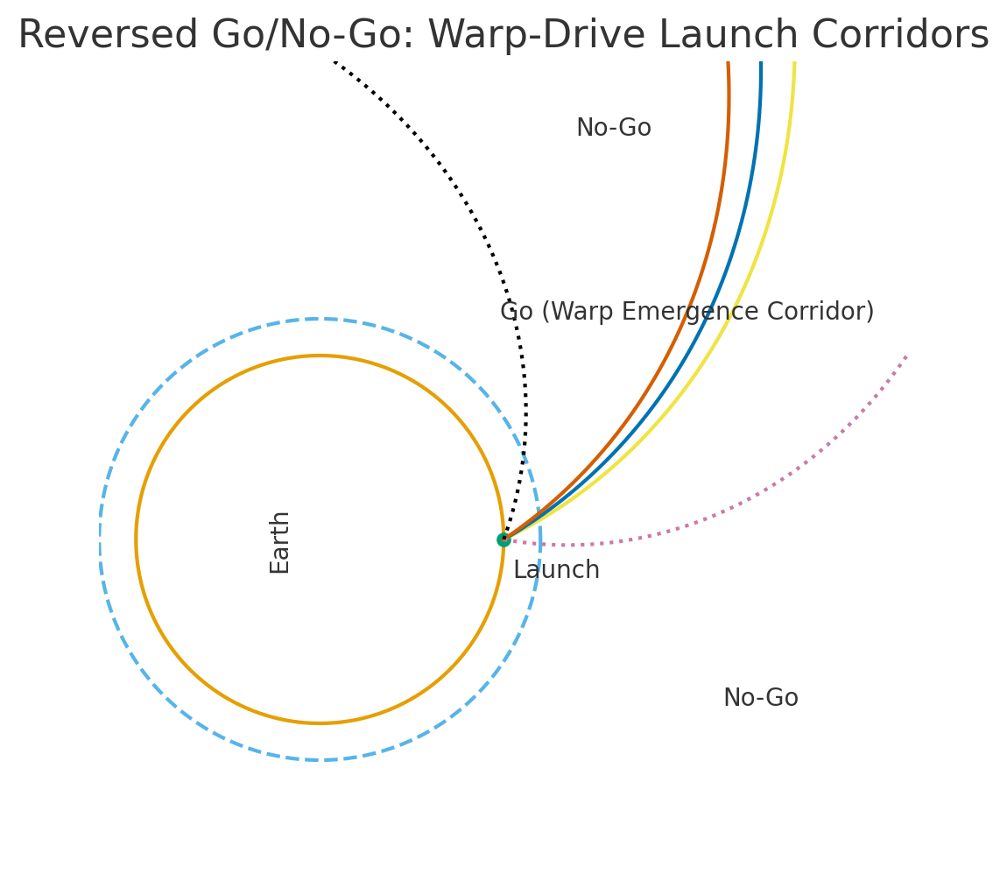

## 3. Implementation Steps (Engineering Workflow)

1) Local Field Survey — gravity gradient, atmosphere, and magnetic environment at launch site/time.  
2) θ* Search — find the angle minimizing Φ_warp while meeting CST phase constraints and load limits.  
3) Corridor Width Δθ — map stability via Halvorsen‑attractor phase‑space with Gaussian‑integer indexing.  
4) Pulse Program — discretize Φ_warp(κ,t) with atomic‑clock timing; include feedback sensors.  
5) Hardware‑in‑the‑Loop — coil/plasma testbed to verify corridor tracking and margins.  
6) Flight Readiness — integrate abort logic tied to corridor deviation and environment sensors.