# Conceptual Warp Drive Engine — Positive-Energy Design (Revised)

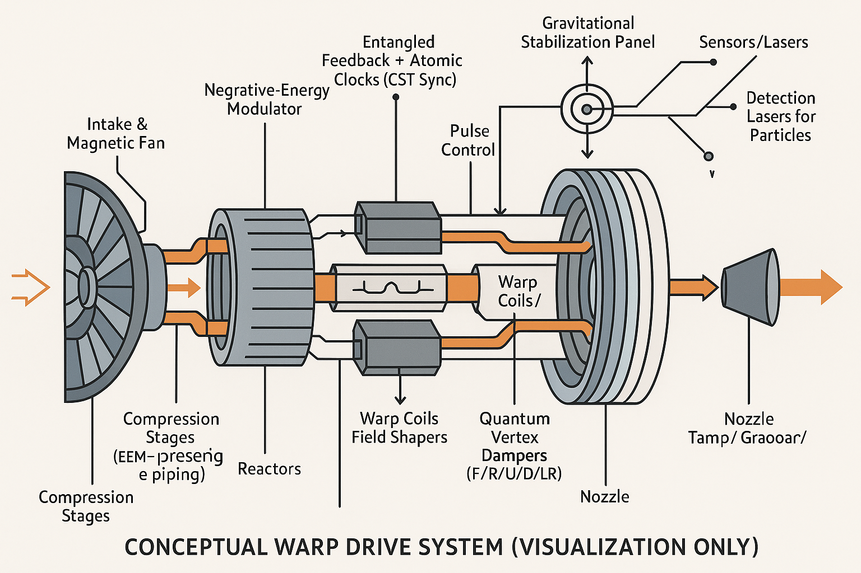

This revised specification adds a clear speed regime and maximums. The concept remains a positive‑energy, non‑exotic warp‑corridor system: electromagnetic compression, plasma–photon coupling, and CST‑synchronized field phasing create a navigable curvature ‘tunnel’ that shortens effective distance while the craft’s local speed stays subluminal (≤ 192 km/s ≈ 0.00064 c).

## Operational Sequence

1) Intake & Magnetic Fan → 2) EM Compression Stages → 3) Reactors (fusion/electro‑plasma) → 4) Field‑Phase Modulator (asymmetric curvature control) → 5) Warp Coils & Field Shapers (bubble) → 6) Entangled Feedback + Atomic Clocks (CST sync) → 7) Quantum Vertex Dampers (F/R/U/D/L/R) → 8) Gravitational Stabilization Panel → 9) Nozzle & Thermal Management.

## Speed Regime & Limits (No Exotic Matter)

**Definitions.**

• Ship cruise speed (local/proper): v_ship = 192 km/s.  
• Distance‑compression factor: 0 < k ≤ 1, where smaller k shortens the path inside the corridor.  
• Effective door‑to‑door velocity: v_eff = v_ship / k (used only for trip‑time planning; local physics remains subluminal).

Examples (Moon distance 384,400 km; Mars close‑approach 54.6 Mkm):

• k = 1 ⇒ v_eff = 192 km/s ≈ 0.064% c; Moon time = 33 min 22.1 s, Mars time = 78 h 59 min 35.0 s.

• k = 0.1 ⇒ v_eff = 1,920 km/s ≈ 0.640% c; Moon time = 3 min 20.2 s, Mars time = 7 h 53 min 57.5 s.

• k = 0.01 ⇒ v_eff = 19,200 km/s ≈ 6.404% c; Moon time = 20.0 s, Mars time = 47 min 23.8 s.

• k = 0.003 ⇒ v_eff = 64,000 km/s ≈ 21.348% c; Moon time = 6.0 s, Mars time = 14 min 13.1 s.

Design cap (engineering): To preserve positive‑energy stress and avoid acausal regimes, this build restricts k ≥ 0.003 (v_eff ≤ 64,000 km/s ≈ 21.3% c). Thus the system is **not FTL** in this configuration.

Note: Arithmetic ‘FTL’ would require k ≤ v_ship/c ≈ 0.000640; this is intentionally prohibited here because maintaining positive energy density and causal synchronization becomes untenable as k approaches that threshold.

## Onboard Gravity & Curvature

Target comfortable gravity is selectable (0.1–1 g) using corridor curvature. For uniform‑curvature segments the proper acceleration felt is a = v²/ρ. At v_ship = 192 km/s and a = 0.1 g, the required radius of curvature is:

ρ = v²/a ≈ 37,590,818 km (≈ 3.759e+10 m)

This very large radius indicates the corridor is nearly straight at cruise, which keeps cabin loads gentle.

## Field Model (Indicative)

Modified warp metric (shape function f controls bubble profile):

ds² = -c² dt² + [dx − v_s(t) f(r_s) dt]² + dy² + dz²

Choose a smooth, compact support shape function, e.g.:

f(r_s) = exp[−(r_s/R)^m], with m ≥ 4 to limit gradients at the wall.

Effective energy density budget (positive‑energy requirement):

u = ½(ε₀E² + B²/μ₀) + u_plasma + u_photon ≥ 0 everywhere.

Trip‑time with compression:

T = (D · k) / v_ship , v_eff = v_ship / k.

## Control Algorithm (Pseudo‑Code)

loop at Δt = 1 ms:  
 read sensors → δφ (phase error), δB (field error), δρ (curvature error)  
 synchronize_clocks(CST_reference)  
 k ← clamp(k + Kp*δρ + Ki*∫δρ dt + Kd*dδρ/dt, k_min, 1)  
 set_coils(B_target(k)), set_modulator(phase = φ₀ + δφ)  
 dampers.apply(Qx,Qy,Qz) # vertex dampers  
 enforce u ≥ 0 and |∇f| bounds; shed power if thresholds exceeded

## Summary

This positive‑energy warp‑corridor design is **subluminal by construction**. It achieves large apparent speedups by compressing the traversed distance (k < 1) while keeping local speeds ≤ 192 km/s and cabin gravity within limits. A conservative cap k ≥ 0.003 yields effective speeds up to ~0.21 c without invoking exotic matter.