Photon Quantum Sensor Tunnel and Atomic-Time–Referenced Interferometric Control within a Curvature Synchronization Framework

Abstract
This work develops a unified theoretical and engineering framework that integrates photon-based dynamics, atomic timekeeping, and quantum interferometric sensing into a closed-loop control architecture for high-speed space systems. Building upon established electromagnetic and quantum principles established by Planck, Einstein, and Maxwell, the framework introduces the Photon Quantum Sensor Tunnel as a structured sensing corridor that continuously measures phase variation and converts it into actionable timing information. This timing information is interpreted through a Curvature Synchronization Theory control layer, defined strictly as a synchronization and navigation methodology rather than a modification of fundamental physics. The approach remains fully consistent with quantum mechanics, interferometric measurement theory, and relativistic timekeeping, while introducing a testable integration between measurement, timing, and control. The resulting system provides a physically grounded method for real-time stability estimation, environmental alignment, and adaptive control in accelerated reference frames.

Introduction
The transition from theoretical physics to applied engineering requires a consistent link between measurable quantities and control mechanisms. Photon-based interactions, as described in quantum theory and electromagnetic field theory, provide a direct pathway for such a transition, as demonstrated in foundational works by Planck, Einstein, and Maxwell. At the same time, atomic clocks, as developed in modern metrology and described by national standards institutions, have established an unprecedented level of temporal precision, enabling synchronization across complex systems.
Quantum interferometric sensing further extends this capability by enabling the detection of phase shifts associated with motion, rotation, and environmental variation. Classical interferometric experiments such as those of Michelson and Morley and rotational measurements based on the Sagnac effect provide a well-established experimental foundation. More recent developments in atom interferometry and entangled photon systems, including experimental demonstrations of Earth’s rotation using large-scale optical fiber interferometers, confirm that phase-based sensing can resolve subtle physical effects with high precision.
This paper proposes that photon dynamics, atomic time, and interferometric measurement can be integrated into a unified control framework. The objective is not to alter existing physical laws, but to organize them into a coherent architecture capable of real-time measurement, synchronization, and correction. The resulting structure is referred to as the Photon Quantum Sensor Tunnel, a conceptual sensing corridor that translates physical measurements into timing corrections within a Curvature Synchronization Theory control system.

Photos and Electromagnetic Foundations
Photon energy, momentum, and flux are defined through established relations in quantum mechanics and electromagnetic theory. These relations enable the direct conversion of irradiance into force through radiation pressure, as used in solar sail propulsion studies and demonstrated in missions such as IKAROS. The dimensional consistency of these relations ensures that photon-based forces can be incorporated into engineering systems without ambiguity.

Photon environments are inherently time-dependent, varying due to rotational motion, orbital dynamics, and solar activity. Measurements of solar irradiance and spectral variation confirm that photon flux is not constant but follows structured temporal behavior. This variability defines a dynamic operating environment in which photon-based systems must function, requiring continuous measurement and adaptive control.

Atomic Time as a Reference Framework
Atomic time provides a stable and physically grounded reference against which all measurements can be compared. Based on atomic transitions, particularly cesium standards, atomic clocks provide a uniform and repeatable measure of time independent of environmental variation. Modern optical atomic clocks further refine this precision, reaching levels where relativistic effects become measurable.
In this framework, atomic time serves as the reference layer for all measurements. Interferometric phase observations are compared against this baseline, allowing phase differences to be translated into timing deviations. This ensures that all system corrections are based on physically meaningful quantities tied to fundamental standards of timekeeping.

Quantum Interferometric Sensing
Quantum interferometry measures phase differences between photon paths, with sensitivity to path length variation, rotation, and environmental effects. The Sagnac effect demonstrates that rotational motion produces measurable phase shifts in closed-loop optical systems. Atom interferometry experiments further extend this capability, allowing precise measurement of gravitational and inertial effects.
Recent experimental work using entangled photons in large optical fiber loops has demonstrated the ability to detect Earth’s rotation with high sensitivity. These results confirm that interferometric systems can function as precise diagnostic tools for dynamic systems, validating their use in real-time sensing architectures.
Within this framework, the interferometer operates as a continuous measurement device, producing a phase signal that reflects the system’s instantaneous condition. This phase signal is then interpreted relative to atomic time.

Phase to Time Conversion
The conversion of phase difference into timing deviation forms the central bridge between measurement and control. A measured phase shift corresponds to a difference in optical path length or frequency alignment, which can be expressed relative to a reference phase derived from atomic time.
This conversion produces an effective timing mismatch that represents the deviation between the system’s current state and its synchronized reference. By expressing measurement results in temporal terms, the system ensures compatibility with synchronization-based control methods.

Curvature Synchronization Theory as a Control Layer
Curvature Synchronization Theory is defined as a control and navigation methodology that operates on timing differences rather than modifying spacetime itself. The central variable is the timing mismatch between the system and its reference.

The objective of control is to maintain this mismatch within a bounded region through feedback correction. Control actions are derived from timing error, its rate of change, and environmental gradients. This formulation is consistent with classical control theory while incorporating real-time measurement inputs from interferometric sensing.
By integrating phase-derived timing information, the control system becomes a closed-loop architecture capable of continuous stabilization.

Photon Quantum Sensor Tunnel
The Photon Quantum Sensor Tunnel is defined as a structured sensing corridor composed of photon pathways, interferometric loops, and measurement intervals. It is not a physical tunnel, but an effective measurement region defined by optical geometry and sampling density.
Within this region, photons propagate through controlled paths, and their phase relationships are continuously monitored. The resulting measurements provide information about system stability, environmental variation, and synchronization errors.
The effective size of this sensing corridor is determined by measurement resolution, optical path length, and sampling structure. Rather than being fixed, the corridor adapts to the required precision of the system.

Periodic Sampling and Measurement Structure
Periodic sampling structures, analogous to ridged reflective systems, provide discrete measurement points that increase resolution. Each sampling event produces a measurable signal, allowing motion and phase variation to be resolved with increasing precision as sampling density increases.
However, sampling density must be matched to system capabilities. Excessive density can introduce noise and signal overlap, while insufficient density reduces resolution. Optimal design requires balancing detector bandwidth, signal clarity, and system dynamics.
This principle governs the structure of the Photon Quantum Sensor Tunnel, ensuring efficient and accurate measurement.

Shared Temporal Reference Loops
The integration of atomic time and interferometric measurement enables the formation of stable temporal reference loops. These loops establish a mapping between phase, time, and environmental conditions that can be reused across systems.
Once established, such temporal loops may be shared between independent platforms, with adjustments for system-specific parameters such as mass, energy, and environmental interaction. This creates a distributed synchronization framework in which multiple systems operate within a common temporal structure.
This concept does not imply faster-than-light transport but rather provides a structured method for analyzing timing relationships, synchronization pathways, and navigation coherence in relativistic or high-speed environments. Any extension to superluminal concepts remains theoretical and subject to experimental validation.

Closed-Loop Measurement and Control
The integration of measurement, timing, and control forms a continuous feedback loop. Interferometric measurements produce phase data, which is converted into timing deviation relative to atomic time. This deviation is processed by the synchronization controller, which generates corrective actions.
This closed-loop system enables real-time adaptation and stabilization, ensuring alignment between the system and its reference. The result is a self-correcting architecture that maintains coherence under dynamic conditions.

Physical Constraints
The framework operates within established physical limits. Optical systems are constrained by power, detector sensitivity, and material properties. Interferometric measurements are subject to noise, thermal variation, and environmental disturbances. Atomic clocks require stable conditions and precise calibration.
These constraints define the practical limits of implementation and ensure that the framework remains grounded in experimentally validated physics.

Testable Predictions
The framework predicts that interferometric systems referenced to atomic time will exhibit reduced drift compared to unreferenced systems. Increased sampling density will improve measurement resolution within detector limits. Closed-loop synchronization will enhance system stability relative to open-loop configurations. Entanglement-assisted interferometry may improve sensitivity under controlled experimental conditions.
These predictions are testable through laboratory experiments and simulation.

Applications
Applications include precision navigation, spacecraft guidance, optical sensing, and environmental monitoring. Systems operating in dynamic or relativistic environments can benefit from real-time synchronization and adaptive control based on physical measurement.

Conclusion
The integration of photon dynamics, atomic timekeeping, and quantum interferometric sensing provides a coherent framework for measurement and control. The Photon Quantum Sensor Tunnel enables continuous translation of physical observations into timing corrections, while Curvature Synchronization Theory provides the control structure for maintaining stability. The framework remains fully consistent with established physics and offers a testable pathway for future research and engineering development.

References
Planck, M. On the Law of Distribution of Energy in the Normal Spectrum. Annalen der Physik.
Einstein, A. On a Heuristic Viewpoint Concerning the Production and Transformation of Light. Annalen der Physik.
Maxwell, J. C. A Dynamical Theory of the Electromagnetic Field. Philosophical Transactions of the Royal Society.
Sagnac, G. The demonstration of the luminiferous aether by an interferometer in uniform rotation. Comptes Rendus.
Michelson, A. A., and Morley, E. W. On the Relative Motion of the Earth and the Luminiferous Ether. American Journal of Science.
Kasevich, M., and Chu, S. Measurement of gravitational acceleration using atom interferometry. Physical Review Letters.
Vienna Center for Quantum Science and Technology. Quantum interferometry measurement of Earth’s rotation using entangled photons.
Wineland, D. J. Nobel Lecture: Superposition, entanglement, and raising Schrödinger’s cat. Reviews of Modern Physics.
Ludlow, A. D., Boyd, M. M., Ye, J., Peik, E., and Schmidt, P. O. Optical atomic clocks. Reviews of Modern Physics.
National Institute of Standards and Technology. Atomic Time and Frequency Standards.
NASA. Solar Radiation Pressure and Spacecraft Dynamics.
Tsander, K., and JAXA IKAROS Mission Team. Solar sail propulsion demonstration.
ANSI Z136. Safe Use of Lasers.
IEC 60825. Safety of Laser Products.

Diagrams
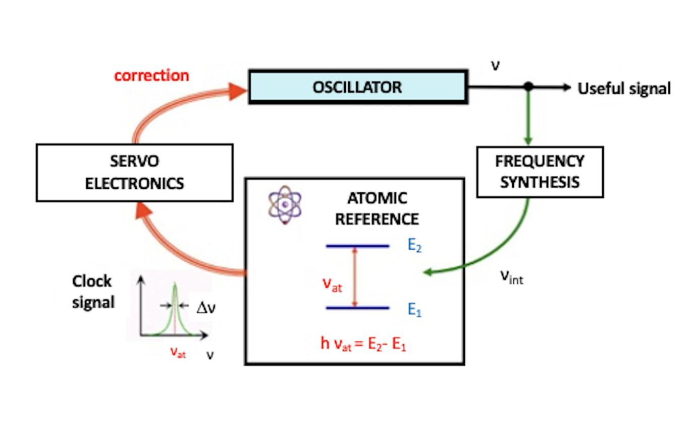
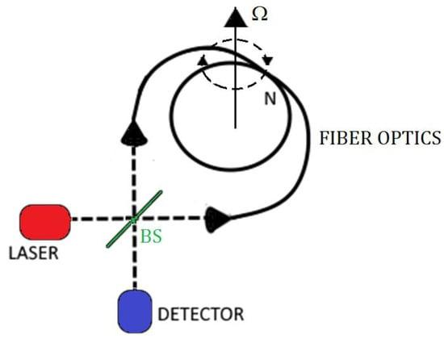

6

Diagram — Photon Quantum Sensor Tunnel Feedback System
The diagram below illustrates the core architecture of the Photon Quantum Sensor Tunnel integrated within the Warp Engine system. Quantum entangled photons circulate along dual optical paths that trace the warp tunnel’s geometry, providing real-time feedback through CST synchronization and EM-field regulation.
╔══════════════════════════════════╗
║ Photon Quantum Sensor Tunnel ║
╚══════════════════════════════════╝
│
┌─────────────┴─────────────┐
▼ ▼
┌─────────────────────┐ ┌─────────────────────┐
│ Left Photon Path │ │ Right Photon Path │
│ (Warp Tunnel Edge) │ │ (Warp Tunnel Edge) │
└─────────┬───────────┘ └─────────┬───────────┘
│ │
▼ ▼
┌──────────────────────────────────────────────┐
│ Interference Node (Phase Δφ) │
└──────────────────────────────────────────────┘
│
▼
┌────────────────────────────────┐
│ CST Processor (CST_r, T_CST) │
└────────────────────────────────┘
│
▼
┌────────────────────────────────────┐
│ Einstein-Master Equation Core (E=) │
│ Energy–Curvature Regulation │
└────────────────────────────────────┘
│
▼
┌────────────────────────────────┐
│ EM Field Controller (Stabilize) │
└────────────────────────────────┘
│
▼
┌────────────────────────────┐
│ Warp Tunnel Environment │
│ (Dynamic Curvature Field) │
└────────────────────────────┘
Photon Quantum Sensor Tunnel integrated within Warp Engine feedback system.
© 2025 Gabino Casanova — Quantum Warp Engineering Research

