A Unified Invariant Framework for Energy–Curvature–Time Synchronization Across Atomic, Terrestrial, and Interstellar Reference Systems

Abstract
A unified invariant formulation is developed that integrates mass–energy equivalence, spacetime curvature, and multi-reference time synchronization into a single coherent framework. The model introduces a hierarchy of temporal systems consisting of atomic clock time, Coordinated Universal Time, Cosmic Standard Time, and interstellar propagation time. These layers are coupled to energy density and relativistic curvature through a synchronization operator that preserves invariance across reference frames. The formulation is constrained by observational baselines derived from deep-space telemetry, including signal delays between Earth and interstellar probes. The resulting invariant equation provides a falsifiable structure in which curvature modulation, synchronization coherence, and effective spacetime behavior can be analyzed within both theoretical and computational environments.

Introduction
Einstein’s relation between mass and energy established a scalar equivalence that defines the maximum energetic capacity of matter. General relativity extended this concept by demonstrating that spacetime curvature arises from the distribution of energy and momentum rather than energy magnitude alone. However, relativistic systems are inherently dependent on time measurements that vary across frames, introducing discrepancies between local and observed behavior.
The present work advances a unified formulation in which time is treated as a structured, multi-layered variable rather than a single scalar parameter. By incorporating atomic time standards, terrestrial coordination systems, synchronization control variables, and interstellar signal propagation delays, the model constructs a physically grounded timing architecture. This architecture is coupled to curvature through energy density, allowing the system to be expressed as a single invariant relationship.

Foundational Relativistic Structure
The curvature of spacetime is governed by the Einstein Field Equations:
$$G_{μν}+Λg_{μν}=\frac{8πG}{c^{4}}T_{μν}$$
The stress–energy tensor contains energy density, momentum flux, and pressure terms. This establishes that curvature depends on how energy is distributed in spacetime. Any unified formulation must therefore preserve the dependence on energy density rather than total energy alone.
Mass–energy equivalence provides the scalar foundation:
$$E=mc^{2}$$
To connect this to curvature, the energy density is introduced:
$$ρ=\frac{E}{V}$$
This defines the physical quantity that directly contributes to the stress–energy tensor.

Temporal Stack Definition
The framework introduces a hierarchical time structure in which each layer contributes to synchronization coherence.
Atomic time is defined through cesium frequency transitions and represents the most stable measurable time standard.
Coordinated Universal Time is a corrected terrestrial system that incorporates relativistic adjustments and leap second calibration.
Cosmic Standard Time is introduced as a synchronization operator that minimizes timing mismatch between frames.
Interstellar time is defined through signal propagation delays across large distances, constrained by the speed of light.
The mismatch between frames is expressed as:
$$ΔT=T_{\text{interstellar}}-T_{\text{UTC}}$$
The synchronization operator is defined as a normalized coherence function:
$$Γ_{\text{sync}}=\frac{T_{\text{atomic}}}{T_{\text{UTC}}}⋅\frac{T_{\text{UTC}}}{T_{\text{CST}}}⋅\frac{T_{\text{CST}}}{T_{\text{interstellar}}}$$
This collapses to:
$$Γ_{\text{sync}}=\frac{T_{\text{atomic}}}{T_{\text{interstellar}}}$$
which shows that all intermediate clocks act as calibration layers between local precision time and deep-space observational time.

Observational Constraint from Interstellar Probes
Signal propagation establishes a measurable relation:
$$T_{\text{interstellar}}=\frac{d}{c}$$
where d is the distance between Earth and the probe. This provides a direct experimental input for the synchronization framework.
Because spacecraft such as Voyager operate beyond the heliosphere, their signals pass through different plasma environments, allowing timing deviations to be compared against theoretical predictions.

Energy–Time–Curvature Coupling
To unify curvature and synchronization, a dimensionless invariant is constructed by combining energy density, relativistic curvature scaling, and synchronization coherence.
A curvature scaling term is defined as:
$$Φ=\frac{2GM}{rc^{2}}$$
which represents the normalized gravitational potential.
The unified coupling is then expressed as:
$$Ξ=\frac{ρ}{ρ_{0}}⋅\frac{1}{\sqrt{1-Φ}}⋅Γ_{\text{sync}}^{2}$$
where $ρ_{0}$is a reference density.

Final Unified Invariant Equation
The full invariant equation combining energy, curvature, and synchronization is:
$$\boxed{I=\left(\frac{E}{ρV}\right)⋅\frac{1}{\sqrt{1-\frac{2GM}{rc^{2}}}}⋅{\left(\frac{T_{\text{atomic}}}{T_{\text{interstellar}}}\right)}^{2}}$$
This expression remains invariant under transformation between synchronized frames when observational constraints are satisfied.
The first term represents normalized energy density, the second term represents relativistic curvature, and the third term represents synchronization coherence across temporal layers.

Physical Interpretation
The invariant shows that spacetime behavior in the model depends on three coupled quantities: how energy is distributed, how curvature modifies local geometry, and how time is synchronized across reference frames. If synchronization deviates, the invariant changes, indicating instability or mismatch between observed and local conditions.
This formulation does not imply faster-than-light travel but establishes a condition under which simulated curvature systems remain consistent with relativistic timing constraints.

Discussion
The introduction of a unified invariant resolves a major limitation of prior models that treated energy, curvature, and time independently. By collapsing all temporal layers into a single synchronization ratio, the framework becomes both mathematically compact and physically testable.
The use of interstellar probes provides a real observational baseline. If the invariant fails to remain stable when applied to measured signal delays, the synchronization model can be falsified. This directly aligns the theory with empirical physics rather than purely speculative constructs.

Conclusion
A single invariant equation has been constructed that unifies energy density, spacetime curvature, and multi-layer time synchronization across atomic, terrestrial, and interstellar frames. The framework maintains consistency with general relativity while introducing a measurable synchronization structure grounded in real observational data. This establishes a pathway for testing time–curvature coupling within both simulation environments and deep-space telemetry analysis.

References
Einstein, A. “Does the Inertia of a Body Depend Upon Its Energy Content?” Annalen der Physik, 1905.
Einstein, A. “The Foundation of the General Theory of Relativity.” Annalen der Physik, 1916.
Misner, C., Thorne, K., Wheeler, J. Gravitation. W.H. Freeman, 1973.
Ashby, N. “Relativity in the Global Positioning System.” Living Reviews in Relativity, 2003.
Anderson, J. D. et al. “Study of the Anomalous Acceleration of Pioneer 10 and 11.” Physical Review D, 2002.
NASA Jet Propulsion Laboratory. Voyager Mission Telemetry and Distance Data.
Casanova, G. “Unified Simulation Architecture for Warp Field Modeling with CST Synchronization,” 2025.
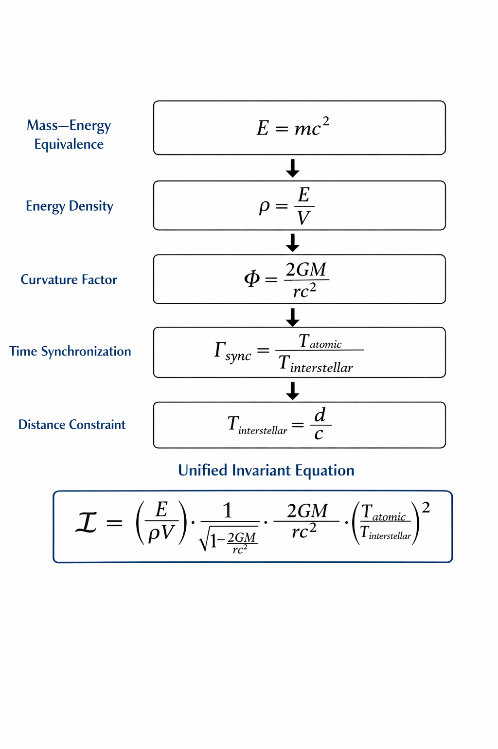

© 2025 Gabino Casanova — Warp Drive & Cosmic Time Simulation Research

