Sail Navigation from Ancient Civilizations to Modern GPS: The Evolution of Celestial and Global Navigation
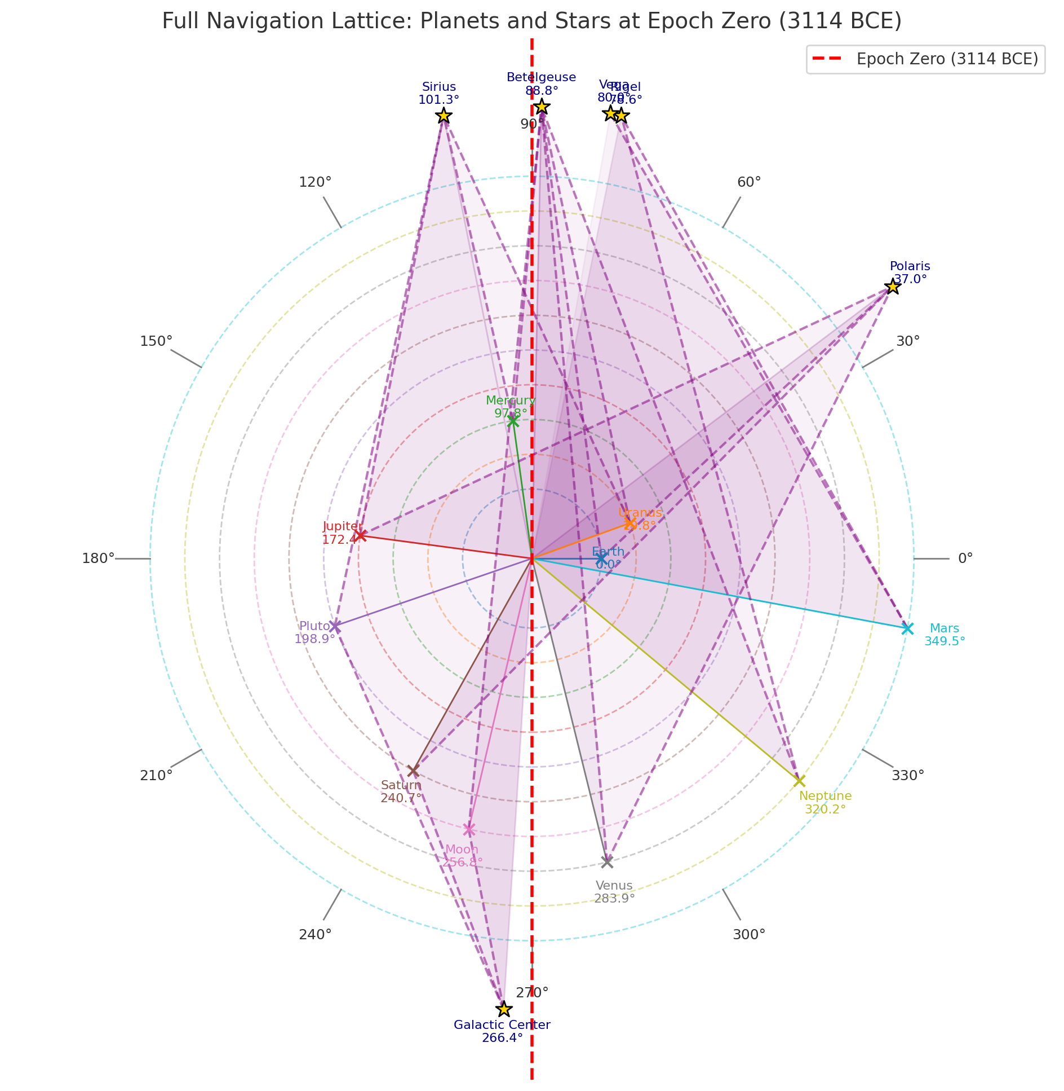
Full Navigation Lattice: Planets and Stars at Epoch Zero (3114 BCE)
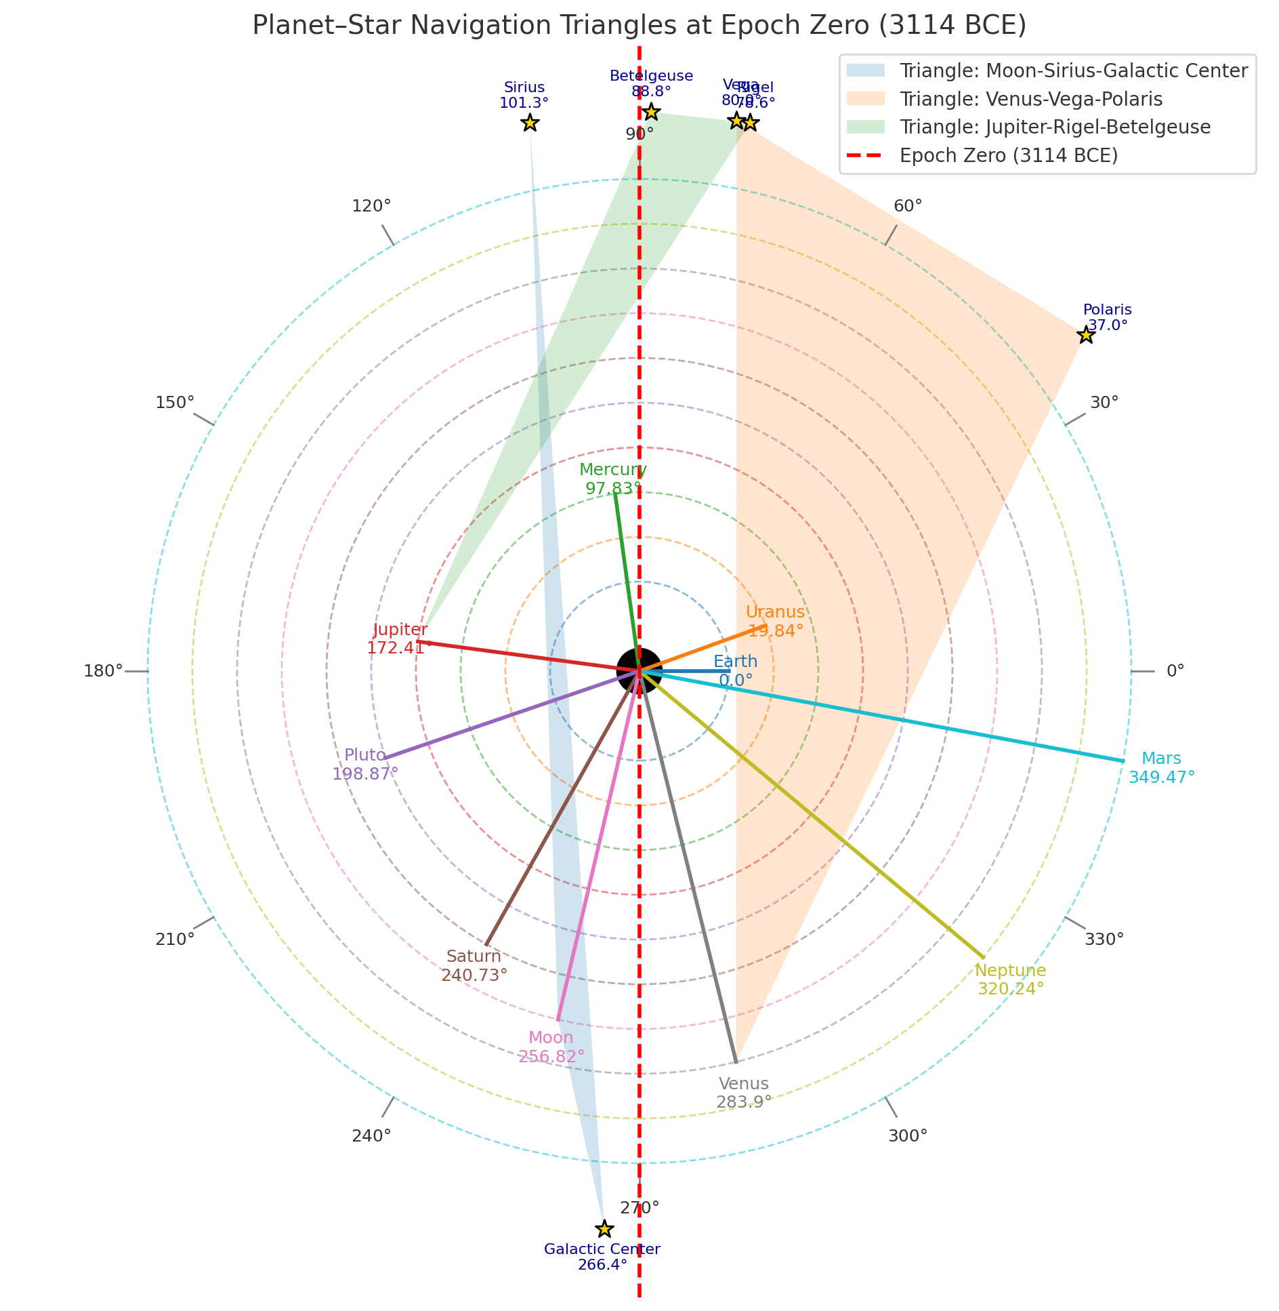
Planet–Star Navigation Triangles and Epochal Star Alignments

Overview
Humanity’s mastery of navigation spans over 5,000 years—from shadow sticks and star compasses to chronometers and GPS satellites. The principles remain constant: triangulation, observation, and adaptation. Ancient navigators used celestial geometry—aligning the Sun, Moon, and stars to the horizon—to cross unknown oceans long before magnetic instruments existed.

Ancient and Viking Navigation Tools
Tool | Function | Material/Type
Shadow stick (sun compass) | Finds latitude and north–south line | Wood + gnomon
Sunstone | Finds Sun direction under clouds | Iceland spar (calcite)
Stars & Moon | Direction and time | Natural celestial compass
Sea signs | Confirmed land proximity | Birds, currents, color, driftwood

1. Ancient Civilizations and Early Ocean Routes
• **Egyptians (2000–1000 BCE):** Navigated the Red Sea and Mediterranean using the stars Orion, Sirius, and Canopus. Canopus, the second-brightest star, was a southern reference for voyages to Punt (modern Somalia). Latitude: ~15° N to 30° N.
• **Phoenicians (1500–600 BCE):** Sailed around Africa and to Britain using Polaris and Ursa Major. Their star triangle: Polaris–Sirius–Canopus. Latitude range: 0° – 35° N.
• **Greeks & Minoans (1600–500 BCE):** Used Arcturus, Spica, and Sirius to define sailing seasons. They introduced mathematical geometry to measure solar declination for latitude.
• **Chinese Navigators (~1000 BCE):** Used Polaris for northfinding and early magnetic lodestones as direction indicators.
• **Polynesians (Ancient to modern):** Used the rising and setting points of stars (e.g., Vega–Altair–Capella) as a living star compass, navigating thousands of miles across the Pacific.

2. The Viking Era (800–1100 CE)
Vikings expanded across the North Atlantic to Iceland, Greenland, and North America (~1000 CE). They used the **sun compass (Uunartoq Disc)**, **sunstone**, and **star triangles (Polaris–Vega–Deneb)** for direction. Their routes connected Norway (~63° N), Iceland (~64° N), Greenland (~61° N), and Newfoundland (~49° N). They practiced 'latitude sailing,' maintaining constant solar elevation at noon using the shadow board.

3. Classical Arab and Chinese Navigation (700–1400 CE)
• **Arab navigators** in the Indian Ocean used Polaris for latitude and developed the *kamal*, a simple wooden sighting tool for angular elevation. They connected East Africa, India, and China along monsoon routes between 15° S and 25° N.
• **Chinese mariners** employed early magnetic compasses by the 11th century and stellar charts including Vega, Altair, and Deneb for orientation.

4. The Age of Exploration (1400–1800 CE)
European explorers such as Columbus, Magellan, and Cook combined celestial and magnetic navigation. The **sextant** and **chronometer** enabled accurate latitude and longitude determination. Key waypoints: Canary Islands (28° N, 15° W), Cape Verde (15° N, 23° W), Caribbean (~18° N, 65° W), and Cape Horn (~56° S, 67° W). They applied mathematical navigation using three-star fixes and lunar distance methods for longitude.

5. Modern and Satellite Navigation (1900 – Present)
By the 20th century, celestial navigation merged with radio and radar. WWII brought **radio direction finding** and **LORAN** (Long Range Navigation). By 1973, the **Global Positioning System (GPS)** was established, using at least three satellites for triangulation— a direct descendant of the ancient three-point celestial fix. GPS allows real-time tracking within ±5 m accuracy anywhere on Earth.

6. Celestial Triangles Through History
Across epochs, navigation relied on three reference points forming a geometric triangle:
• **3114 BCE (Mayan Epoch Zero):** Venus–Vega–Polaris (latitude 0°, longitude 90° W – Yucatán; opposite 90° E – Sumatra).
• **1000 CE (Viking Triangle):** Polaris–Vega–Deneb (~60° N, 20° W – North Atlantic corridor).
• **1500 CE (Phoenician & Arab):** Polaris–Sirius–Canopus (0–30° N, Red Sea & Indian Ocean).
• **Today (GPS):** At least three orbital satellites (20,000 km altitude) triangulate Earth position with millisecond timing accuracy.

Summary and Global Coordinates
Navigation evolved from observing Sun shadows and star triangles to precise satellite triangulation. Each era followed the same principle: fix position by referencing three known points. The consistent geometric alignments include:
• **Ancient Prime Crossing (Venus–Vega–Polaris):** Latitude 0°, Longitude 90° W (Yucatán)
• **Opposite Meridian:** Longitude 90° E (Sumatra)
• **Viking Corridor:** Centered near Latitude 61° N, Longitude 20° W
• **Modern Reference (Greenwich):** Latitude 51.48° N, Longitude 0° (Prime Meridian)
From the Egyptian sun-staff to Viking shadow boards, from sextants to GPS, humanity’s journey across oceans has always relied on triangles of light—whether drawn by stars, Sun, or satellites in orbit.

