Quantum Optimization of Warp-Field Parameters Under Multi-Clock Synchronization Constraints

Abstract
Quantum optimization methods have been proposed as tools for exploring high-dimensional physical systems, including hypothetical warp-field configurations derived from general relativity. However, prior conceptual models often suffer from a lack of physical constraints, absence of testable predictions, and ambiguity in time-reference systems. This work introduces a constrained optimization framework in which a Quantum Optimization Engine (QOE) operates under a multi-clock synchronization architecture combining atomic time standards (UTC), onboard reference clocks, and a proposed Curvature Synchronization Time (CST) control parameter. The model replaces unconstrained optimization with a physically bounded objective function that minimizes stress–energy divergence while enforcing temporal coherence. A hierarchical “memory floor” computational architecture is proposed to stabilize optimization, reduce noise, and improve thermal efficiency. The framework is presented as a falsifiable, simulation-ready model rather than a claim of physical warp realization.

Introduction
The search for physically consistent warp-field solutions remains an open challenge in theoretical physics. The formulation introduced by Miguel Alcubierre demonstrated that spacetime metrics permitting effective faster-than-light travel can be derived within the framework of general relativity, but such solutions require extreme and currently unattainable energy densities.
Quantum computing platforms developed by organizations such as IBM Quantum provide a new computational pathway for exploring complex optimization landscapes. These systems leverage superposition and entanglement to evaluate large parameter spaces, but they are inherently sensitive to decoherence and temporal instability.
This paper proposes that time synchronization—specifically the integration of atomic clock standards with a secondary control variable (CST)can act as a stabilizing constraint in quantum optimization workflows applied to warp-field parameter discovery.

Theoretical Background
The governing structure of spacetime curvature is described by the Einstein field equations developed by Albert Einstein:
$$G_{μν}+Λg_{μν}=\frac{8πG}{c^{4}}T_{μν}$$
Warp-field proposals extend this framework by introducing localized curvature distortions. However, unconstrained exploration of such solutions leads to non-physical regimes unless bound by energy conditions and temporal coherence constraints.
Quantum optimization algorithms such as QAOA and VQE operate by iteratively minimizing an objective function. Without constraints, these methods can converge toward mathematically valid but physically meaningless solutions.

Multi-Clock Synchronization Framework

Atomic Time (UTC) as Baseline Stability
Atomic clocks based on cesium-133 transitions provide the most stable known time reference. UTC serves as a global invariant baseline, ensuring consistency across computational and physical systems.

Curvature Synchronization Time (CST)
CST is introduced as a control variable representing temporal deviation between local system time and a reference frame:
$$ΔT=T_{local}-T_{UTC}$$
Rather than redefining time itself, CST acts as a phase-alignment constraint applied during optimization.

Role in Quantum Systems
Quantum processors suffer from decoherence and timing noise. By enforcing synchronization between:
- quantum gate timing
- classical control systems
- atomic clock references
the system reduces phase drift and improves solution stability.

Constrained Optimization Function
The objective function is reformulated as:
$$f=∣∇⋅T_{μν}∣+α∣ΔT∣$$
Where:
- $∇⋅T_{μν}$represents stress–energy divergence
- $ΔT$represents CST timing deviation
- $α$is a weighting coefficient

Interpretation
- Minimizing the first term enforces spacetime stability
- Minimizing the second term enforces temporal coherence
The solution is defined not as a “perfect balance,” but as a:
local minimum energy configuration that is numerically stable under both spatial and temporal constraints

Memory Floor Architecture
To address instability and thermal inefficiency in quantum-classical hybrid systems, a hierarchical memory structure is proposed.

Concept
The system is divided into multiple memory layers (“floors”), each responsible for:
- storing intermediate optimization states
- managing synchronization signals
- distributing computational load

Advantages
- Reduced noise propagation between layers
- Improved thermal distribution (heat spread across layers)
- Modular control structure (like distributed computing networks)

Signal Routing (Spider Network Model)
A web-like signal relay system distributes information between layers:
- central control node (clock synchronization)
- distributed nodes (optimization variables)
This reduces latency and allows localized corrections without destabilizing the entire system.

Physical Constraints
To prevent non-physical interpretations, the model enforces:

Energy Constraints
Warp metrics require energy densities far exceeding current technological capabilities, often estimated above:
$${10}^{45}\text{ J}$$

Quantum Limits
Quantum inequalities restrict the magnitude and duration of negative energy densities.

Relativistic Consistency
No claim is made that this model bypasses relativity; it operates strictly within known theoretical limits.

Testable Predictions
The model is considered falsifiable through the following:

Prediction 1
Improved stability in quantum optimization when synchronized with atomic clock signals compared to unsynchronized systems.

Prediction 2
Reduction in phase drift in quantum circuits when CST-like correction terms are applied.

Prediction 3
Correlation between timing synchronization and reduced energy variance in simulated field configurations.

Discussion
The integration of time as a control variable represents a shift from purely spatial optimization toward spacetime-coherent optimization. While the concept of CST remains theoretical, its formulation as a measurable timing deviation allows it to be tested experimentally.
The introduction of hierarchical memory structures further aligns the computational model with scalable architecture used in modern distributed systems.

Limitations
- No experimental validation currently exists
- Energy requirements remain beyond current engineering capability
- CST is defined operationally, not derived from first principles
- Quantum hardware limitations restrict near-term implementation

Conclusion
This work reframes warp-field exploration as a constrained optimization problem governed by both spatial curvature and temporal synchronization. By integrating atomic time standards with a CST control parameter and a layered memory architecture, the model provides a structured and testable framework for future simulation and experimentation.
The results do not claim the realization of warp propulsion but instead establish a pathway for exploring physically consistent solutions within known theoretical boundaries.

References
Einstein, A. (1915). The field equations of gravitation.
Alcubierre, M. (1994). The warp drive: hyper-fast travel within general relativity.
Feynman, R. (1965). The character of physical law.
Preskill, J. (2018). Quantum computing in the NISQ era.
IBM Quantum documentation (QAOA, VQE frameworks).
Casimir, H. B. G. (1948). On the attraction between two plates.
NIST Atomic Time Standards documentation (UTC, Cs-133).

Diagram (Conceptual System Flow)
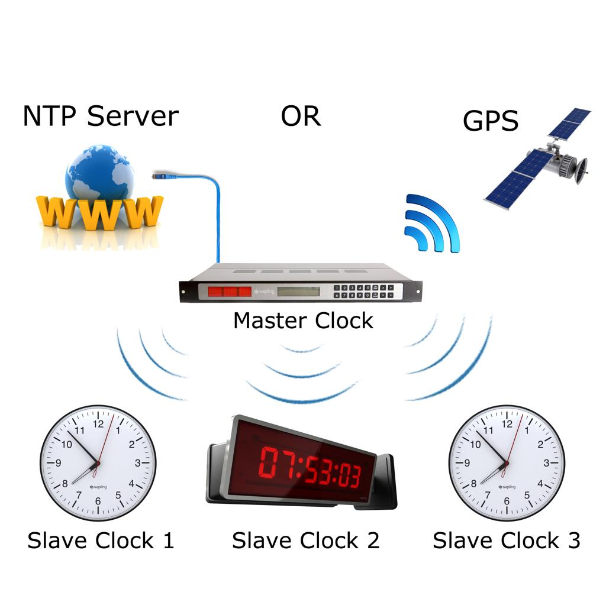
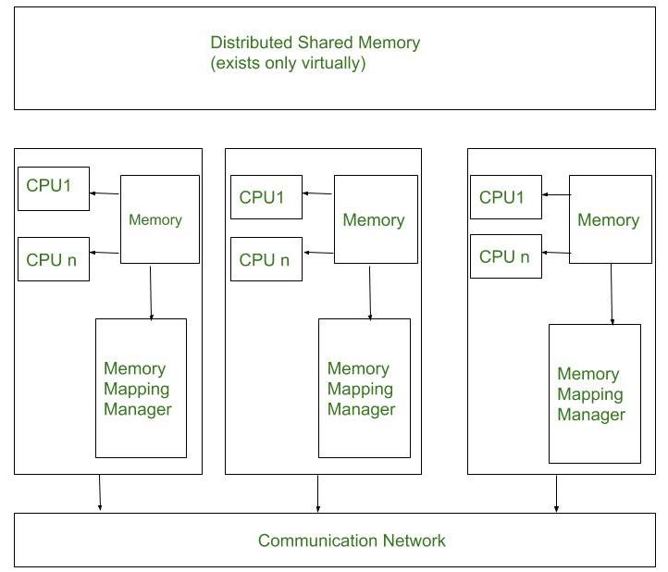
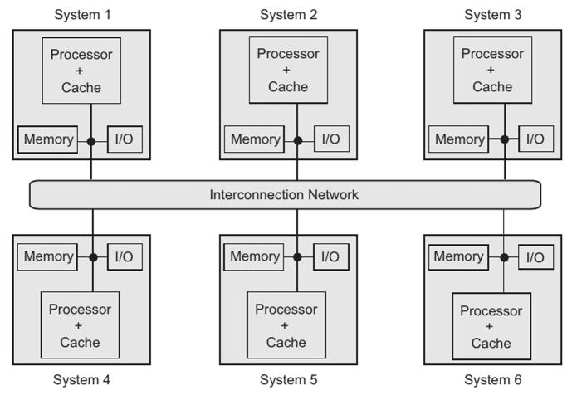
6

Credit: Concept and framework © 2025 Gabino Casanova — Quantum Warp Navigation Research Initiative

