Trust in Machines: The Human Role in the Quantum Age
Gabino Casanova
Abstract
This paper examines the evolution of computation from early mechanical systems to modern quantum machines and argues that increasing computational power does not guarantee truth. Instead, it amplifies the consequences of input error, making human judgment the critical factor in determining reliable outcomes. While machines extend calculation, they do not possess understanding or meaning. The responsibility for truth remains with the human operator. Drawing from historical computing, modern algorithmic systems, and quantum computation theory, this work frames computation as a reflection of input integrity and human oversight.
Introduction
The development of computing has progressed from mechanical punch-card systems to advanced quantum processors capable of exploring vast computational spaces. Despite these advances, a foundational principle persists: the quality of output is constrained by the quality of input. This concept, commonly summarized as “garbage in, garbage out,” remains valid across all computational paradigms. This paper argues that human oversight remains essential, as machines execute instructions without interpretation, meaning, or ethical consideration. Increasing computational power magnifies both accuracy and error, making human validation the limiting factor in achieving truthful results.
Historical Foundations of Computation
Early computing systems relied on binary logic expressed through physical mechanisms such as punch cards. These systems demonstrated both precision and fragility, where minor input errors could invalidate entire computations. As described in early computing architecture work by John von Neumann, stored-program machines enabled scalable computation but did not introduce independent reasoning or validation capabilities.
The transition from mechanical systems to electronic computation preserved the same logical structure while increasing speed and scale. Later developments in theoretical computing, particularly the work of Alan Turing, established that machines operate strictly within defined rules and symbolic manipulation. These systems do not evaluate truth; they process formal structures.
The Amplification of Error
As computational systems increase in speed and complexity, the impact of error becomes more significant. In early systems, errors affected isolated outputs. In modern systems, especially those operating at large scale, errors can propagate rapidly and influence entire datasets, models, or decision-making processes.
This amplification effect can be expressed conceptually as a dependency relationship in which output accuracy is bounded by both input quality and algorithmic integrity. No level of computational power can compensate for fundamentally flawed input conditions. This is particularly evident in modern machine learning systems, where biased or incomplete data leads to systematically distorted outputs, as discussed in contemporary studies on algorithmic bias.
Human Responsibility in Computational Systems
Machines do not possess awareness or the ability to question the validity of their input. They operate within predefined rules and execute instructions as given. Human operators therefore serve as the source of validation, interpretation, and correction.
As emphasized by Grace Hopper, rigid adherence to systems without questioning assumptions leads to systemic error. Human responsibility includes verification, validation, and interpretation. These are not optional procedures but necessary components of any reliable computational system. Without human oversight, computational outputs risk being accepted as truth despite underlying inaccuracies.
The Quantum Context
Quantum computing introduces probabilistic computation, where results emerge from superposition and measurement processes rather than deterministic calculation. As outlined in foundational quantum computing literature such as Nielsen and Chuang’s work on quantum information, quantum systems produce distributions of possible outcomes rather than single definitive answers.
The probabilistic nature of quantum computation increases the importance of human judgment. Interpretation, statistical validation, and contextual understanding are required to distinguish meaningful results from noise or misrepresentation. The machine produces possibilities; the human assigns meaning.
Falsifiability and Limits
The central claim of this paper can be tested by examining whether systems with high-quality input and stable algorithms produce reliable outputs, and whether flawed input conditions consistently degrade output accuracy regardless of computational power. If it can be demonstrated that computation alone can overcome poor input conditions, then the argument presented here would be invalid.
This framework positions the argument within a falsifiable structure, consistent with scientific methodology as described in the philosophy of science by Karl Popper.

Implications for Advanced Computational Frameworks
In emerging theoretical frameworks where timing, synchronization, and precision play critical roles, the importance of input integrity becomes even more pronounced. Systems that rely on atomic-scale measurement or synchronization-based control are particularly sensitive to error propagation. Small inaccuracies in input can lead to large deviations in interpretation, especially in high-energy physics, relativistic modeling, or quantum-scale systems.
This reinforces the broader principle that computational systems, regardless of sophistication, remain dependent on the correctness and structure of their inputs.
Conclusion
The evolution of computing demonstrates that while machines have become more powerful, they have not become autonomous sources of truth. Computation extends human capability but does not replace human responsibility. The relationship between input and output remains fundamental, and the human role as evaluator and interpreter persists as the defining element in determining meaning and truth.
Computers are tools that reflect the structure and intent of their input. They do not create truth; they process information. As computational systems continue to evolve, the necessity of human oversight remains constant. The future of computing depends not only on technological advancement but on the discipline, judgment, and responsibility of those who guide it.
References
Turing, A. M. Computing Machinery and Intelligence. Mind, 1950.
Von Neumann, J. First Draft of a Report on EDVAC. 1945.
Hopper, G. Keynote and programming lectures on system reliability and debugging.
Nielsen, M. A., and Chuang, I. L. Quantum Computation and Quantum Information. Cambridge University Press.
Popper, K. The Logic of Scientific Discovery. Routledge.

Computational Truth Flow Model
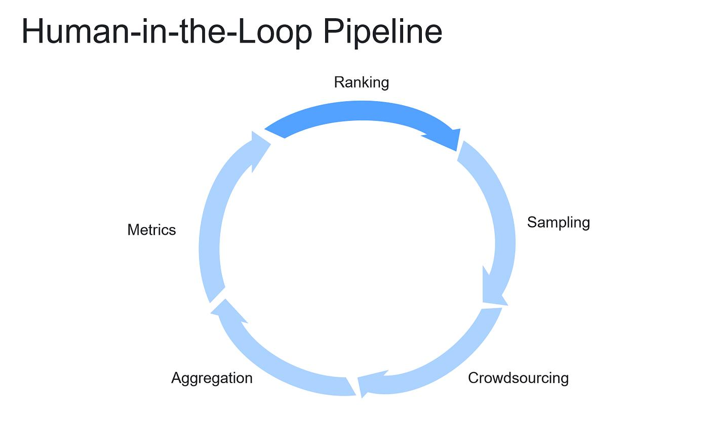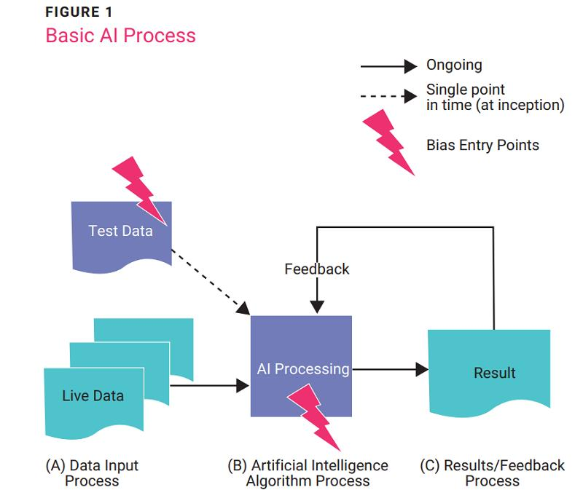

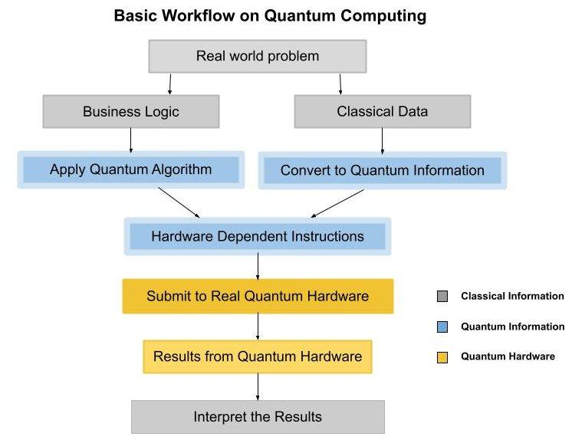

In the end, the computer is a mirror. It shows us not only what we know — but who we are.
© 2025 Gabino Casanova — Reflections on Computing, Ethics, and the Quantum Age.

