A Geometric Interpretation of Cubic Equations Through Measurement Frameworks in Bounded Space
Abstract
This paper presents a geometric interpretation of cubic equations that connects classical algebra with spatial measurement frameworks defined by cube and circle geometry. Rather than proposing a replacement for imaginary numbers, the work reframes their role as indicators of limitations within linear algebraic representation. The central idea is that certain solution structures are not absent but remain unparameterized in purely algebraic form. By introducing a circular framework within a bounded square or cube face, angular variables provide a means of measuring relationships that algebra alone does not explicitly reveal. The circle is treated not as a physical object embedded in the cube, but as a constructed measurement system that enables the transition from linear to angular representation. This interpretation offers a visual and conceptual correspondence to the trigonometric solution of cubic equations while preserving the validity of classical algebra.
Introduction
Cubic equations have historically played a central role in the development of algebra, particularly in the emergence of complex numbers. Solutions derived through Cardano’s method often require intermediate expressions involving square roots of negative quantities, even when the final roots are real. This phenomenon led to the formal introduction of imaginary numbers as a necessary extension of algebra. At the same time, alternative approaches such as the trigonometric method developed by Viète demonstrated that certain cubic equations could be solved using real-valued functions defined on the unit circle.
The coexistence of algebraic and trigonometric methods suggests that cubic equations contain an underlying structure that can be expressed in multiple forms. This paper explores that structure by introducing a geometric interpretation based on bounded space and measurement frameworks. The goal is not to alter established mathematics, but to provide a clearer understanding of how different representations relate to one another.
Historical Context
Early work on cubic equations revealed both the power and limitations of algebraic methods. Pacioli initially regarded cubic equations as unsolvable, while del Ferro and Tartaglia developed techniques for solving specific forms. Cardano later published a general method that relied on radical expressions, which in many cases required manipulation of complex quantities. Bombelli formalized the use of imaginary numbers to resolve these intermediate steps, establishing them as a legitimate mathematical tool.
In parallel, Viète demonstrated that cubic equations with three real roots could be solved using trigonometric identities, particularly the cosine triple-angle relation. This method bypassed the need for complex numbers by expressing solutions in terms of angular variables. The existence of both approaches indicates that the structure of cubic equations is not inherently tied to a single representation but can be understood through multiple frameworks.
Mathematical Framework
Consider a cube with side length a. Within one face of this cube, define a circular measurement framework whose radius is half the side length. This circle is not treated as a physical feature of the cube, but as a reference structure imposed on the bounded domain. It introduces an angular variable that allows positions within the square to be parameterized in a non-linear way.
Define a mapping between the angular parameter and the algebraic variable of the cubic equation by setting the algebraic variable equal to twice the radius multiplied by the cosine of an angle. Substituting this expression into a depressed cubic equation yields a transformed equation involving powers of cosine. Through the application of the cosine triple-angle identity, the cubic expression can be rewritten in terms of a single angular function. Under appropriate scaling conditions, the equation reduces to a relation in which the cosine of three times the angle is equal to a constant.
This transformation demonstrates that the solutions of the cubic can be interpreted as projections of angular motion onto a linear axis. The variable traditionally treated as purely algebraic is revealed to be a function of an underlying angular parameter. The cubic equation therefore encodes rotational structure within its algebraic form.
Geometric Interpretation
The cube represents a domain defined by linear boundaries, while the circle represents a domain defined by rotational symmetry. When a circular framework is imposed within a square face of the cube, the interior region becomes a space in which linear and angular descriptions coexist. The circle does not introduce new structures into space but provides a way to measure relationships that are not directly accessible through linear coordinates.
The apparent gap encountered in algebraic solutions can be understood as a limitation of the coordinate system rather than an absence of structure. Imaginary numbers serve as a formal mechanism for bridging this gap within algebra. In contrast, the circular framework offers a geometric interpretation by introducing angular measurement. The two approaches describe the same underlying relationships from different perspectives.
In this interpretation, the region within the square that is not explicitly parameterized by linear variables corresponds to a space that requires additional structure for measurement. The circle provides this structure by defining a continuous mapping between angle and position. The so-called hidden aspect of the cubic is therefore not an extra dimension in a physical sense, but a transformation between coordinate systems.
Measurement Framework Interpretation
The central concept of this work is that the circle functions as a measurement framework rather than a constructed object within the cube. The bound square defines the limits of the domain but does not fully determine how values within that domain are related. By introducing circular parameterization, space becomes measurable in terms of angular variables.
This interpretation shifts the focus from the existence of mathematical objects to the methods used to describe relationships. Algebra and geometry are not competing systems, but complementary representations of the same structure. The transition from algebra to geometry is not a contradiction, but a change in the way the space is parameterized.
The idea of an empty or missing space can therefore be reinterpreted as an unparameterized region. Once a suitable framework is applied, the relationships within that region become accessible. The circle serves as one such framework, enabling a correspondence between linear variables and angular motion.
Discussion
The geometric interpretation presented here aligns with the known equivalence between algebraic and trigonometric solutions of cubic equations. It does not challenge the validity of complex numbers but provides an alternative way to understand their role. Imaginary numbers remain essential within algebraic manipulation, but their function can be viewed as indicating a transition to a different representation.
This perspective has implications for how mathematical structures are understood more broadly. It suggests that apparent complexities may arise from the limitations of a chosen coordinate system rather than from intrinsic properties of the equations themselves. By exploring alternative frameworks, it is possible to reveal underlying simplicity and coherence.
The interpretation also highlights the importance of measurement in mathematics. Structures are not only defined by their equations, but by the ways in which they are observed and parameterized. The introduction of angular variables provides a means of accessing information that is not immediately visible in linear form.
Limitations
This work does not propose a new method for solving cubic equations and does not replace established algebraic techniques. The interpretation is most directly applicable to depressed cubic equations that admit trigonometric solutions. It serves as a conceptual and visual framework rather than a computational tool.
The use of geometric language should not be interpreted as implying physical structure within the cube. The circle is a mathematical construct used for parameterization, and the interpretation remains within the domain of abstract mathematics.
Conclusion
Cubic equations contain an underlying structure that can be expressed through both algebraic and geometric representations. The introduction of a circular measurement framework within a bounded square or cube face provides a way to interpret this structure in terms of angular variables. This approach reveals that the apparent gaps in algebraic solutions correspond to limitations of linear representation rather than missing information.
By viewing the circle as a tool for measurement rather than a constructed object, the relationship between algebra and geometry becomes clearer. The cubic equation can be understood as encoding rotational behavior within a linear form, and the transition between these representations reflects a change in coordinate systems rather than the introduction of new dimensions.
This interpretation offers a coherent and conceptually grounded perspective on classical results, contributing to a deeper understanding of the connection between algebra and geometry.
Cardano, G. Ars Magna. Nuremberg, 1545. English translation by T. Richard Witmer, Dover Publications, 1968.
Bombelli, R. L’Algebra. Bologna, 1572. English translation by J. P. Smith, Dover Publications, 1966.
Viète, F. In Artem Analyticem Isagoge. Tours, 1591.
Pacioli, L. Summa de Arithmetica, Geometria, Proportioni et Proportionalità. Venice, 1494.
Katz, V. J. A History of Mathematics: An Introduction. Addison-Wesley, 2009.
Boyer, C. B., and U. C. Merzbach. A History of Mathematics. Wiley, 2011.
Stillwell, J. Mathematics and Its History. Springer, 2010.
Cox, D. A. Galois Theory. John Wiley and Sons, 2012.
Stewart, I. Galois Theory. Chapman and Hall, 2004.
Conway, J. B. Functions of One Complex Variable. Springer, 1978.
Needham, T. Visual Complex Analysis. Oxford University Press, 1997.
Ahlfors, L. V. Complex Analysis. McGraw-Hill, 1979.
Weisstein, E. W. “Cubic Equation.” From MathWorld—A Wolfram Web Resource.
Weisstein, E. W. “Trigonometric Solution of the Cubic.” From MathWorld—A Wolfram Web Resource.
Courant, R., and H. Robbins. What Is Mathematics? Oxford University Press, 1996.
Arnold, V. I. Mathematical Methods of Classical Mechanics. Springer, 1989.
Hilbert, D., and S. Cohn-Vossen. Geometry and the Imagination. Chelsea Publishing, 1999.
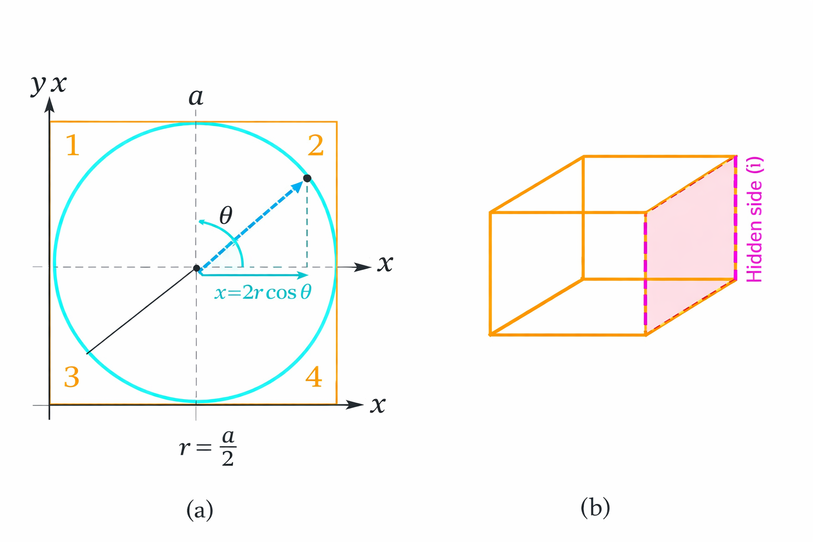

Publication-Ready Diagram Concept

Figure — Complex Plane as Measurement Framework
