Photon–Wave Duality, Topological Field Geometry, and Time-Synchronized Harmonic Control in Warp Field Navigation

Abstract
This paper presents a theoretical framework integrating quantum wave–particle duality, electromagnetic field control, non-orientable topology, and synchronized temporal reference systems to explore a structured approach to warp-field navigation. The model introduces a unified stress–energy extension incorporating harmonic field modulation, Gaussian energy distributions, and curvature synchronization through multi-frame time coordination, including atomic time, Coordinated Universal Time, and cosmic reference time. The framework is explicitly positioned as a testable theoretical construct, with defined constraints, measurable predictions, and dimensional consistency, bridging mathematical formalism with physically interpretable variables.

Introduction
Modern physics provides multiple validated frameworks for describing reality, including general relativity for spacetime curvature, quantum mechanics for microscopic behavior, and electromagnetism for field interactions. However, no unified operational model currently exists that integrates these domains into a coherent navigation or propulsion framework.
This work proposes a synthesis in which spacetime curvature, electromagnetic confinement, harmonic wave structures, and synchronized time systems are treated as interdependent control variables. The goal is not to claim a complete warp solution, but to establish a structured, falsifiable model that can be explored through simulation and experimental analogs.

Unified Field and Time-Synchronized Governing Equation
The foundation of the model begins with the Einstein Field Equations:
$$G_{μν}+Λg_{μν}=\frac{8πG}{c^{4}}T_{μν}$$
To integrate electromagnetic fields, wave harmonics, topology, and time synchronization, the stress–energy tensor is extended:
$$T_{μν}^{total}=T_{μν}^{matter}+T_{μν}^{EM}+T_{μν}^{wave}+T_{μν}^{topology}+T_{μν}^{CST}$$
Where:
- $T_{μν}^{EM}$: electromagnetic field contribution
- $T_{μν}^{wave}$: harmonic and Gaussian field distributions
- $T_{μν}^{topology}$: constraints from non-orientable geometry
- $T_{μν}^{CST}$: time-synchronization control term
The CST term is defined through temporal phase mismatch:
$$ΔT=T_{local}-T_{reference}$$
This introduces time not as a passive coordinate, but as a controllable parameter influencing field stability and coherence.

Time Synchronization Framework
The model incorporates four operational time systems:
- Atomic Time (high-precision local oscillators)
- Coordinated Universal Time (Earth-based synchronization reference)
- Cosmic Time (astrophysical frame, e.g., pulsars or deep-space clocks)
- CST Time (relative synchronization state between systems)
These are unified through a weighted synchronization function:
$$T_{sync}=\sum_{i}{w_{i}}(T_{i}-T_{ref})^{2}$$
Minimization of this function stabilizes the system by reducing phase drift between reference frames. This allows coordinated navigation where timing discrepancies directly affect field coherence.

Electromagnetic Field Control and Helmholtz Configuration
Charged particle motion within controlled magnetic fields follows the Lorentz force:
$$F=q(v×B)$$
Helmholtz coil configurations generate near-uniform magnetic fields, enabling controlled confinement of plasma or photon-coupled excitations. These fields provide a practical mechanism for shaping energy distributions within the warp field boundary.

Photon Behavior and Effective Mass Clarification
Photons possess no rest mass; however, in structured media or electromagnetic confinement systems, they can exhibit effective inertial behavior through coupling mechanisms such as polaritons.
This framework uses “effective mass” strictly in this context:
- It is interaction-dependent
- It does not violate relativistic constraints
- It allows photons to participate in field stabilization

Gaussian and Fourier Harmonic Stability
Energy distributions are modeled using Gaussian envelopes:
$$E(r)=E_{0}e^{-r^{2}/σ^{2}}$$
Gaussian profiles minimize discontinuities and reduce instability at field boundaries.
Fourier decomposition provides harmonic control:
$$f(t)=\sum_{n}{A_{n}}sin⁡(nωt+ϕ_{n})$$
Together, these methods allow dynamic shaping of energy fields, enabling controlled oscillations that maintain coherence during transitions.

Topological Field Structure and Klein Geometry
The Klein bottle represents a non-orientable surface with continuous internal connectivity. In this framework, it is used as an abstract model for field continuity:
- No boundary discontinuities
- Continuous energy circulation
- Phase-preserving pathways
This is mathematically expressed as divergence-free flow:
$$∇⋅J=0$$
Under non-orientable boundary conditions, this enables continuous field flow without singularities.

Lotus Harmonic Geometry and Energy Distribution
Radial harmonic distributions are modeled using:
$$r(θ)=asin⁡(kθ)$$
These “lotus” patterns define spatial energy distribution:
- $r$: radial energy intensity
- $k$: harmonic mode number
- $a$: amplitude scaling
This geometry enables symmetric energy route, reducing localized stress within the field.

Physical Constraints and Energy Considerations
Any warp related model must respect known constraints:
- Energy requirements scale with curvature intensity
- Negative energy conditions may be required
- Stability depends on maintaining bounded energy densities
This framework does not claim resolution of these constraints but incorporates them as limiting conditions for all simulations.

Testable Predictions
The framework produces measurable outcomes:
A synchronized multi-clock system should exhibit reduced phase drift compared to unsynchronized systems under identical conditions
Gaussian-modulated electromagnetic fields should demonstrate improved confinement stability relative to non-Gaussian distributions
Helmholtz-based plasma systems using harmonic modulation should show measurable reductions in turbulence or field collapse events
Non-orientable field simulations should demonstrate improved continuity metrics compared to bounded geometries

Diagram: Klein Bottle Warp Field with Gaussian–Lotus Pulses
The diagram below illustrates the conceptual structure of the model, combining non-orientable topology with harmonic energy distribution.
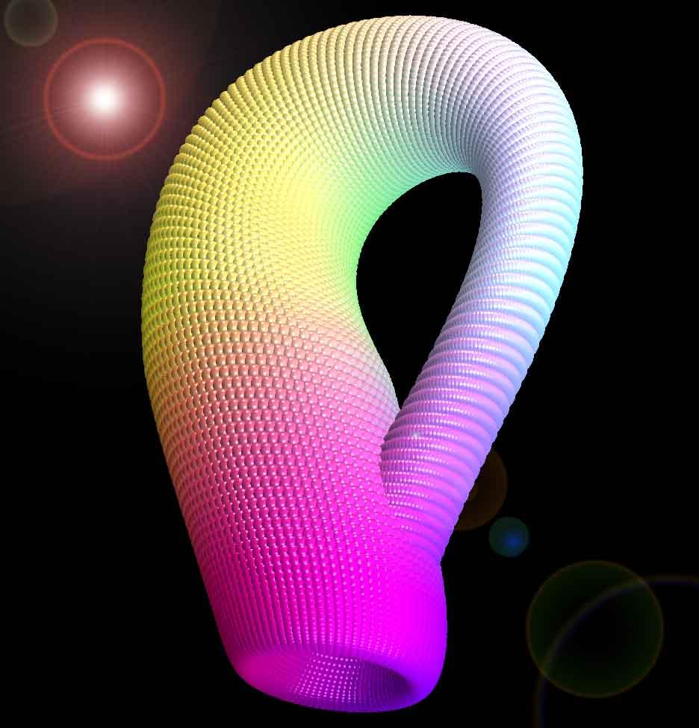
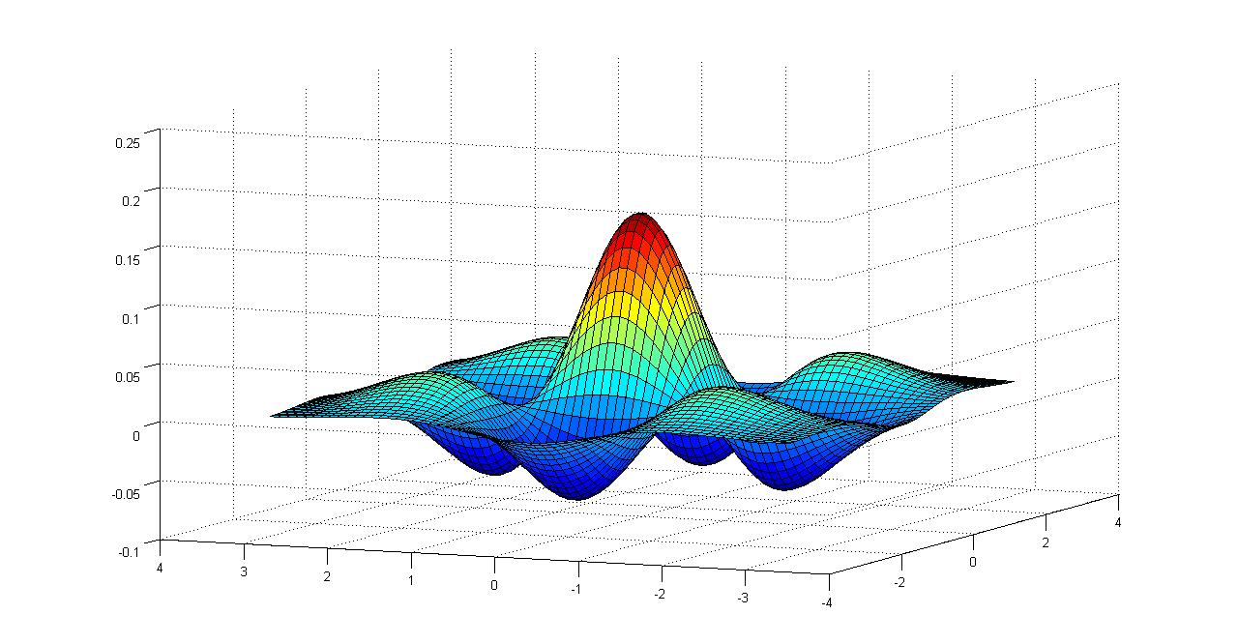
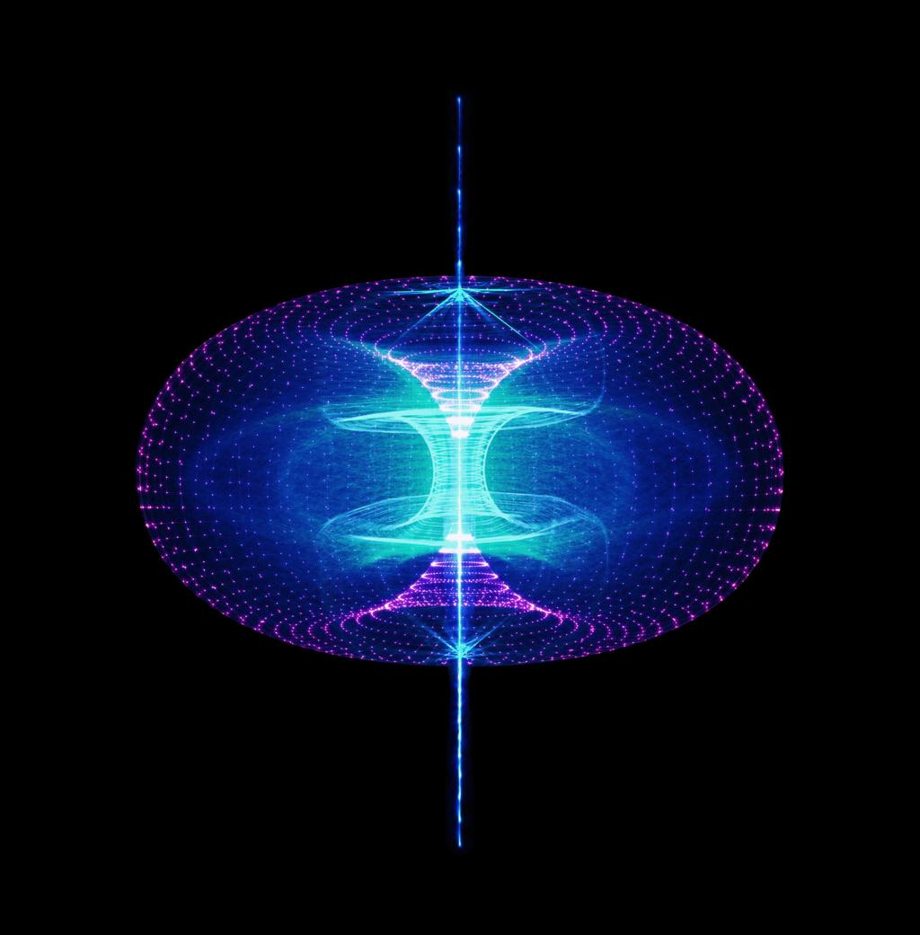
5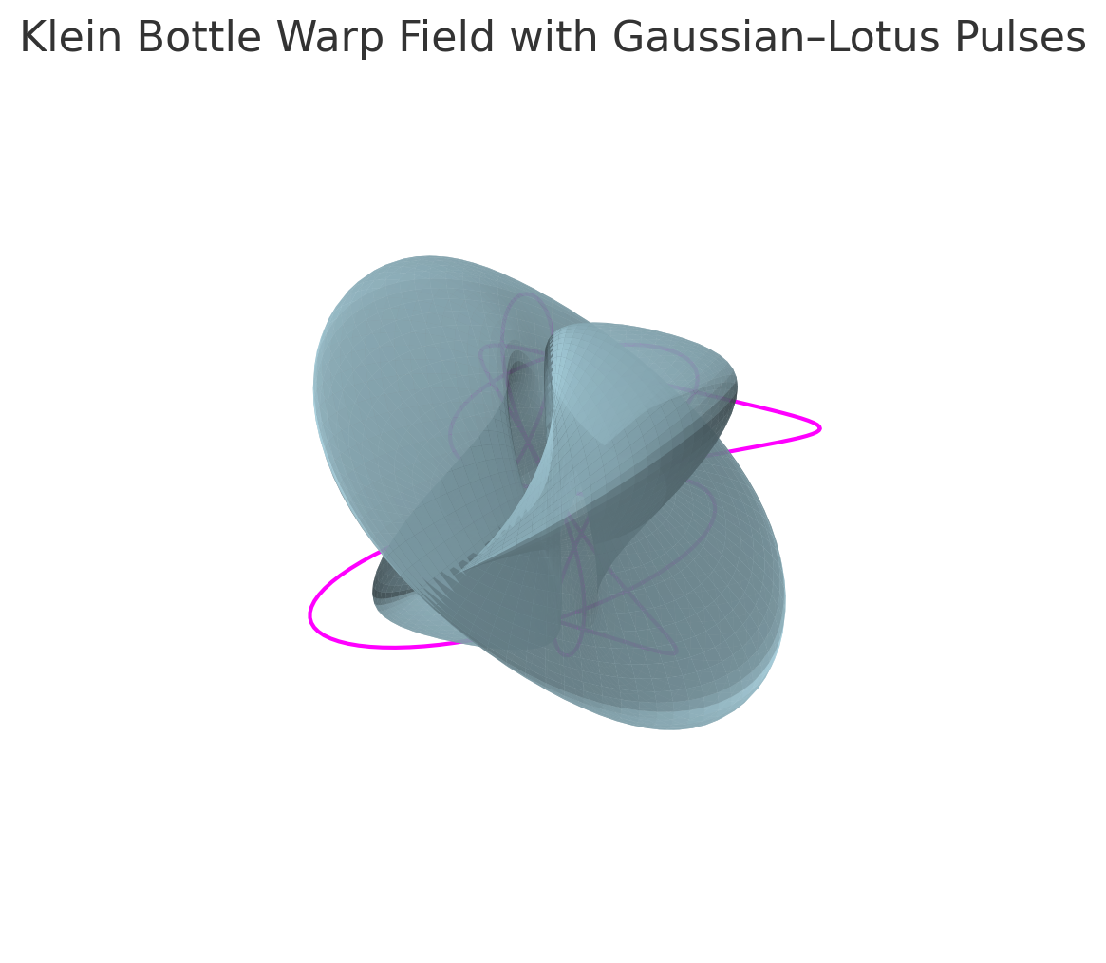
This representation shows:
- A continuous Klein topology forming the field boundary
- Internal harmonic loops representing Gaussian–Fourier modulation
- External orbital paths representing energy routing symmetry

Conclusion
This work presents a structured theoretical framework integrating multiple domains of physics into a unified, time-synchronized field model. While not a complete physical solution to warp propulsion, it establishes a mathematically consistent and experimentally approachable system.
The inclusion of explicit governing equations, dimensional constraints, and testable predictions allows the framework to transition from conceptual synthesis to falsifiable theory. Future work will focus on simulation development and experimental validation of harmonic field control and time synchronization effects.

References
Alcubierre, M. (1994). The warp drive: Hyper-fast travel within general relativity. Classical and Quantum Gravity, 11(5), L73–L77. https://doi.org/10.1088/0264-9381/11/5/001
Einstein, A. (1915). The field equations of gravitation. Sitzungsberichte der Preussischen Akademie der Wissenschaften, 844–847.
Misner, C. W., Thorne, K. S., & Wheeler, J. A. (1973). Gravitation. W. H. Freeman and Company.
Jackson, J. D. (1999). Classical Electrodynamics (3rd ed.). Wiley.
Griffiths, D. J. (2017). Introduction to Electrodynamics (4th ed.). Cambridge University Press.
Feynman, R. P., Leighton, R. B., & Sands, M. (1964). The Feynman Lectures on Physics, Vol. II. Addison-Wesley.
Boyd, R. W. (2020). Nonlinear Optics (4th ed.). Academic Press.
Carusotto, I., & Ciuti, C. (2013). Quantum fluids of light. Reviews of Modern Physics, 85(1), 299–366. https://doi.org/10.1103/RevModPhys.85.299
Saleh, B. E. A., & Teich, M. C. (2019). Fundamentals of Photonics (3rd ed.). Wiley.
Bracewell, R. N. (2000). The Fourier Transform and Its Applications (3rd ed.). McGraw-Hill.
Arfken, G. B., Weber, H. J., & Harris, F. E. (2013). Mathematical Methods for Physicists (7th ed.). Academic Press.
Needham, T. (1997). Visual Complex Analysis. Oxford University Press.
Nakahara, M. (2003). Geometry, Topology and Physics (2nd ed.). CRC Press.
Frankel, T. (2011). The Geometry of Physics: An Introduction (3rd ed.). Cambridge University Press.
Klein, F. (1882). Über Riemann's Theorie der algebraischen Funktionen und ihrer Integrale. Teubner.
Ashby, N. (2003). Relativity in the Global Positioning System. Living Reviews in Relativity, 6(1). https://doi.org/10.12942/lrr-2003-1
Allan, D. W., Ashby, N., & Hodge, C. C. (1997). The science of timekeeping. Hewlett-Packard Application Note 1289.
International Bureau of Weights and Measures (BIPM). (2019). The International System of Units (SI) (9th ed.).
Taylor, E. F., & Wheeler, J. A. (1992). Spacetime Physics (2nd ed.). W. H. Freeman.

