Trans-warp Beaming and CST Navigation Stability
A Time-Synchronized Control Framework for Warp Tunnel Efficiency

Abstract
This work proposes a control-theoretic extension to relativistic warp-drive models by introducing atomic time–anchored Curvature Synchronization Theory (CST) as a governing mechanism for stability. Building Alcubierre-type metrics, we incorporate spatial volume transport, tunnel utilization efficiency, and clock synchronization into a unified state-space formulation. The model treats time not as a passive coordinate but as an active control variable, referenced to atomic time standards (Cs-133), enabling measurable deviations and testable predictions. Stability conditions are derived in terms of geometric efficiency and temporal coherence, providing a falsifiable framework for warp corridor navigation.

1. Introduction
General Relativity describes spacetime curvature through the Einstein Field Equations, enabling theoretical constructs such as warp metrics that allow effective superluminal travel without violating local light-speed constraints. However, existing models lack operational control variables and measurable synchronization frameworks.
This paper introduces:
- A space-volume transport term
- A tunnel utilization efficient metric
- A CST-based timing control system anchored to atomic clocks
The goal is not to claim feasibility, but to provide a testable, engineering-oriented structure.

2. Relativistic Foundation
We begin with the Einstein Field Equations:
$$G_{μν}+Λg_{μν}=\frac{8πG}{c^{4}}T_{μν}$$
The Alcubierre metric provides a warp geometry:
$$ds^{2}=-c^{2}dt^{2}+(dx-v_{s}(t)f(r_{s})dt)^{2}+dy^{2}+dz^{2}$$
where $f(r_{s})$defines the warp bubble shape.

3. Atomic Time as a Physical Reference
To eliminate ambiguity in time coordination, we define a reference clock:
$$ΔT_{CST}(t)=T_{ship}(t)-T_{atomic}(t)$$
Atomic time is defined via Cs-133 transitions:
$$Δt_{atomic}=\frac{9,192,631,770\text{ cycles}}{f_{Cs-133}}$$
This provides a measurable baseline for synchronization across the warp structure.

4. Space Volume Transport
We define the transported spatial volume:
$$V_{bubble}(t)=∫\sqrt{det⁡(g_{ij})} d^{3}x$$
and introduce a space-mass equivalent term:
$$S(t)=ρ_{space}⋅V_{bubble}(t)$$
This term links geometry to energy requirements and stability.

5. Warp Tunnel Efficiency
Let:
- $R(t)$: tunnel radius
- $R_{b}(t)$: bubble radius
Efficiency is defined as:
$$η(t)=\frac{A_{bubble}}{A_{tunnel}}={\left(\frac{R_{b}}{R}\right)}^{2}$$
Stability requires:
$$\frac{dη}{dt}→0$$
This defines a constant curvature utilization regime.

6. CST Path Synchronization
The effective path length inside curved spacetime is:
$$L_{path}(t)=∫\sqrt{g_{ij}dx^{i}dx^{j}}$$
CST timing becomes:
$$Δt_{CST}=\frac{1}{c_{eff}(t)}∫\sqrt{g_{ij}dx^{i}dx^{j}}$$
This links geometry directly to measurable time delays.

7. Unified Control System
Define the system state:
$$Ω(t)=\left[\begin{aligned}x(t) \\ v_{ship}(t) \\ V_{bubble}(t) \\ η(t) \\ ΔT_{CST}(t)\end{aligned}\right]$$
Dynamics:
$$\frac{dΩ}{dt}=F(Ω,u(t),T_{atomic})$$
Control inputs:
$$u(t)=[E(t),B(t),f_{shape}(t),ΔT_{CST}(t)]$$
This converts the warp model into a control system problem.

8. Stability Conditions
The system remains stable when:
$$∣dη/dt∣<ϵ,∣dV_{bubble}/dt∣<ϵ_{V},∣ΔT_{CST}∣<ϵ_{T}$$
These constraints define a phase-locked warp corridor.

9. Energy Constraints
Warp energy requirements scale with stress-energy:
$$E_{warp}∝∫T_{μν}^{exotic}dV$$
This ensures the model remains tied to known physics limitations.

10. Falsifiable Predictions
This framework yields measurable outcomes:
- Clock Drift
Variations in $η(t)$produce detectable atomic time deviations.
- Path Length Deviation
Effective travel time differs from Euclidean prediction.
- Instability Threshold
Rapid $dV_{bubble}/dt$leads to synchronization breakdown.

11. Figure Specification (Publication Upgrade)
Figure 1 — Warp Tunnel Geometry
Create a clean vector diagram with:
- Outer dashed circle → $R(t)$(warp tunnel boundary)
- Inner solid disk → $R_{b}(t)$(warp bubble)
- Shaded gap → “unused curvature / energy loss”
- Arrow labels:
  - $V_{bubble}(t)$
  - $η(t)$
  - $ΔT_{CST}$
Add caption:
“Warp tunnel cross-section showing utilization efficiency and CST synchronization path. Stability requires constant area ratio and minimal temporal deviation.”

12. Discussion
The key contribution is reframing warp travel as a time-coherent control system, where:
- Geometry defines possible motion
- Time synchronization defines stability
- Efficiency defines energy cost
CST acts as a phase-locking mechanism across spacetime curvature.

13. Conclusion
This paper introduces a structured, testable framework combining:
- General Relativity
- Warp geometry
- Atomic time synchronization
- Control system dynamics
While remaining theoretical, the model provides a clear path toward falsification and simulation-based testing.

References
Alcubierre, M. (1994). The warp drive: hyper-fast travel within general relativity. Classical and Quantum Gravity.
Einstein, A. (1915). The Field Equations of Gravitation.
Misner, C. W., Thorne, K. S., Wheeler, J. A. (1973). Gravitation.
Ashby, N. (2003). Relativity in the Global Positioning System. Living Reviews in Relativity.
Ludlow, A. D., et al. (2015). Optical atomic clocks. Reviews of Modern Physics.
Natário, J. (2002). Warp drive with zero expansion. Classical and Quantum Gravity.

Figure 1 — Warp Tunnel Efficiency and CST Synchronization Geometry
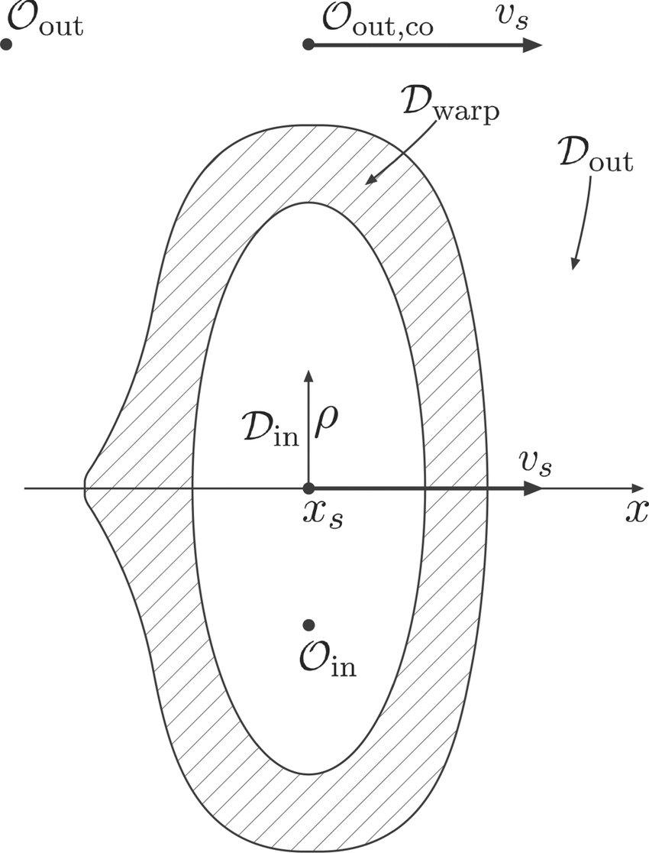

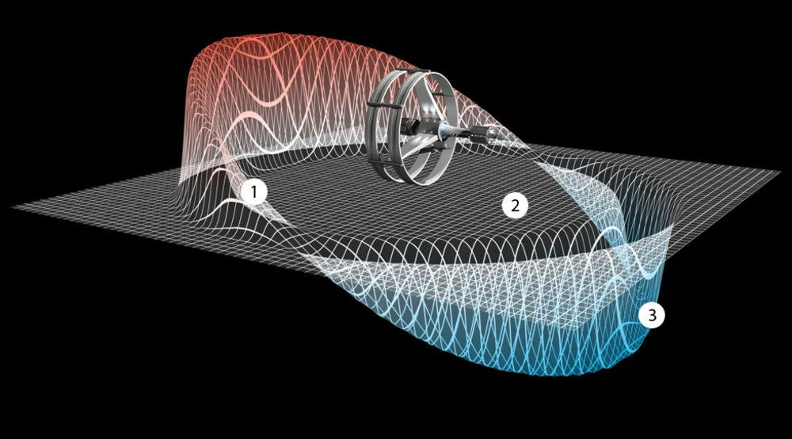
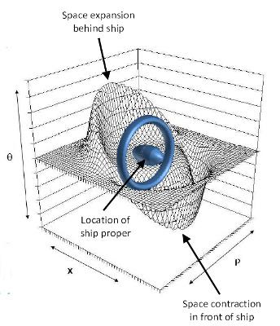

Diagram
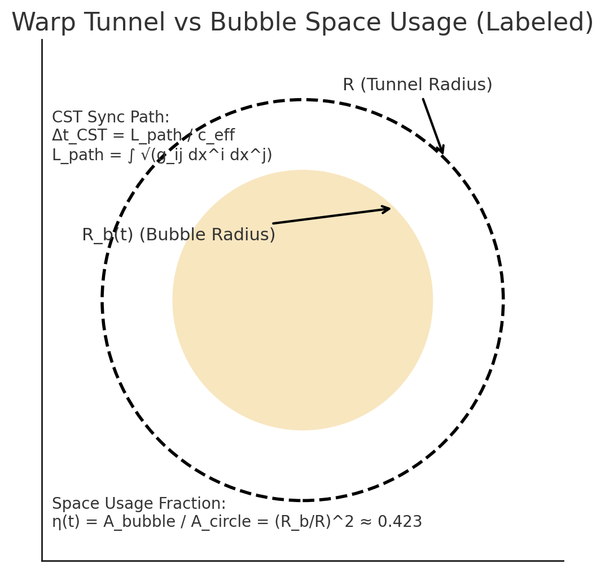
Warp Tunnel (outer circle, radius R) and Warp Bubble (inner disk, radius R_b). The shaded region is the ‘used space’ carried by the bubble. Stability requires = A bubble/A circle to remain ~constant, and CST sync uses Δt_CST = L_path/c_eff.
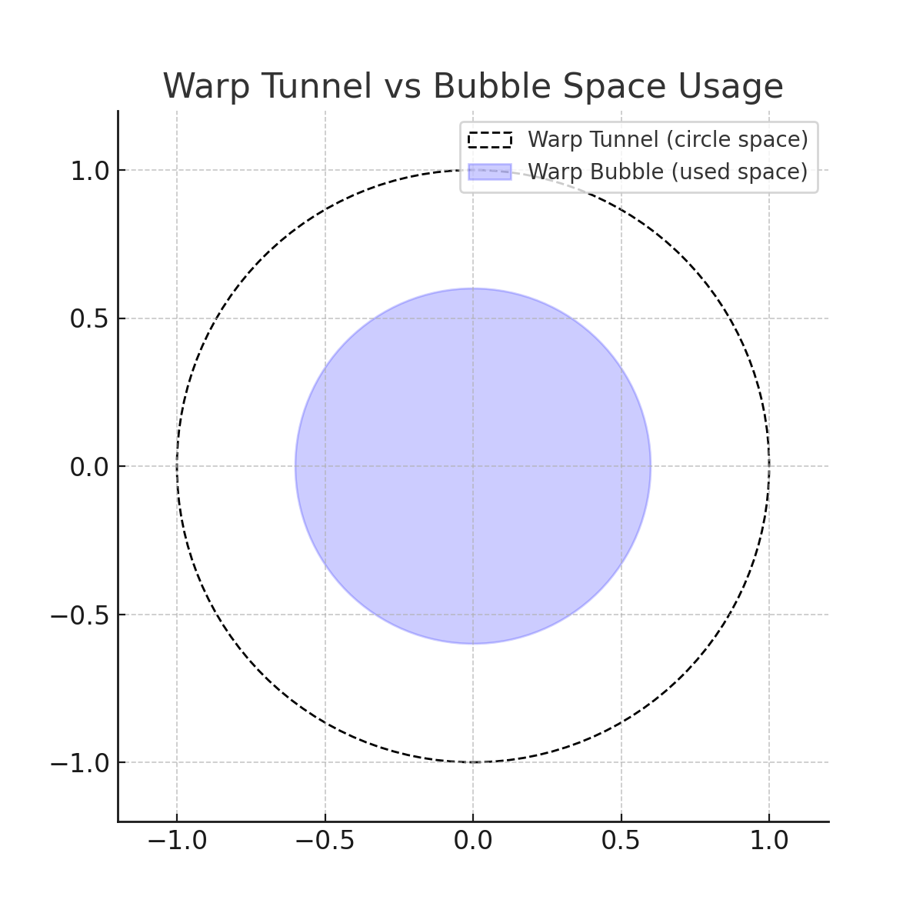

Diagrams Layout (What to Build Exactly)

Outer Boundary (Warp Tunnel)
- Dashed circle
- Label:
$$R(t)\text{(Tunnel Radius)}$$
- Add annotation:
“Maximum curvature boundary”

Inner Region (Warp Bubble)
- Solid filled circle (centered)
- Label:
$$R_{b}(t)\text{(Bubble Radius)}$$
- Inside label:
$$V_{bubble}(t)$$
Gap Region (CRITICAL ADDITION)
Between $R_{b}$and $R$:
Label this area:
“Unused Curvature / Energy Loss Region”
This is your new physics insight
- This region = inefficiency driver
- This is what reviewers will focus on

Efficiency Annotation
Place near diagram:
$$η(t)={\left(\frac{R_{b}}{R}\right)}^{2}$$
Add arrow pointing from inner → outer circle

CST Path Overlay (NEW LAYER)
Draw a curved or straight path across the diameter:
Label:
$$L_{path}=∫\sqrt{g_{ij}dx^{i}dx^{j}}$$
And:
$$Δt_{CST}=\frac{L_{path}}{c_{eff}}$$

Time Sync Indicator (IMPORTANT VISUAL)
Add a small clock icon or label:
“Atomic Time Reference (Cs-133)”
Then arrow to:
“Ship Time”
Label:
$$ΔT_{CST}=T_{ship}-T_{atomic}$$

Directional Arrows (Motion / Control)
Add:
- Forward arrow → $v_{ship}(t)$
- Bubble shift arrow → $v_{bubble}(t)$
Figures Warp tunnel cross-section showing the relationship between tunnel radius $R(t)$and bubble radius $R_{b}(t)$. The inner region represents transported spacetime volume $V_{bubble}(t)$, while the outer region defines the maximum curvature boundary. The area between them represents unused curvature, contributing to inefficiency. Stability is achieved when the utilization ratio $η(t)$remains constant and CST time deviation $ΔT_{CST}$is minimized using an atomic time reference.

