Oscillatory Synchronization, Atomic Time Referencing, Nuclear Energy Conversion, and Speculative Moving-Space Transport

Abstract
Efficient motion in natural systems emerges from the synchronization of energy input, oscillatory dynamics, and environmental coupling. This paper develops a unified theoretical framework extending biological wave-based locomotion to engineered propulsion systems and speculative spacetime transport concepts. Atomic time is introduced as a universal timing ruler, the speed of light as an ideal propagation bound, and mass–energy equivalence as an energy accounting relation. Nuclear energy is incorporated as a practical onboard source capable, in theory, of sustaining propulsion through appropriate conversion mechanisms. The framework connects timing, distance, energy, and motion into a coherent structure and applies it to an Earth–Mars transit expressed in atomic-time units. The model emphasizes synchronization, phase stability, and energy conversion, and introduces a set of testable predictions to enable experimental validation.

Introduction
Biological locomotion provides a natural example of efficient motion governed by oscillatory synchronization. A shark swimming through water generates a traveling wave along its body, producing thrust through vortex interactions with the surrounding fluid. This motion remains efficient only within a narrow oscillatory range, reflecting a balance between internal energy input and environmental coupling. When this balance is disrupted, motion becomes inefficient or collapses.
This paper generalizes that principle to a broader class of systems. Motion is treated as an oscillatory process evolving relative to a temporal reference. Atomic time, defined by cesium-133 oscillations, provides a universal timing standard. The speed of light establishes a fundamental relationship between space and time, while mass–energy equivalence provides a means of quantifying energy resources. By integrating these elements, a unified framework is constructed that applies to biological motion, conventional spacecraft propulsion, and speculative moving-space transport models.

Oscillatory Motion and System Stability
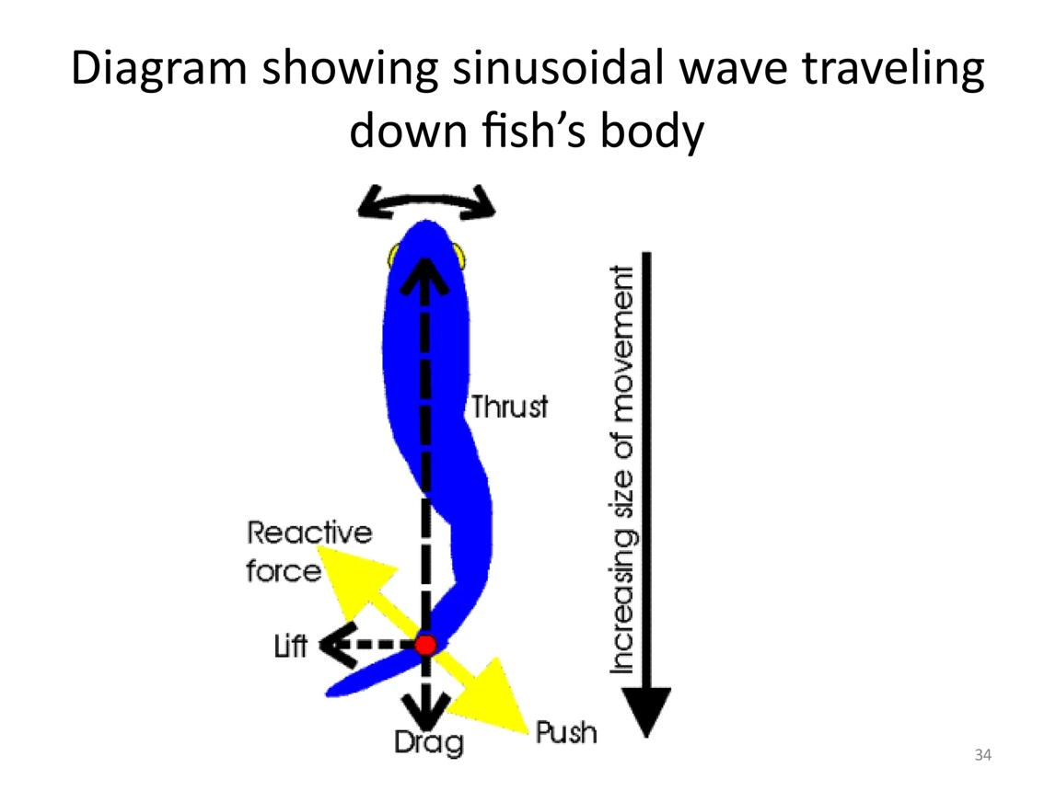
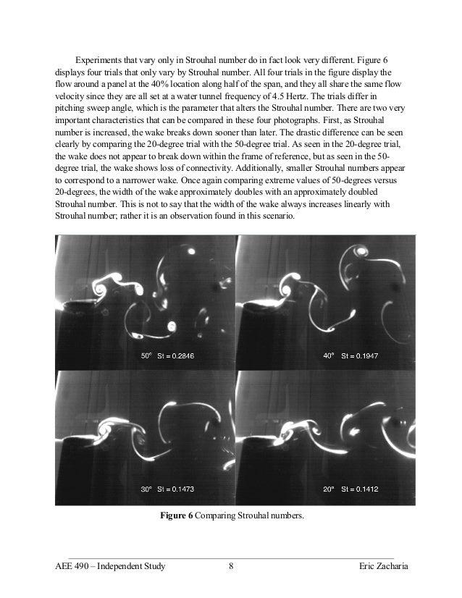
The motion of a shark can be modeled as a traveling wave:
$$y(x,t)=A(x)sin⁡(kx-ωt)$$
where efficiency depends on maintaining a stable oscillatory relationship with the surrounding medium. This reflects a general principle: systems require synchronization between internal oscillation and external coupling.
When this synchronization is lost, the system destabilizes. This principle applies broadly across biological and engineered systems.

Atomic Time and the Spatial–Temporal Ruler
Atomic time is defined by the Cesium-133 hyperfine transition:
$$1\text{ s}=9,192,631,770\text{ oscillations}$$
The speed of light is:
$$c=299,792,458\text{ m/s}$$
From these definitions:
$$Δx≈0.0326\text{ m per oscillation}$$
This provides a universal atomic ruler, linking time and space.

Earth–Mars Transit in Atomic Units
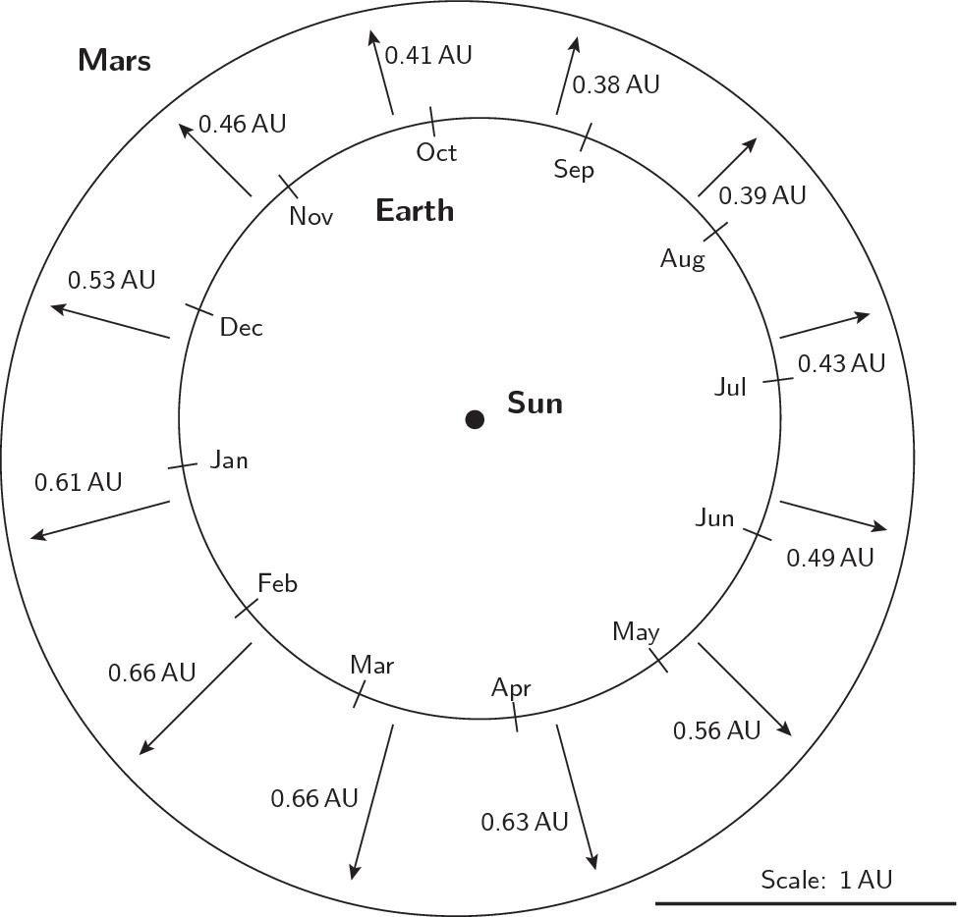
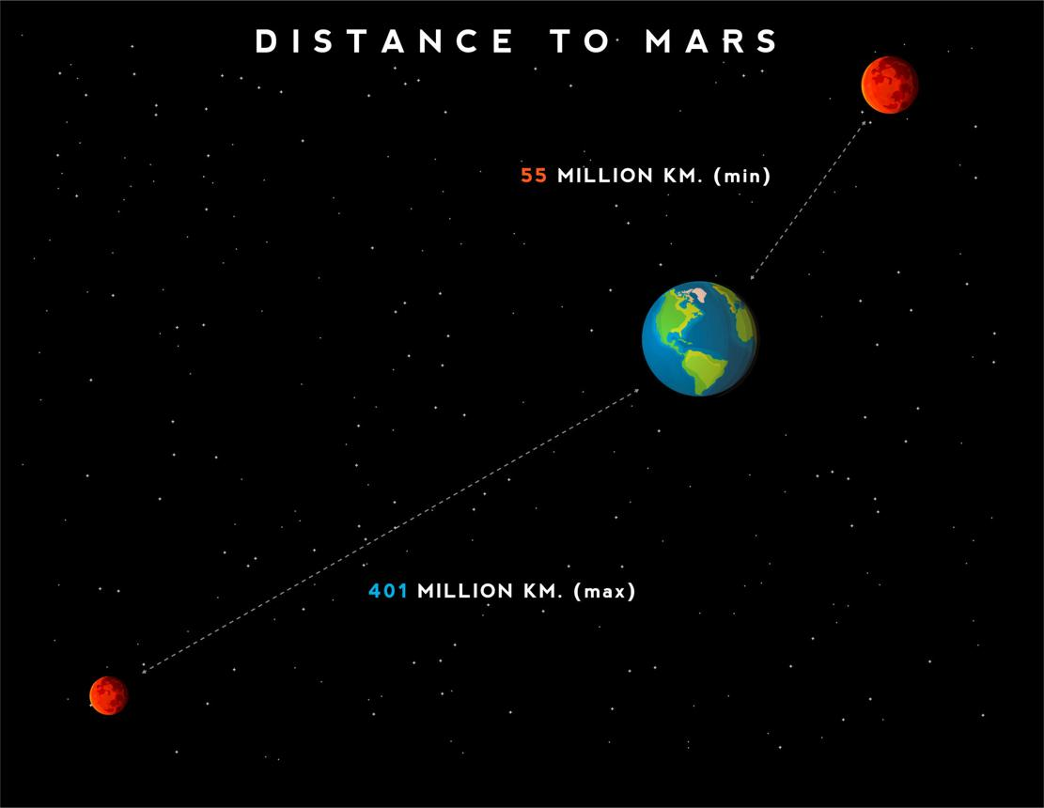
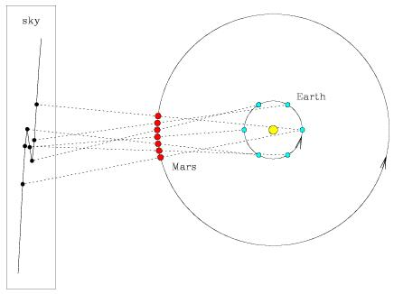
Using average distance:
$$D≈2.25×{10}^{11}\text{ m}$$
Light time:
$$t≈750\text{ s}$$
Atomic steps:
$$N≈6.9×{10}^{12}$$
This converts spatial travel into a timing framework.

Nuclear Energy and Propulsion Conversion
Nuclear energy provides an onboard energy source capable of sustained operation. However, propulsion requires conversion of energy into momentum through a propulsion system.
Systems include:
- thermal propulsion
- plasma propulsion
- electric propulsion
Energy alone does not create motion; it must be coupled to a propulsion mechanism.

Mass–Energy Equivalence as Accounting
$$E=mc^{2}⟺m=\frac{E}{c^{2}}$$
This relation provides energy scaling, not propulsion dynamics.

Synchronization and CST Time
$$ΔT=T_{\text{system}}-T_{\text{reference}}$$
Stability requires bounded timing deviation.

Moving Space and Warp Interpretation
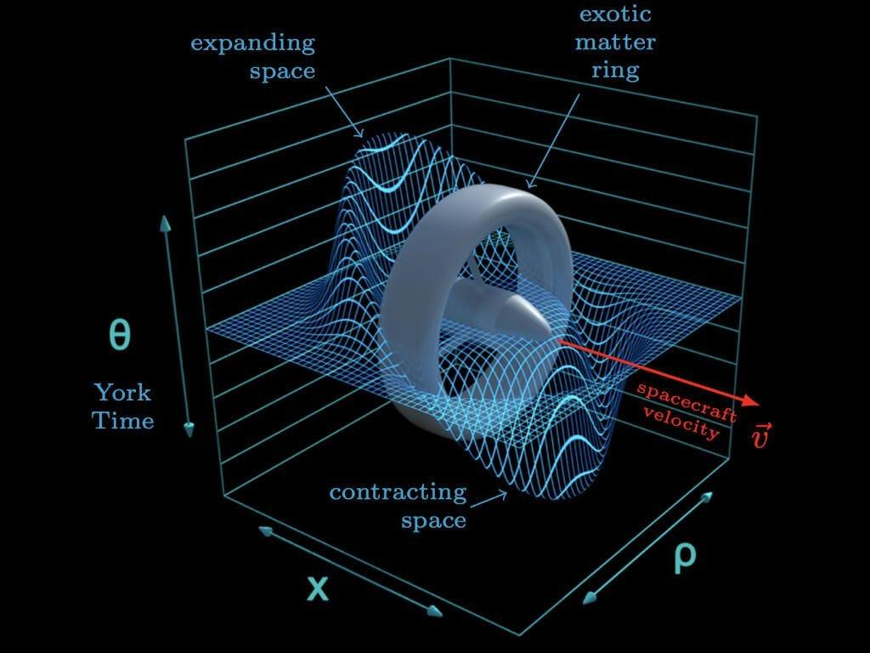
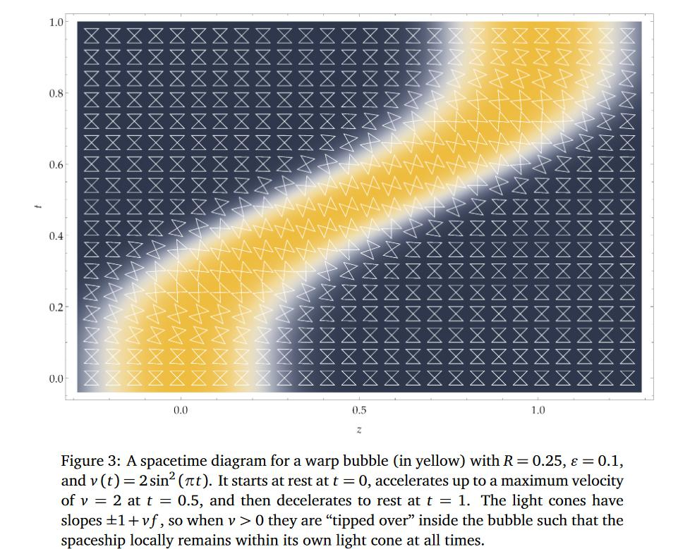
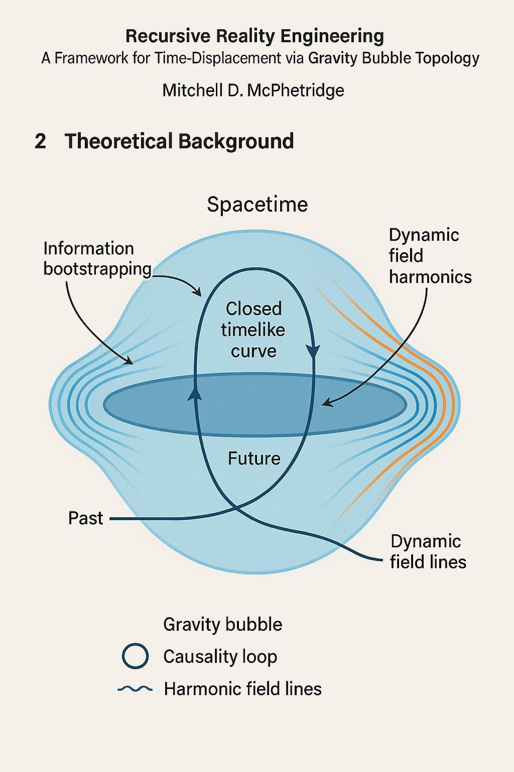

In speculative warp models such as the Alcubierre Drive, motion is achieved through dynamic spacetime curvature.
The structure must propagate and remain synchronized.

Testable Predictions
To move beyond conceptual theory, the following predictions are proposed:

Prediction 1 — Oscillation Stability Window
Any propulsion system based on oscillatory energy transfer will exhibit a narrow stability band. Operating outside this band will produce measurable inefficiencies such as increased heat, vibration, or energy loss.
Test Method:
Laboratory plasma or ion propulsion systems can be driven across varying frequencies to identify optimal stability ranges.

Prediction 2 — Phase Drift Instability
Systems with a measurable timing difference $ΔT$relative to a reference clock will exhibit instability when phase drift exceeds a threshold.
Test Method:
Use synchronized atomic clocks in high-speed control systems and measure performance degradation under induced timing offsets.

Prediction 3 — Atomic-Time Navigation Precision
Navigation systems using atomic-time synchronization will outperform classical timing methods in long-distance trajectory accuracy.
Test Method:
Compare deep-space navigation simulations using atomic-clock synchronization versus conventional timing systems.

Prediction 4 — Energy–Oscillation Coupling Scaling
Energy input required for stable propulsion scales with oscillation frequency and amplitude.
Test Method:
Measure energy consumption across varying oscillation regimes in propulsion testbeds.

Prediction 5 — Environmental Decoupling Collapse
Removing a propulsion system from its coupling medium (e.g., fluid, plasma, or field) will result in measurable loss of efficiency or collapse of motion stability.
Test Method:
Compare propulsion efficiency across different environmental conditions.

Conclusion
This work establishes a unified framework linking biological motion, atomic time, energy conversion, and propulsion systems. Motion is treated as an oscillatory process requiring synchronization between energy input, system dynamics, and temporal reference. Atomic time provides a universal ruler, the speed of light defines an ideal timing bound, and mass–energy equivalence provides energy accounting.
Nuclear energy is incorporated as the onboard source capable, in theory, of sustaining propulsion, provided it is properly converted into momentum transfer. The framework does not claim faster-than-light travel but introduces a structured approach to analyzing timing, energy, and synchronization in advanced propulsion concepts.

References
- Bureau International des Poids et Mesures
- National Institute of Standards and Technology
- NASA
- Mass–energy equivalence
- Special Relativity
- General Relativity
- Strouhal number
- Alcubierre Drive

