Title: Multi-Clock Conscious Control Framework Using Atomic Time, CST Motion Synchronization, and Probabilistic Decision Systems
Author: Gabino Casanova
Abstract
This paper presents a multi-layered timing and control architecture that integrates atomic clock synchronization, a secondary motion-based timing layer referred to as Curvature Synchronization Theory (CST), and a probabilistic decision mechanism inspired by quantum measurement principles. The framework introduces a hierarchical command structure in which a stable atomic time reference governs global system coherence, while CST enables localized motion control and adaptive timing. A probabilistic decision layer, modeled through statistical sampling, initiates command selection and propagates instructions through a distributed “spider web” memory network. The system is proposed as a conceptual engineering framework designed to improve precision, coordination, and response time in autonomous and distributed systems. The model remains consistent with established physics and is presented as a testable control architecture rather than a new physical theory.
Introduction
Precise timekeeping is fundamental to modern science and engineering. Atomic clocks, based on transitions such as those of cesium atoms, provide the most stable and universally accepted time standard. In contrast, physical systems in motion operate under varying temporal conditions influenced by velocity, gravity, and system dynamics, as described by relativity.
This work proposes a separation between stable reference time and dynamic operational time. Atomic clock synchronization is used as the foundational timing layer, while CST is introduced as a motion-dependent timing framework that governs system behavior under changing conditions. A probabilistic decision layer initiates system actions, creating a structured hierarchy of control.
The key concept is that decision-making, timing, and execution are not unified under a single clock, but distributed across multiple synchronized clocks, each optimized for a specific role.
Mathematical Foundation
The system is defined by three interacting components: reference time, motion time, and probabilistic state selection.
Reference time is defined as
T_ref
representing atomic clock synchronization.
Motion time is defined as
T_CST
representing system-specific temporal evolution.
The synchronization conditions are
ΔT = T_CST − T_ref
where ΔT is actively regulated to maintain coherence between layers.
The probabilistic decision layer is modeled using a normalized state
ψ = α|0⟩ + β|1⟩
with
|α|² + |β|² = 1
Measurement outcomes follow the Born rule, where probabilities are determined by squared amplitudes. This formalizes the decision process as statistical sampling rather than deterministic selection.
System evolution follows standard quantum-inspired dynamics, conceptually aligned with the Schrödinger framework
iħ (dψ/dt) = Hψ
not as a literal physical implementation, but as a structured analogy for state evolution and transition.
Multi-Clock Hierarchical Control System
The architecture consists of three coordinated layers.
Atomic Clock Layer (Global Stability)
This layer provides invariant timing. It acts as the master reference for all subsystems, ensuring synchronization across distributed components. It does not change with system motion and maintains long-term stability.
Probabilistic Decision Layer (Command Initiation)
This layer functions as the system’s decision engine. A probabilistic sampling process selects an outcome based on weighted states. This replaces deterministic triggers with adaptive selection, allowing the system to evaluate multiple possible actions before committing.
The decision process can be interpreted as a controlled statistical sampling mechanism, analogous to quantum measurement without invoking physical wavefunction collapse.
CST Motion Layer (Execution and Adaptation)
Once a decision is made, CST governs the execution timing. This layer adjusts local timing conditions to optimize motion, coordination, and system response. It allows operations to occur at different effective rates while remaining synchronized with the atomic reference.
Conscious Command Interpretation as System Coordination
Within this framework, what is traditionally referred to as “consciousness” is reinterpreted as a coordination mechanism rather than a metaphysical property. It represents the point at which probabilistic decisions are resolved into actionable commands.
The process can be described as follows:
A probabilistic state is evaluated
A decision outcome is selected through statistical sampling
The selected command is issued under atomic time synchronization
CST modulates execution timing for system efficiency
The result is distributed through the memory network
This creates a layered command structure where decision, timing, and execution are separated but synchronized.
Spider Web Memory Network
The memory architecture is modeled as a distributed network of interconnected nodes referred to as spider web memory. Each node represents a state, command, or stored interaction.
Key properties include:
Global synchronization through atomic time ensures all nodes share a consistent temporal reference
Local adaptation through CST allows nodes to update asynchronously without losing coherence
Probabilistic inputs allow dynamic restructuring of connections based on system behavior
This structure enables rapid signal propagation, redundancy, and adaptive learning. It also supports parallel processing, where multiple nodes operate simultaneously under coordinated timing.
System Integration and Performance Implications
The integration of atomic time, CST motion control, and probabilistic decision-making produces several system-level advantages.
Temporal precision is maintained through atomic synchronization
Execution efficiency improves through CST-based timing modulation
Decision flexibility is enhanced through statistical sampling
Memory coherence is preserved across distributed networks
The result is a system capable of operating with higher precision and reduced latency compared to single-clock architectures.
Testable Predictions
The framework produces measurable outcomes that can be evaluated experimentally.
Systems using atomic reference time with CST modulation will show reduced timing drift
Probabilistic decision layers will demonstrate convergence toward stable outcomes under repeated sampling
Distributed memory networks synchronized by atomic time will maintain coherence during dynamic updates
Multi-clock architectures will outperform single-clock systems in coordination and response time
These predictions can be tested using robotic systems, distributed computing environments, and simulation platforms.
Limitations
This framework does not claim to replicate quantum mechanical processes. The probabilistic layer is an abstracted statistical model and does not include phase coherence or interference effects. CST is defined as a control methodology rather than a validated physical theory. The concept of consciousness is treated operationally as a coordination mechanism, not as a biological or philosophical claim.
Further work is required to formalize CST mathematically and to validate system performance experimentally.

Conclusion
A multi-clock control architecture has been presented that separates stable atomic time, probabilistic decision-making, and motion-based execution timing. By structuring these components into a hierarchical system, it is possible to achieve improved synchronization, adaptability, and performance in complex systems.
This framework provides a pathway for integrating precise timekeeping with dynamic control and probabilistic decision processes. Future research will focus on simulation, implementation, and empirical validation of the proposed architecture.

References
Albert Einstein Relativity and time dilation principles
Niels Bohr Quantum measurement and probabilistic interpretation
Richard Feynman Quantum systems and probabilistic behavior
David Deutsch Universal quantum computation framework
Michael Nielsen Quantum computation and information theory
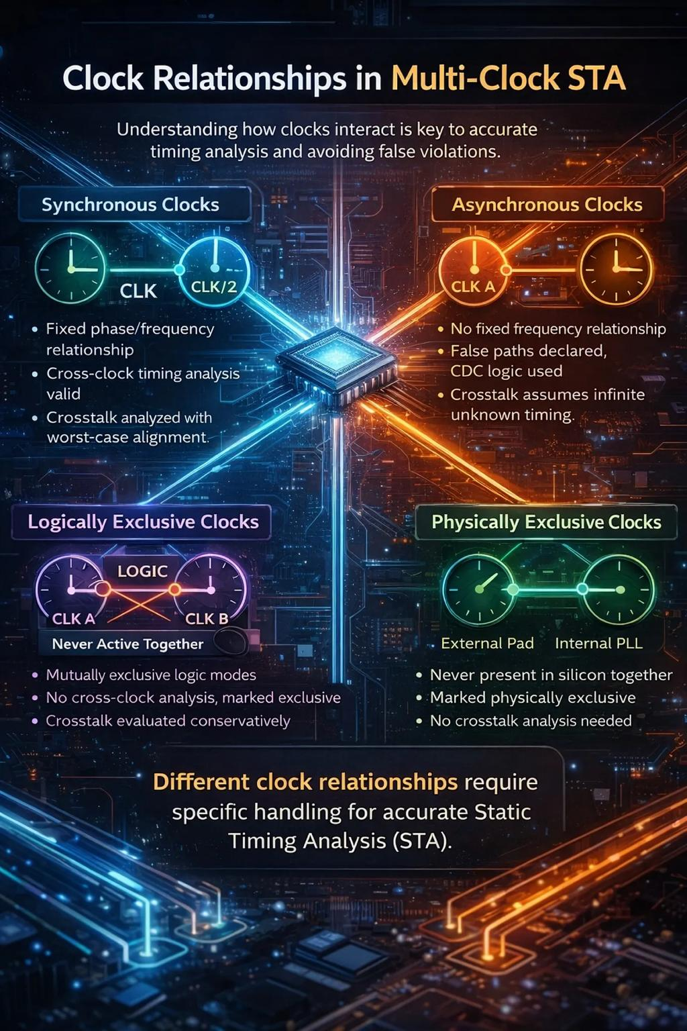
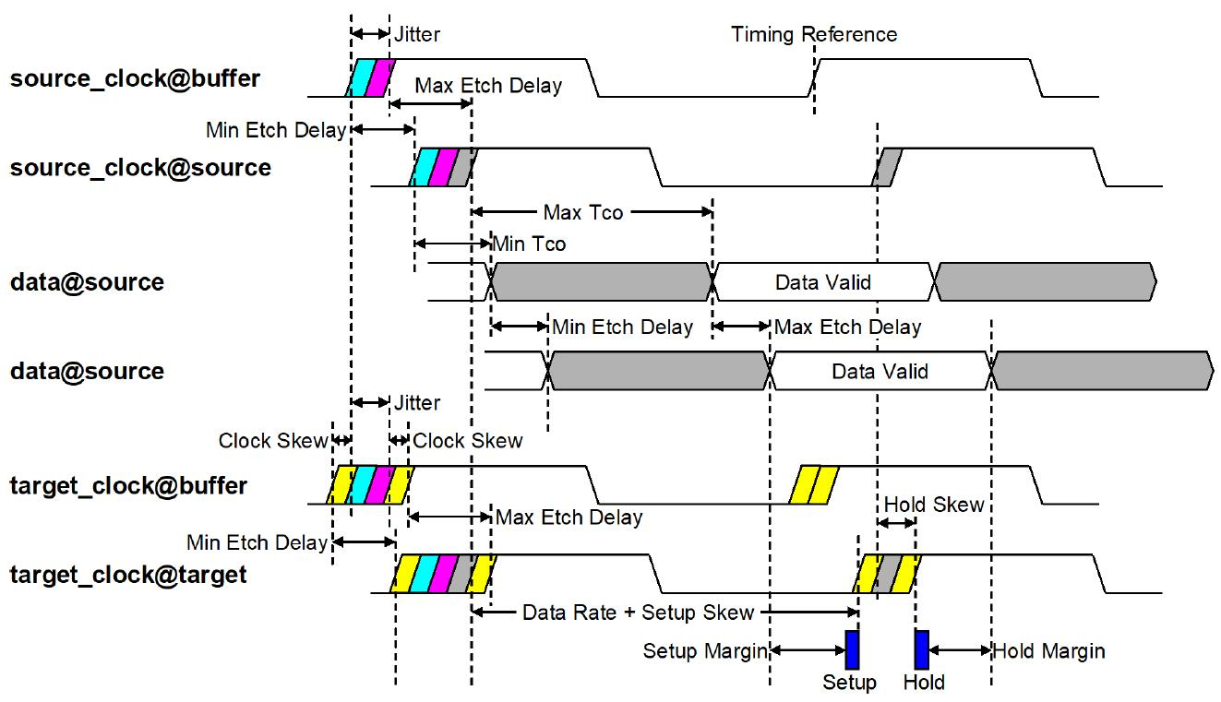

© 2025 Gabino Casanova — Conceptual Education Framework for Quantum and Robotic Simulation Systems.

