Photon Flux, Neutral Rhythms, and Engineering Applications for High-Speed Space Systems
Expanded draft with careful CST extension layer

Abstract
Photons are the quanta of the electromagnetic field and provide a direct bridge between measurable physics and engineering design. This paper develops a calculation-first framework for photon energy, photon flux, momentum, and radiation pressure, then places those quantities inside a time-structured environmental model termed neutral rhythm. The practical aim is to show how established equations can support navigation timing, hybrid propulsion analysis, radiation-management concepts, and high-speed but non-FTL mission design.
A careful Curvature Synchronization Theory (CST) extension layer is added here only as a control-and-navigation framework, not as a replacement for Maxwell's equations, relativity, or standard propulsion physics. In this paper, CST means synchronizing clocks, guidance windows, and environmental reference signals so that a vehicle operates more efficiently inside measurable photon and plasma conditions rather than fighting them blindly.
The paper is written so that each section can be understood by a technically curious reader while still remaining useful to engineers who want equations, workflow, figures, and explicit assumptions.

1. Photon Fundamentals (what this section is for)
This section establishes the minimum set of equations needed to convert light into engineering numbers. The point is not to invent new photon physics; the point is to use standard photon physics in a disciplined way.
Energy: E = h*c/lambda
Frequency form: E = h*f
Momentum: p = E/c
Photon flux: Phi = I/E
Radiation pressure for absorption: P_absorb = I/c
Radiation pressure for reflection: P_reflect = 2I/c
These relations let a designer move from irradiance to photon count, from photon count to momentum transfer, and from momentum transfer to force and acceleration. This is the main bridge from theory to hardware relevance.
Example at lambda = 550 nm: E ≈ 3.61 x 10^-19 J per photon. This value is useful because visible-light examples are easy to understand and give the correct order of magnitude for photon counting.

2. Neutral Rhythm (formal definition and why it matters)
The phrase neutral rhythm refers to regular baseline variation in photon environment that does not depend on a local engine or local electronics. It is 'neutral' in the sense that the environment itself is cycling whether a vehicle uses it or not.
Formal definition: I(t) = I0 + DeltaI_day(t) + DeltaI_season(t) + DeltaI_solar(t)
Here I0 is the baseline irradiance, DeltaI_day is the day-night modulation driven by planetary rotation, DeltaI_season is the slower geometric modulation associated with orbital position and axial tilt, and DeltaI_solar is the longer-timescale variation tied to solar activity.
This definition turns a descriptive idea into a modelable one. Instead of saying 'light changes with time,' the paper says exactly where the changes come from and how they can be represented in calculations.
For engineering, that matters because any mission using solar power, optical sensing, laser communication, thermal control, or photon-assisted propulsion is already operating inside these rhythms whether the design accounts for them or not.

3. Engineering Calculation Workflow (how to actually use this paper)
The workflow below is the practical heart of the paper. It provides a repeatable sequence for converting environmental or engineered light into performance estimates.
Step A - Choose or measure irradiance I. Example values include I_TOA ≈ 1361 W/m^2 at top of atmosphere and roughly 700 to 1000 W/m^2 for clear-sky surface conditions.
Step B - Choose a wavelength lambda or a spectral band. Example: lambda = 550 nm gives E ≈ 3.61 x 10^-19 J.
Step C - Compute photon flux using Phi = I/E. At I = 1000 W/m^2 and lambda = 550 nm, Phi ≈ 2.8 x 10^21 photons/m^2/s.
Step D - Convert irradiance to radiation pressure using P = I/c for absorption or P = 2I/c for reflection.
Step E - Convert pressure to force and then to acceleration using F = P*A and a = F/m.
This sequence is intentionally simple. It makes the paper useful for first-pass design, concept comparison, educational explanation, and future simulation dashboards.

4. Dimensional Consistency (why reviewers look for this)
A short dimensional check makes the argument more credible because it shows that the equations are not just symbolically appealing but physically coherent.
Pressure relation: P = I/c
Unit check: (W/m^2)/(m/s) = (J/s/m^2)/(m/s) = J/m^3 = N/m^2
That last equality is important because pressure must have units of force per area. Including such checks reduces the chance that a reviewer dismisses the work as hand-waving.

5. Worked Numbers (clear examples)
Example 1 - Photon count at 550 nm. For I = 1361 W/m^2 and E_ph ≈ 3.61 x 10^-19 J, the photon flux is Phi ≈ 3.77 x 10^21 photons/m^2/s.
Example 2 - Radiation pressure for absorption. P_absorb = I/c ≈ 1361/(2.998 x 10^8) ≈ 4.54 x 10^-6 Pa.
Example 3 - Radiation pressure for reflection. P_reflect ≈ 9.08 x 10^-6 Pa.
Example 4 - Idealized sail acceleration. For a 10 kg probe with a 10 m^2 perfectly reflecting sail at I = 1361 W/m^2, force F ≈ 9.08 x 10^-5 N and acceleration a ≈ 9.08 x 10^-6 m/s^2. Over 1 day, Delta v ≈ 0.79 m/s. Over 100 days, Delta v is about 79 m/s if the assumptions remain valid.
These are not fantasy numbers. They are small-force, long-duration numbers, which is exactly why photon propulsion is realistic in some mission classes but not a replacement for high-thrust launch systems.

6. Figures
The figures below are included to make the paper easier to understand for both technical and non-technical readers.
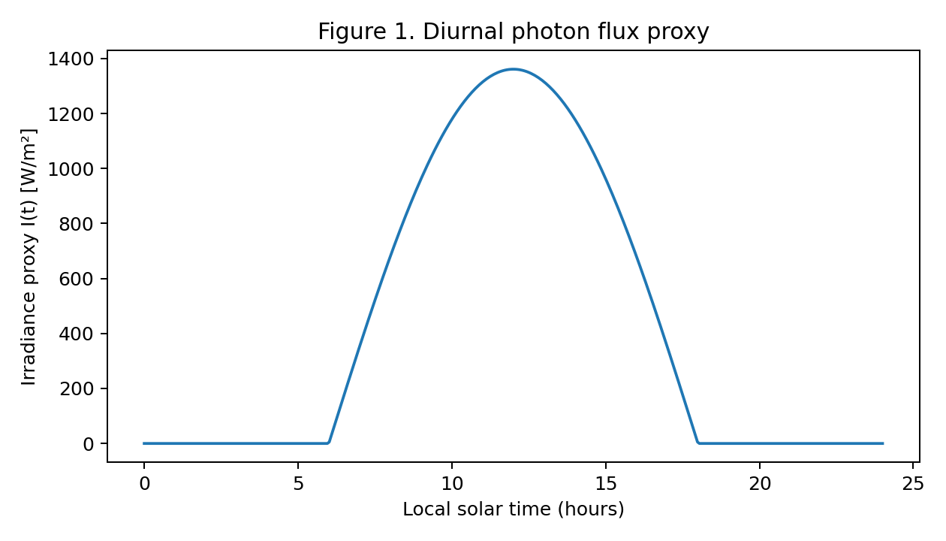
Figure 1. Diurnal photon flux proxy. This plot shows how irradiance varies across a day in a simple idealized model. The point is not to claim exact atmospheric data from this one curve; the point is to visualize that usable photon flux is a structured time signal rather than a static constant.
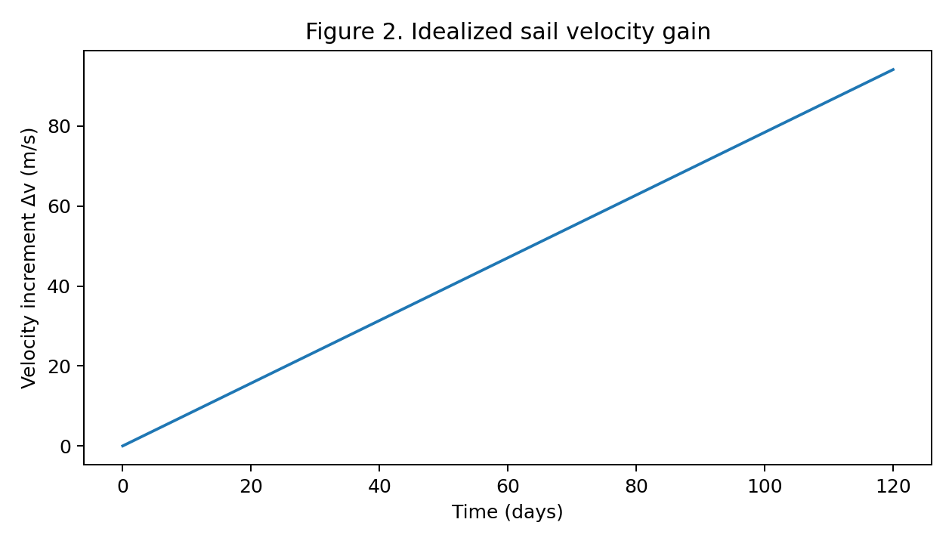
Figure 2. Idealized sail velocity gain. A nearly constant low acceleration creates a steadily increasing velocity increment over long durations. This is the operational logic of solar sail and beam-assisted sail concepts.
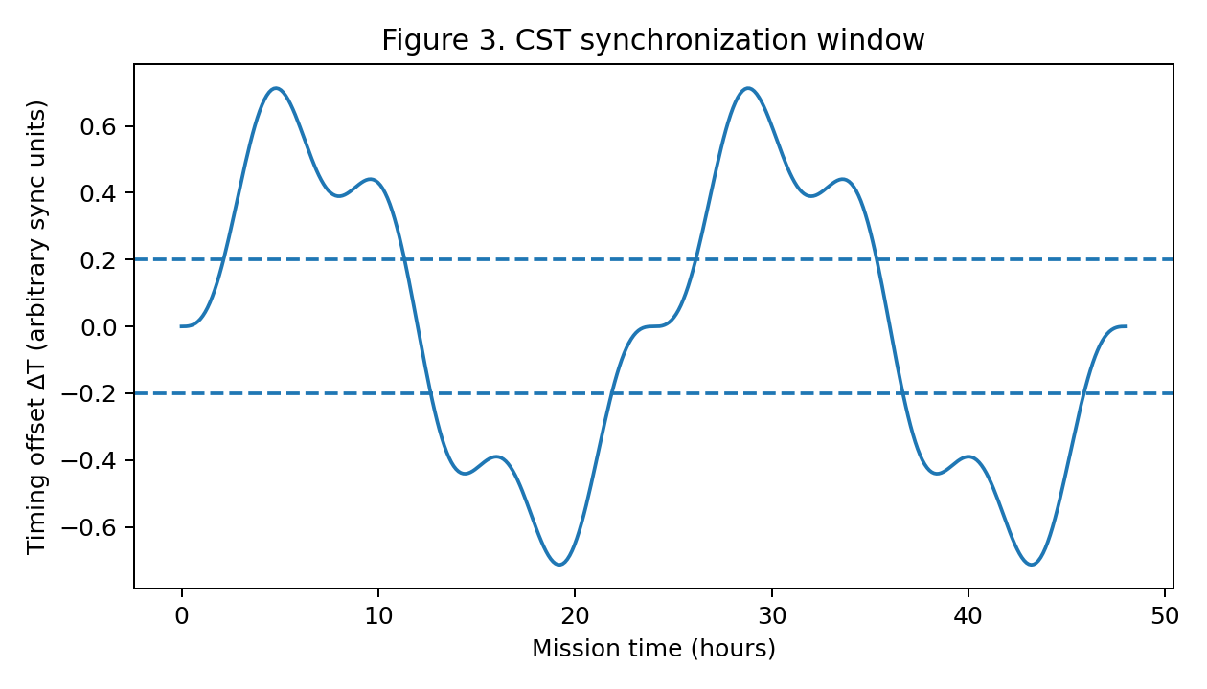
Figure 3. CST synchronization window. The plotted timing offset DeltaT is shown against a notional acceptable synchronization band. In this paper CST is used only as a control concept: if timing error remains bounded, guidance and environmental alignment stay more stable.

7. Variability and Uncertainty (what the simple model leaves out)
A serious engineering paper should say what its simplified equations do not capture. This section prevents overclaiming.
- Atmospheric attenuation changes the delivered surface irradiance relative to top-of-atmosphere values.
- Spectral distribution matters because real sunlight is broadband, not monochromatic.
- Clouds, aerosols, and albedo changes alter local and time-dependent photon availability.
- Solar activity changes ultraviolet, extreme-ultraviolet, and X-ray flux much more dramatically than visible flux, which matters for ionization, drag, and communication.
- Optical material degradation, pointing losses, finite reflectivity, and thermal effects reduce ideal sail performance.

8. Additional Photon Sources and What They Can Really Do
This section distinguishes realistic photon effects from exaggerated claims. Additional photons can come from natural variability, human-made beams, or reflective surface engineering.
Upper atmosphere and ionosphere: enhanced ultraviolet and X-ray input increases ionization, which can alter radio propagation and satellite drag.
Surface and near-space technology: high-power beams can produce local heating, ablation, or momentum transfer on small particles. Those are real effects, but they are scale-dependent and must be power-budgeted honestly.
Weather and climate scale: brief small visible-light changes usually do not dominate weather. Long-term broadband forcing or cloud and aerosol changes matter more.
Biological and materials exposure: wavelength and dose matter. Any beam-based concept must respect known safety and materials limits.

9. Applications to High-Speed Spacecraft (non-FTL)
This paper is not arguing for faster-than-light travel. Instead, it identifies where photon physics can support a high-speed spacecraft architecture that still obeys known physics.
Photon-assisted propulsion: sunlight or directed beams can add momentum gradually over long durations, especially for low-mass or large-area systems.
Timing and navigation: photons are the carriers of laser ranging, optical communication, pulsar navigation, and star tracking. They therefore act as both information carriers and timing anchors.
Forward-path conditioning: directed optical or microwave power might help clear dust, alter local plasma response, or perturb very small hazards ahead of a vehicle. The useful interpretation is path conditioning and risk reduction, not magic tunnel creation.
Hybrid mission logic: a practical high-speed vehicle may use high-thrust propulsion for departure and capture, then rely on photon-assisted or beam-assisted methods for continuous cruise gain, fine timing, and environmental management.

10. Careful CST Extension Layer (control, timing, and navigation only)
This is the CST extension layer added carefully so the paper stays grounded. Nothing in this section replaces general relativity, electromagnetism, or standard astrodynamics. CST here is introduced as a synchronization and control overlay that sits on top of conventional physics.
Core synchronization variable: DeltaT(t) = T_vehicle(t) - T_reference(t)
In practice, T_reference can be defined from a chosen timing source: onboard atomic time, Earth-referenced time, pulsar timing, solar geometry timing, or an optical beacon network. The engineering goal is to keep DeltaT bounded rather than letting timing drift accumulate freely.
A simple synchronization objective can be written as: J = w1*(DeltaT)^2 + w2*(dDeltaT/dt)^2 + w3*(DeltaI_mismatch)^2
Here J is a penalty function used by guidance or control software. The first term penalizes absolute timing mismatch, the second penalizes rapid timing drift, and the third penalizes operating away from preferred photon-environment windows. This is not new spacetime physics. It is an optimization layer.
A guidance-linked control law can then be written in compact form as: u(t) = -K1*DeltaT - K2*(dDeltaT/dt) - K3*grad(P_env)
In this expression, u(t) stands for a control action such as pointing adjustment, sail attitude trim, beam dwell correction, or navigation timing correction. The term grad(P_env) represents the gradient of an environmental cost or opportunity map, such as photon pressure quality, plasma stability, thermal load, or sensor quality.
For route selection, a mission can define an effective path cost: C_path = integral[(alpha*energy_cost + beta*timing_error + gamma*environmental_hazard) ds]
This is where CST can be connected to navigation without making extraordinary claims. The idea is that some trajectories, timings, or attitudes are more synchronized with the environment than others. Those routes may reduce correction load, reduce heating peaks, improve sensor lock, or improve long-duration momentum accumulation.
A weak-field analogy can also be written in engineering language: if a vehicle cannot change spacetime itself, it can still change how well it synchronizes with an already structured environment. In that sense CST behaves as a timing-and-alignment strategy, not a claim of metric engineering.
This framing keeps the paper acceptable because it treats CST as a systems-engineering layer. The novelty lies in using structured timing and environmental maps together, not in asserting unsupported new field equations.

11. What this means for warp-navigation language
If the term warp is used at all, it should be used carefully. A safe phrasing is that photon timing, plasma conditions, and trajectory alignment may support advanced navigation geometries or field-structured transit concepts in a control-theoretic sense. The paper should avoid claiming that photons alone create faster-than-light motion or literal spacetime tunnels.
A stronger and safer claim is this: better synchronization with environmental timing layers can reduce waste, reduce correction burden, and increase mission stability. That claim is testable with simulation and, in some cases, with lab or mission data.

12. Reference Page (established equations and what they prove)
Equation | Meaning | What it proves
E = h*c/lambda | Photon energy from wavelength | Photon energy is measurable and scales inversely with wavelength
p = E/c | Photon momentum | Light can transfer momentum even without rest mass
Phi = I/E | Photon rate from irradiance | Power-per-area can be converted into particle arrival rate
P = I/c or 2I/c | Radiation pressure | Light can produce force on surfaces
F = P*A | Force from pressure over area | Surface design matters directly for propulsion or loading
a = F/m | Acceleration from force | Photon effects can be translated into Delta v predictions
I(t) = I0 + DeltaI_day + DeltaI_season + DeltaI_solar | Neutral rhythm model | Environmental photon input has structured time dependence
DeltaT = T_vehicle - T_reference | CST synchronization variable | Timing mismatch can be measured and controlled

13. Conclusion
Photons provide a clean bridge between theory and measurable engineering effects. With E = h*c/lambda, Phi = I/E, and P = I/c, a designer can estimate energy, particle count, momentum transfer, force, and long-duration velocity gain.
The neutral rhythm concept strengthens that framework by showing that photon environments are time-structured rather than static. The CST extension added here remains conservative: it uses synchronization, timing penalties, and environmental alignment as guidance tools layered over standard physics.
Taken together, these ideas support a realistic message: photons are not a fantasy propulsion source, but they are a real, measurable, and strategically useful part of future high-speed mission architectures when combined with honest power budgets and control logic.

Selected References
- Einstein, A. (1905). On a heuristic viewpoint concerning the production and transformation of light.
- Kopp, G. and Lean, J. (2011). A new, lower value of total solar irradiance.
- ASTM G173. Reference solar spectral irradiance: air mass 1.5.
- ANSI Z136. Laser safety standards.
- IEC 60825. Safety of laser products.

