Photon’s Neutral Rhythms, and Synchronization: A Calculation-Driven Framework for Earth and Near-Space Environments
Photons, as quanta of the electromagnetic field formally established by Albert Einstein, carry discrete energy and momentum while propagating at the invariant speed of light. Their measurable interaction with matter provides a direct bridge between quantum theory, classical electrodynamics, and engineering applications. This work presents a calculation-driven framework that preserves established photon physics while introducing a temporal synchronization model linking photon flux to Earth’s cyclic environmental structure. The objective is not to redefine photon behavior, but to reorganize it within a measurable timing framework that connects energy transfer, environmental modulation, and engineered systems.
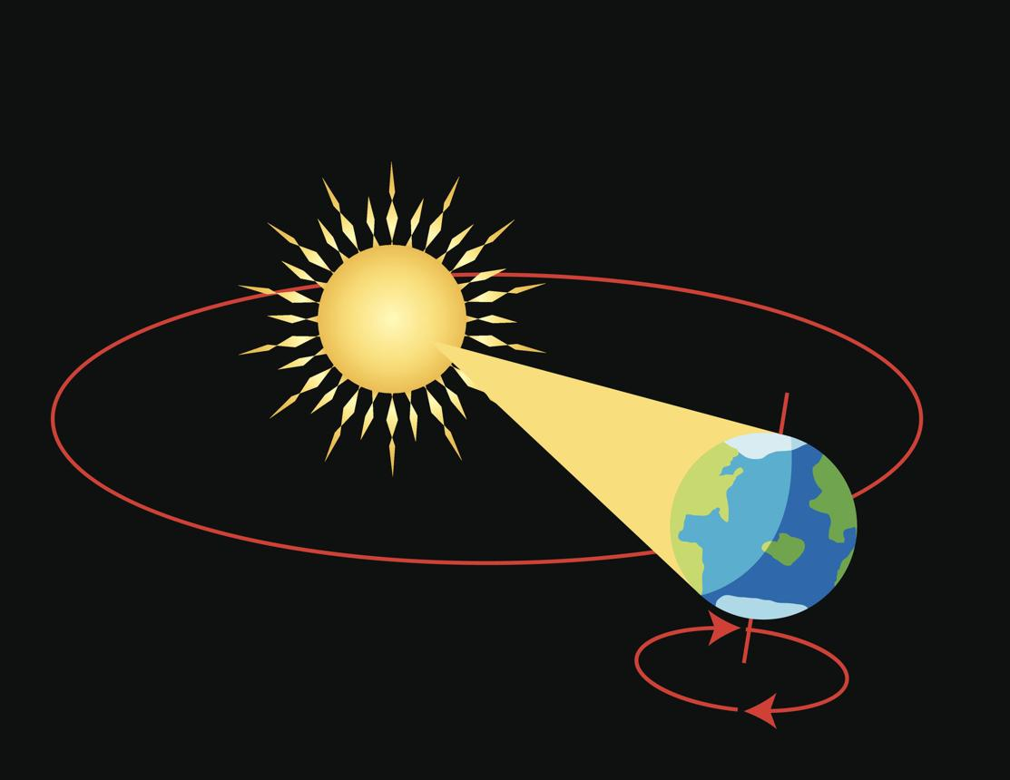
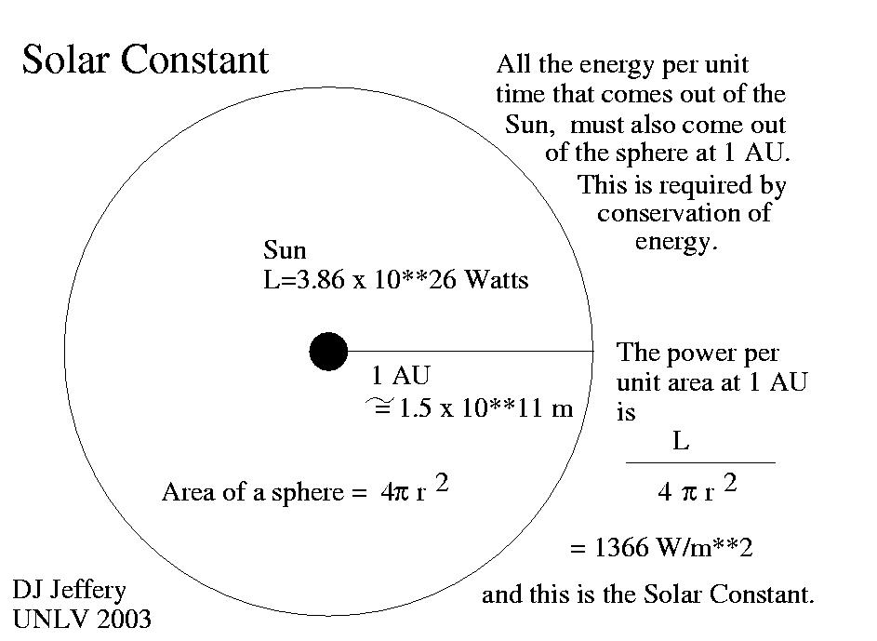

Photon energy follows the Planck–Einstein relation, linking frequency and wavelength to quantized energy transfer, while momentum is defined through relativistic relationships. These principles are foundational to quantum electrodynamics and are supported by extensive experimental validation, including radiative transfer models and solar spectral measurements such as ASTM G173. Observational datasets maintained by NASA confirm that the solar constant near Earth averages approximately 1361 watts per square meter, establishing a baseline for photon flux calculations. Additional long-term atmospheric and solar variability data from NOAA demonstrate that photon flux is not static, but varies in structured and predictable ways.
This study formalizes the concept of a neutral rhythm as a temporally structured modulation of photon flux resulting from Earth’s rotation, orbital dynamics, and solar activity cycles. Rather than treating irradiance as a constant or averaged value, the framework introduces a synchronization function that captures these periodic variations. The neutral rhythm is therefore defined as a continuous temporal signal composed of overlapping harmonic components associated with diurnal rotation, seasonal solar geometry, and solar-cycle variability. This transforms photon flux from a static engineering parameter into a time-dependent variable that can be analyzed using periodic functions and measured with high temporal resolution.
The central theoretical contribution of this work is the formulation of an effective photon flux that incorporates synchronization. In this model, photon arrival rates are modulated by a temporal function representing Earth’s environmental cycles. This allows photon flux to be treated not only as a magnitude but as a structured waveform evolving over time. The framework aligns with established physical laws while extending their application into a synchronized domain where timing becomes an active parameter in analysis and design. The result is a unified approach that connects photon energy transfer with temporal structure in a measurable and testable manner.
Engineering implications emerge directly from this formulation. Radiation pressure, though extremely small in magnitude, becomes a predictable time-varying force that follows solar geometry and atmospheric conditions. Over extended durations, these micro-forces accumulate, producing measurable changes in momentum for spacecraft and exposed surfaces. This principle is consistent with solar sail experiments and precision metrology studies in optical trapping, where photon momentum transfer has been experimentally verified. Similarly, photon-driven ionization in the upper atmosphere varies with synchronized solar exposure, influencing radio propagation, satellite drag, and ionospheric density. These effects are well documented in space weather research and provide a direct experimental pathway for validating the synchronization model.
The framework also extends to controlled photon environments. Directed electromagnetic systems, including high-power laser and microwave sources, can locally modify photon flux and produce measurable physical effects such as heating, ablation, and momentum transfer. When analyzed through the synchronization model, these engineered photon inputs can be aligned with natural cycles to enhance efficiency and reduce unintended interference. This creates a unified perspective in which both natural and artificial photon sources operate within the same temporal structure.
To establish scientific validity, the framework produces explicit testable predictions grounded in measurable phenomena. Surface photon flux should exhibit harmonic variation consistent with Earth’s rotation and solar angle, observable using calibrated radiometric instruments. Radiation pressure on reflective surfaces should vary in direct correlation with solar incidence angle, producing periodic force signatures detectable with sensitive instrumentation such as micro-cantilevers. Upper atmospheric ionization levels should show synchronized variation with solar flux intensity, particularly during periods of increased solar activity. These predictions align with existing observational capabilities and provide clear opportunities for experimental verification or falsification.
The framework is constrained by established physical limits. Photon energy and momentum remain governed by quantum and relativistic principles, and no assumptions are made that violate conservation laws. Radiation pressure remains on the order of micro-Pascals under typical solar conditions, ensuring that its effects are gradual rather than instantaneous. Atmospheric and climatic impacts from short-term photon variations are limited, with significant changes requiring sustained and large-scale energy inputs. These constraints reinforce that the proposed model operates entirely within accepted physics while extending its interpretive structure.
The originality of this work lies in its integration of temporal synchronization with photon flux modeling. Rather than introducing new physical laws, it reorganizes established principles into a coherent framework in which timing becomes a central variable. This perspective aligns with modern precision measurement systems and timing-based control architectures, where synchronization across reference frames enhances predictability and system stability. Within this framework, photon flux is not only a carrier of energy and momentum but also a structured temporal signal that can be measured, predicted, and utilized.
In conclusion, photons provide a direct and measurable connection between theory and engineering practice. By embedding photon behavior within a synchronized temporal framework, this study transforms a static description into a dynamic system governed by predictable environmental rhythms. The neutral rhythm model offers a pathway for integrating environmental observation, engineering application, and timing-based analysis within a unified structure. This approach remains fully grounded in established physics while opening new directions for experimental validation and practical implementation.

References
Albert Einstein. On a heuristic point of view concerning the production and transformation of light. Annalen der Physik.
NASA. Total Solar Irradiance measurements and solar constant datasets.
NOAA. Solar cycle, atmospheric, and ionospheric observational data.
ASTM International. Standard G173 Solar Spectral Irradiance (AM1.5).
Planck, Max. On the theory of energy distribution in the normal spectrum.
Jackson, John David. Classical Electrodynamics.
Rybicki, George B., and Lightman, Alan P. Radiative Processes in Astrophysics.

Figure 1. Idealized daylight cycle of relative surface photon flux. Real curves depend on latitude, season, clouds, and aerosols.
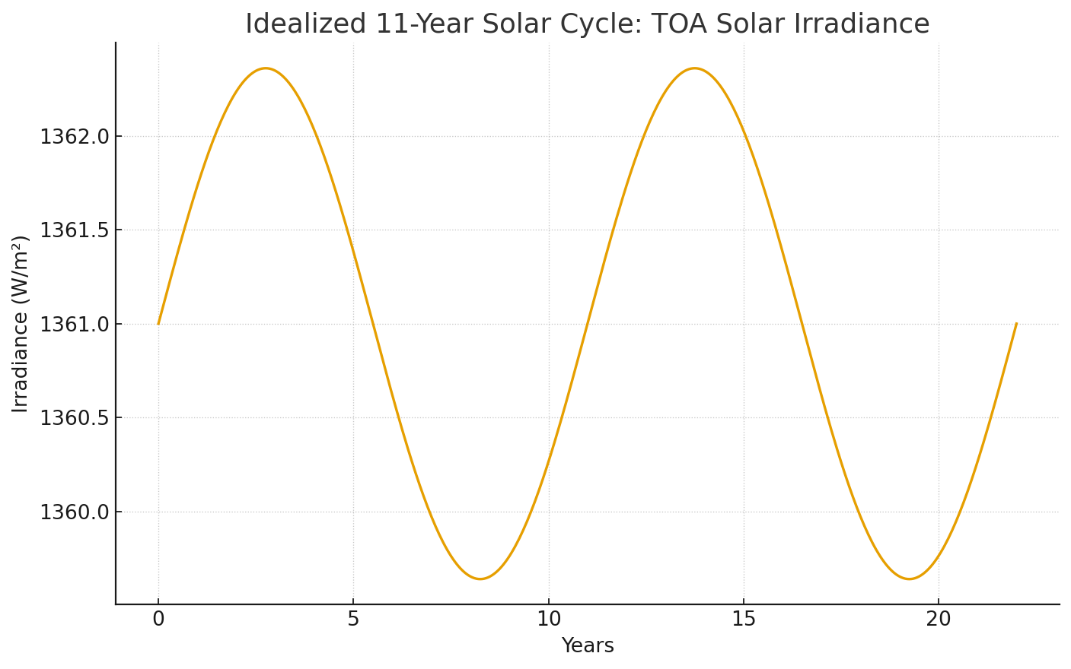
Figure 2. Simplified 11‑year variation (~±0.1%) in top‑of‑atmosphere solar irradiance (≈1361 W/m² baseline). 