Cosmic Clock Hypothesis: Humanity’s Deep Past and Resets

This document presents the Cosmic Clock hypothesis in a professional format. It argues that humanity’s existence may extend far deeper into the past than recognized, with catastrophic events acting as periodic resets of civilization. Although fossils and artifacts are often erased by geological recycling, population modeling suggests that human survival through bottlenecks was possible. The Cosmic Clock framework integrates astronomical cycles, day length changes, and catastrophic resets into one continuous narrative.

# Earth Recycling and Timeline of Events

The diagram below illustrates Earth’s history, recycling events, and the Cosmic Clock perspective. The colored bars represent surface eras, while the blue line shows changes in Earth’s day length over billions of years.

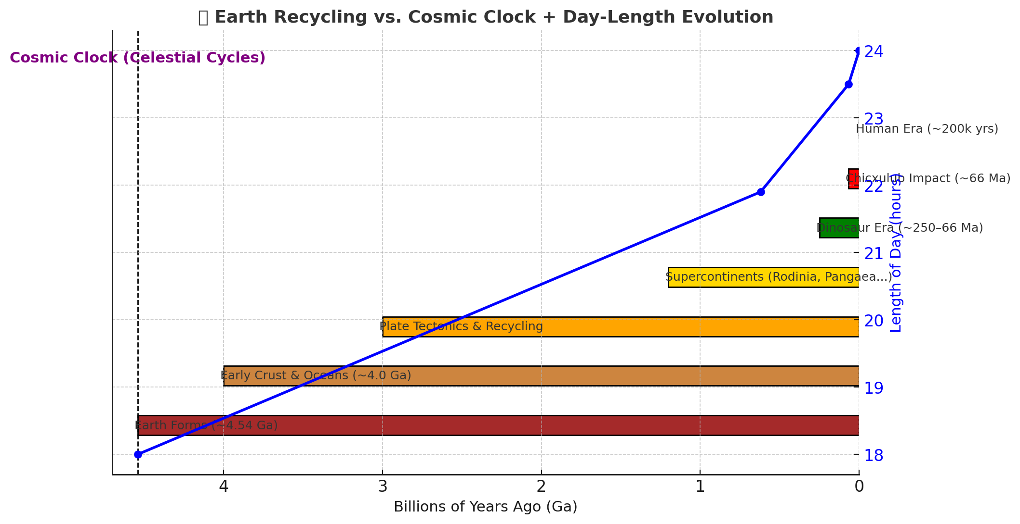

# Population Bottlenecks and Survival

Human survival across deep time depends on passing through repeated population bottlenecks. Genetic studies suggest that as few as 5,000–10,000 breeding adults (20,000–50,000 total individuals) would be sufficient for long-term survival. If humanity reached billions in the past, catastrophic events like asteroid impacts, pandemics, or volcanic winters could have reduced us to isolated survivors. From these refuges, populations recovered, creating new branches of humanity adapted to their regions.

# Fossil Record and Erasure

The scarcity of fossils does not disprove deep-time humanity. Fossilization is rare, and geological processes like erosion and subduction erase most traces older than a few hundred million years. If humans or human-like beings existed billions of years ago, their remains could have been completely recycled.

# The Cosmic Clock Cycles

The Cosmic Clock links astronomical and geological cycles to resets:  
- ~620 Ma: Earth had ~400 days/year (21.9-hour days).  
- ~66 Ma: ~372–374 days/year (23.5-hour days), Chicxulub impact.  
- Today: 365.24 days/year (24-hour days).  
This framework connects changes in Earth’s spin and cosmic cycles to the survival and resetting of humanity.

# Hypothesis Summary

Humanity may have existed billions of years ago, repeatedly reset by catastrophic events. Each reset reduced populations to small groups, which later repopulated the Earth. This mirrors creation myths like Adam and Eve: survival of a few leading to global repopulation. The Cosmic Clock suggests that humanity’s tree is far larger than the preserved fossil record shows.