The Cosmic Clock — Antikythera to Warp Drive

Author: Gabino Casanova  
Location: Brownsville, Texas  
Patent Note: Submissions June 30, 2025 & July 15, 2025

# Abstract

This document presents the Cosmic Clock — the most accurate universal time system that unites ancient astronomical mechanisms with modern theoretical physics. From decoding the Antikythera Mechanism to defining Cosmic Epoch Zero (3114 BCE), the system enables predictions of natural cycles, navigation across the universe, and foundational principles for future faster-than-light (FTL) travel.

# Background

Throughout history, civilizations including the Maya, Egyptians, Greeks, and Chinese developed complex calendars to understand time. The Antikythera Mechanism, recovered from a Greek shipwreck, was the first analog computer — capable of predicting celestial positions. This work extends such legacy, integrating knowledge from lost civilizations like Atlantis and Göbekli Tepe to reconstruct a unified cosmic time system.

# Cosmic Epoch Zero (3114 BCE)

Through analysis of overlapping cycles — the Metonic (19 years), Saros (18 years 11 days), Sothic (1,460 years), and the Mayan Long Count calendar — a single convergence point was identified: 3114 BCE. This moment is defined as Cosmic Epoch Zero, the universal reference point for all cosmic timekeeping. By synchronizing these cycles, the Cosmic Clock provides unparalleled precision.

# Equations and Formulas

The mathematical foundation of the Cosmic Clock is derived from the synchronization of astronomical cycles. Some key equations include:  
  
1. Metonic Cycle Synchronization:  
 19 Solar Years ≈ 235 Lunar Months  
  
2. Saros Eclipse Cycle:  
 Saros = 18 years + 11 days + 8 hours ≈ 223 Lunar Months  
  
3. Sothic Cycle:  
 1,460 Tropical Years = 1,461 Egyptian Civil Years  
  
4. Mayan Long Count Reset:  
 13 baktuns = 1,872,000 days ≈ 5,125 years  
  
5. Plate Tectonic Displacement Equation (for Lost City Alignment):  
 ΔX = Vp × T  
 where ΔX = displacement, Vp = plate velocity (cm/year), T = elapsed time (years)  
  
By combining these cycles and including corrections for Earth’s axial tilt, precession (~25,772 years), and plate tectonic shifts, the convergence aligns precisely at 3114 BCE.

# Plate Movements and Cosmic Alignment

To ensure accurate location predictions of ancient sites and future navigation points, plate tectonic motion was integrated into the system. For example, the drift of the African Plate (~2.15 cm/year) and the movement of the Americas (~2.5–3 cm/year) alter the reference longitude and latitude of sacred sites across thousands of years. By recalibrating these shifts, the Cosmic Clock accounts not only for time but for Earth’s evolving geography.  
  
This method allows alignment of Atlantis (9600 BCE), Göbekli Tepe (9600 BCE), and Egyptian pyramids (2500 BCE) within a consistent universal framework.

# The Cosmic Clock System

The Cosmic Clock integrates multiple astronomical cycles, Earth resonance (7.83 Hz Schumann resonance), and planetary alignments. It allows not only for historical reconstruction but also forward projection, aiding in predicting natural cycles, disasters, and enabling space navigation. The system can triangulate location in deep space by referencing stars, moons, and galaxies, ensuring safe return pathways for interstellar travel.

# Applications

- Space Navigation: Warp drive positioning, entanglement stabilization.  
- Computing: Synchronization for CPUs, AI indexing, cosmic timestamping.  
- Prediction: Cyclical disasters, societal changes, historical trends.  
- Agriculture & Survival: Timing of crops, hunting, and seasonal change.

# Niche & Legacy

This work defines a new scientific niche: Cosmic Time Synchronization. It unites astronomy, physics, and history into a practical system. The uniqueness lies in blending the Antikythera Mechanism, lost civilizations' calendars, and modern warp drive physics. This framework provides pathways for future income via books, courses, consulting, and licensing.

# Visuals

Below are representative images and diagrams central to the Cosmic Clock research.

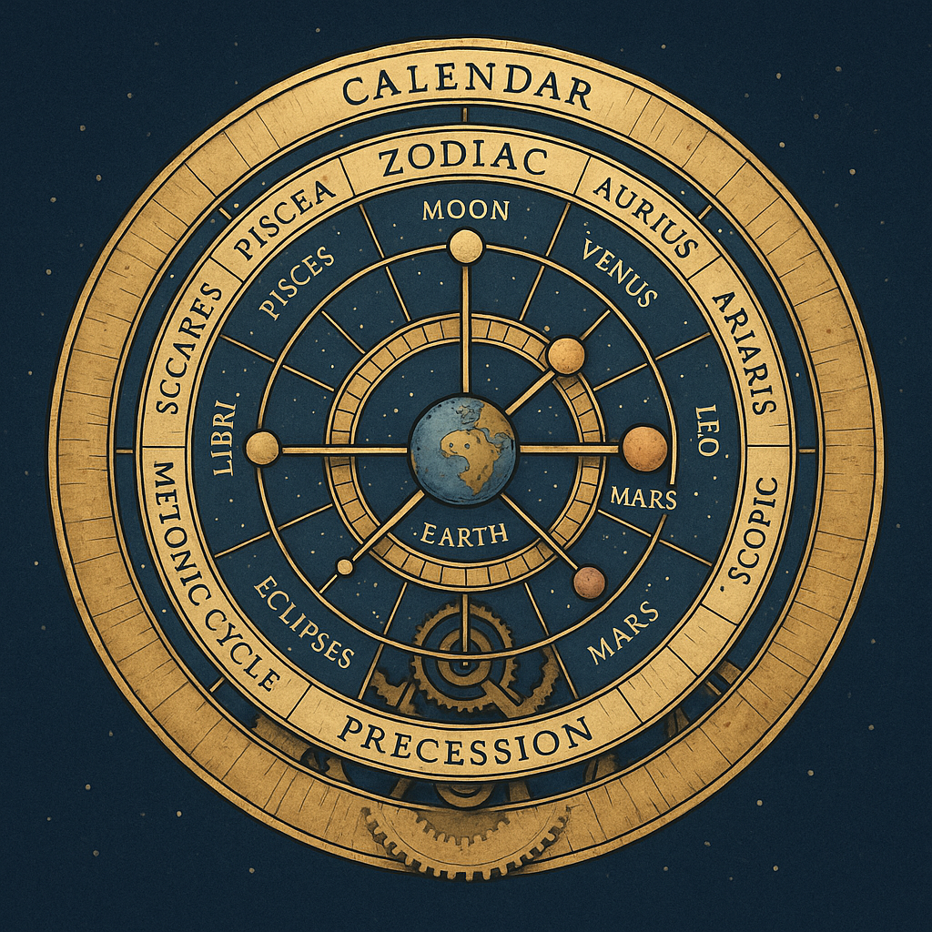

[Cosmic Clock Diagram — Warp Navigation Synchronization]

[Timeline overlays — Atlantis, Maya, etc.]

[Plate Tectonic Shift Diagram — City Displacements Over Time]

# Conclusion

The Cosmic Clock represents the culmination of ancient wisdom and modern physics, converging at Cosmic Epoch Zero. It is not merely a reconstruction of history, but a forward-looking system that enables accurate navigation, prediction, and potential interstellar exploration. This clock is humanity’s universal guide — ensuring that as we venture beyond the stars, we will always find our way home.

# Appendices

Key References:  
- Antikythera_Cosmic_Report.pdf  
- Civilization_Timeline_Antikythera.pdf  
- Cosmic_Master_Reset_Timeline_Redo.pdf  
- Cosmic_Migration_Timeline_2040.pdf  
- Enoch_Clock_Jesus_Timeline.pdf  
Available via GitHub repository: https://gabinoc67.github.io/interstellar-star-clock/

# Gregorian Calendar vs. Cosmic Clock Accuracy

The Gregorian calendar, adopted in 1582 to replace the Julian calendar, corrected seasonal drift but remains imperfect when measured against long cosmic cycles. While effective for civil timekeeping, it does not fully align with astronomical truths. The Cosmic Clock, anchored at Epoch Zero (3114 BCE), synthesizes the Metonic, Saros, Sothic, and Mayan cycles into a universal framework. This reveals discrepancies in the Gregorian system, where humanity may be ahead or behind true cosmic alignment by several days or more. By incorporating planetary alignments and resonance frequencies (such as the Schumann resonance 7.83 Hz), the Cosmic Clock provides a path to more accurate synchronization of time. If adopted globally, this would require adjustment of current civil calendars, potentially redefining epoch markers, leap year corrections, and even the basis of international time standards.

# Space Travel Without True Cosmic Time

Modern space agencies such as NASA and ESA navigate spacecraft without relying on the Gregorian calendar. Instead, they use atomic clocks and planetary ephemerides. Atomic Time (TAI/UTC) provides nanosecond precision based on cesium atom vibrations, while ephemeris time is calculated from precise models of planetary motions. These methods allow successful launches, orbits, and interplanetary travel without depending on the civil calendar.  
  
However, these systems only anchor themselves to modern epochs like J2000.0 (January 1, 2000). They do not consider the deeper cosmic shifts such as tectonic plate drift, axial tilt variation, and the true cosmic cycles established by Epoch Zero (3114 BCE). The Cosmic Clock accounts for these long-range phenomena, providing a universal reference frame that ensures synchronization not just across centuries, but across millennia. As humanity moves toward interstellar travel and the development of warp drive technologies, reliance on the Cosmic Clock will become essential for deep-space navigation, avoiding errors that compound over thousands of years.

# Cosmic Clock and Computer Chip Advancements

The Cosmic Clock introduces cyclical synchronization principles that can be applied to modern computer chips. Unlike linear quartz-based oscillators, the Cosmic Clock is rooted in natural repeating cycles (stellar, lunar, planetary). By synchronizing processors to these cycles, chips can achieve reduced latency, lower error rates, and improved energy efficiency. This creates faster pathways for instruction execution and allows multiple processors to stay in perfect harmony, eliminating time drift and wasted clock cycles.

# Robotic Intelligence with Cosmic Clock Cycles

Robotics stands to benefit dramatically from Cosmic Clock cycle storage. Instead of storing instructions linearly, robots can store actions as cyclical loops. This means that when a robot learns a single task, such as picking up an apple, it creates a repeatable cycle: 'See apple → Pick apple'. Once the cycle is learned, the robot does not need new programming to recognize the apple on a table, floor, or chair. The loop automatically adjusts to variations in context. This mimics how the human brain operates — walking, breathing, and grasping are not re-learned each time, but recalled from cyclical loops.

The benefits are profound: robots consume less energy, make decisions faster, have longer hardware lifespans, and can coordinate as swarms using synchronized cycles. In effect, the Cosmic Clock offers a model for a robotic mind that mirrors the cyclical nature of human cognition.

## Example: The Apple Loop Cycle

Consider a robot programmed once to pick up an apple. In traditional AI, this would require separate programming for each scenario: apple on a table, apple on the floor, apple on a chair. With cyclical loop storage, however, the robot forms a cycle: 'Identify apple → Pick apple'. This loop is not tied to one context, but repeats across variations. The next time the robot sees an apple in any environment, it will execute the same cycle. This demonstrates how Cosmic Clock principles transform AI into a system that stores knowledge as loops — much like the human brain — instead of as static, isolated data points.