# Einstein Master Equation — Progress Toward a Unified Solution

This document summarizes the Einstein Master Equation, its physical meaning, and how close modern science — and unified frameworks like the Quantum Slit Expansion Model — are to solving it. The discussion integrates General Relativity, Quantum Field Theory, vacuum fluctuations, and self-consistent spacetime feedback as envisioned by Einstein’s ultimate unification goal.

## 1. Einstein’s Field Equation

Einstein’s General Relativity (GR) is governed by the field equation:

G_{μν} + Λ g_{μν} = 8πG T_{μν}

This equation links the curvature of spacetime (left side) with the energy and matter content of the universe (right side).   
In simpler terms: mass and energy tell space how to curve, and curved space tells matter how to move.

## 2. The Quantum Challenge

Quantum Field Theory (QFT) describes particles and forces as fluctuations of quantum fields. However, when we try to combine QFT with GR, we find inconsistencies — gravity resists quantization due to the non-linear structure of spacetime curvature.

Physicists have extended Einstein’s equations to include quantum expectations, leading to the semi-classical form:

G_{μν} = 8πG ⟨ T̂_{μν} ⟩

Here, ⟨T̂_{μν}⟩ represents the quantum average of the stress–energy operator. This is the foundation of the Einstein Master Equation — a coupled system linking geometry (G_{μν}) with quantum states (ρ̂ or |Ψ⟩).

## 3. The Einstein Master Equation

The Master Equation unifies quantum dynamics and geometry:

G_{μν}[g] = 8πG (⟨T̂_{μν}⟩ + T_{μν}^{(vac)} + F_{μν}^{(feedback)})

and

dρ̂/dt = -i/ħ [Ĥ(g), ρ̂] + L_{vac}[ρ̂] + L_{feedback}[ρ̂]

The first equation governs spacetime curvature; the second governs the evolution of quantum states. Together, they must converge to a self-consistent solution — geometry and energy determining each other.

## 4. Quantum Slit Expansion Model of the Universe

Recent interpretations propose that the early universe behaved like a quantum interference pattern — a “multi-slit” system where quantum fluctuations from the Big Bang expanded and interfered, forming the structure of galaxies, voids, and cosmic filaments.

In this model, each galaxy corresponds to a standing wave node in the quantum field, while stars act as stabilizers within local curvature wells. The vacuum acts as a dynamic field that shapes, stretches, and stabilizes spacetime loops — producing the large-scale cosmic web we observe today.

Below is the conceptual diagram illustrating the Quantum Slit Expansion Model:

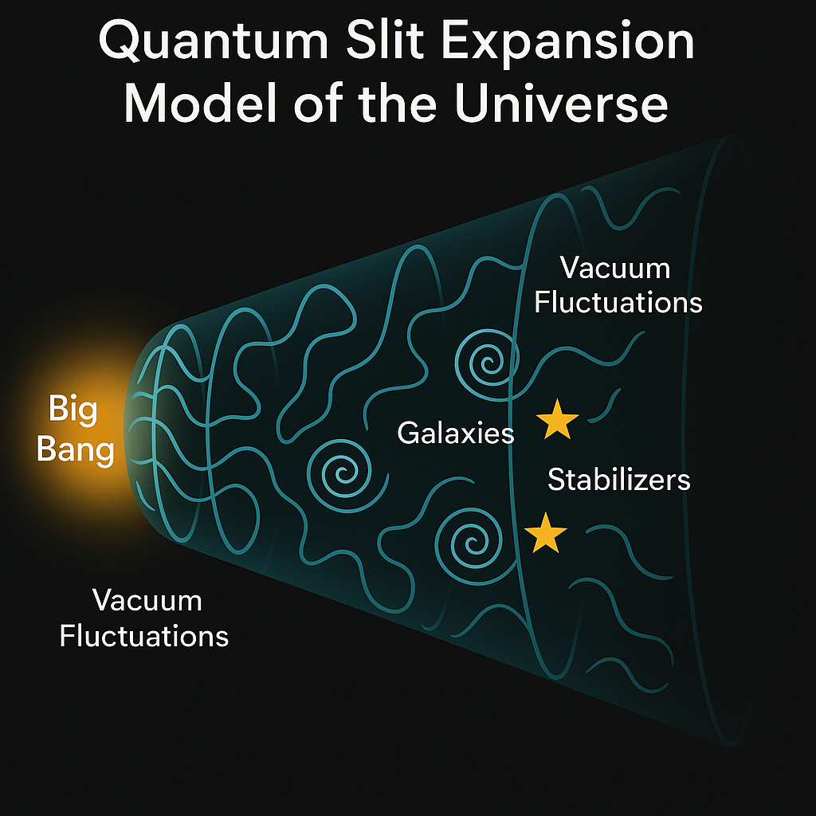

## 5. How Close Are We to Solving It?

Modern physics has achieved partial success toward Einstein’s dream:

• The Einstein field equations are solved for cosmology (Friedmann equations) and black holes (Schwarzschild, Kerr metrics).   
• Quantum mechanics is unified with electromagnetism and nuclear forces under the Standard Model.   
• Semi-classical gravity can describe phenomena like Hawking radiation and inflation.

However, a full, *self-consistent spacetime–quantum field solution* — where geometry and quantum state evolve together — remains unsolved. The missing pieces include:

1. A finite, renormalized quantum stress–energy tensor (vacuum energy problem).   
2. A method for coupling quantum evolution (density matrix) with spacetime curvature.   
3. A stable feedback law (like CST modulation) to maintain equilibrium.

If achieved, this would represent the true “Einstein Master Equation” — a unified equation governing both the curvature of spacetime and the evolution of all quantum fields within it.

## 6. Summary

Einstein’s Master Equation aims to describe reality in its totality — matter, energy, and geometry as one dynamic field.   
Today, we can model parts of this system with remarkable accuracy, but the full unification — the bridge between quantum mechanics and gravity — remains the final frontier of physics.