# Photon–Wave Duality, Klein Topology, and Gaussian–Lotus Geometry in Warp Drive Navigation

This document unifies principles from quantum mechanics, electromagnetism, and complex geometry to illustrate how light’s dual nature, topological field control, and harmonic wave modulation can assist in warp-drive design and navigation. The concepts include particle–wave duality, Lorentz-deflected beams in Helmholtz configurations, Klein-bottle field topology, Gaussian integrals, Fourier harmonic control, conformal mappings, and lotus-equation energy routing.

## 1. Light as Particle and Wave

Light behaves simultaneously as a wave and a particle, carrying momentum p = h/λ despite zero rest mass. When interacting with structured electromagnetic or quantum fields, photons can exhibit effective inertial mass, forming polaritons or field condensates. This controllable effective mass allows light to shape and stabilize warp-field boundaries without mechanical thrust.

## 2. Beam Deflection and Helmholtz Coil Dynamics

According to the Lorentz force (F = q·v×B), an electron beam in a uniform magnetic field experiences a deflection following the left-hand rule. Helmholtz coil configurations produce near-uniform B-fields that allow for controlled plasma or photon guidance, forming the magnetic basis for warp field symmetry and feedback loops.

## 3. Klein Bottle and Non-Orientable Warp Topology

The Klein bottle represents a non-orientable topology—continuity without boundaries. Applied to warp-field geometry, it allows energy lines and entangled photon paths to circulate infinitely without discontinuities, achieving smooth phase transitions between interior and exterior spacetime zones. This continuity helps maintain field coherence in CST-synchronized warp bubbles.

## 4. Gaussian Integrals and Fourier–Conformal Stability

Gaussian integrals normalize energy densities and describe the smoothest possible beam envelopes. Fourier analysis decomposes field harmonics, while conformal maps translate curved space into solvable flat geometries. Together, they enable stable field computation and navigation algorithms that preserve phase and minimize energy loss during warp transitions.

## 5. Equation de Lotus and Energy Routing

The lotus equations r = a·sin(kθ) or r = a·cos(kθ) describe radial harmonic distributions, creating natural ‘petal’ patterns. By arranging warp coils or energy emitters in lotus symmetry, energy flows can be distributed evenly, balancing curvature stresses within the bubble. These patterns combine with Gaussian modulation to form standing-wave petals seen in advanced warp geometries.

## 6. Diagram: Klein Bottle Warp Field with Gaussian–Lotus Pulses

The diagram below visualizes a Klein-bottle field topology intertwined with Gaussian–Lotus harmonic pulses. It represents a unified field geometry where light, magnetic flow, and curvature harmonics form a coherent warp navigation system.

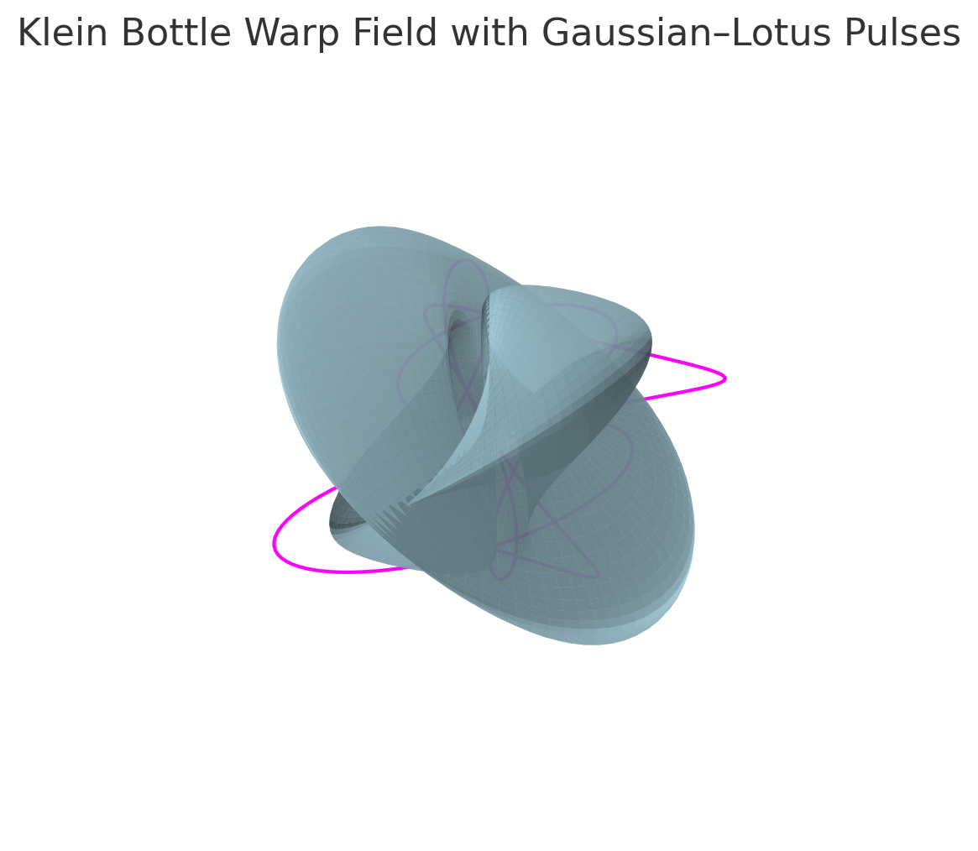

Figure 1. Klein-bottle warp-field model with Gaussian–Lotus pulse harmonics.