# Reversing the Re-Entry Equation for Warp Drive Launch and Navigation

This document explores how reversing the classical re-entry geometry used in NASA’s Mercury Program—famously checked by Katherine Johnson—could inspire new approaches to warp-drive launch and navigation from Earth without relying on conventional thrust. Because both entering and exiting a gravitational field inherently involve curved trajectories, the mathematics of ‘Go/No-Go’ zones may be inverted to design warp bubble emergence paths.

## 1. Classical Re-Entry Geometry

The original ‘Go/No-Go’ equations define the conditions under which a spacecraft transitions from orbit to the atmosphere. These conditions balance velocity, flight path angle, and altitude to ensure a safe re-entry. They rely on conic section geometry (ellipses, parabolas, hyperbolas) to model the capsule’s path under drag and gravity.

## 2. Reversing the Equation for Warp Drive Launch

If the re-entry equations are inverted, one obtains a mathematical framework for exiting a gravity well along a ‘least-resistance’ curvature. Instead of computing how to slow down and intersect the atmosphere safely, the reversed problem computes how to shape a warp bubble’s space-time curvature so the craft emerges smoothly into space without high-energy thrust.

This reversed equation could provide:  
- **Energy Minimization:** Identify the geometric corridor where warp-field activation requires the least power.  
- **Trajectory Pre-Shaping:** Pre-calculate the space-time curvature necessary to ‘surf’ out of Earth’s well.  
- **CST Synchronization:** Align the warp bubble’s phase with Earth’s rotation and orbital motion for stable emergence.

## 3. Benefits for Warp Drive Navigation

Using curved geometry rather than straight-line thrust provides a natural alignment with gravitational potentials. A warp drive tuned to these curves could:  
- Reduce inertial stress on passengers and equipment.  
- Minimize atmospheric disturbances or sonic booms.  
- Enable smoother transitions between CST-synchronized time frames.

## 4. Diagram: Go/No-Go Zones Reinterpreted for Warp Drive Launch

The diagram below shows the classical Go/No-Go zones for re-entry, which, when mathematically reversed, represent potential warp-bubble launch corridors out of Earth’s gravity well. By following these curves, a warp field could emerge with minimal force.

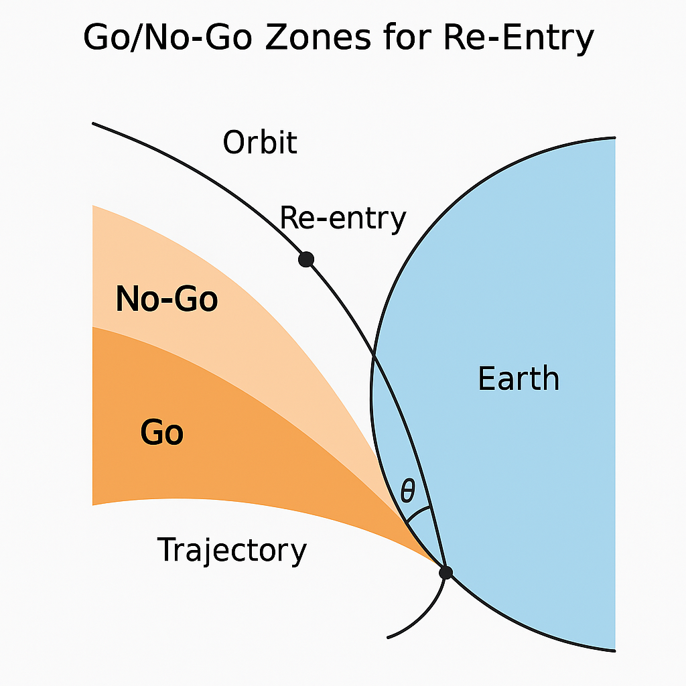

Figure 1. Classical Go/No-Go geometry reinterpreted as warp-drive emergence corridors.