# Sail Navigation from Ancient Civilizations to Modern GPS: The Evolution of Celestial and Global Navigation

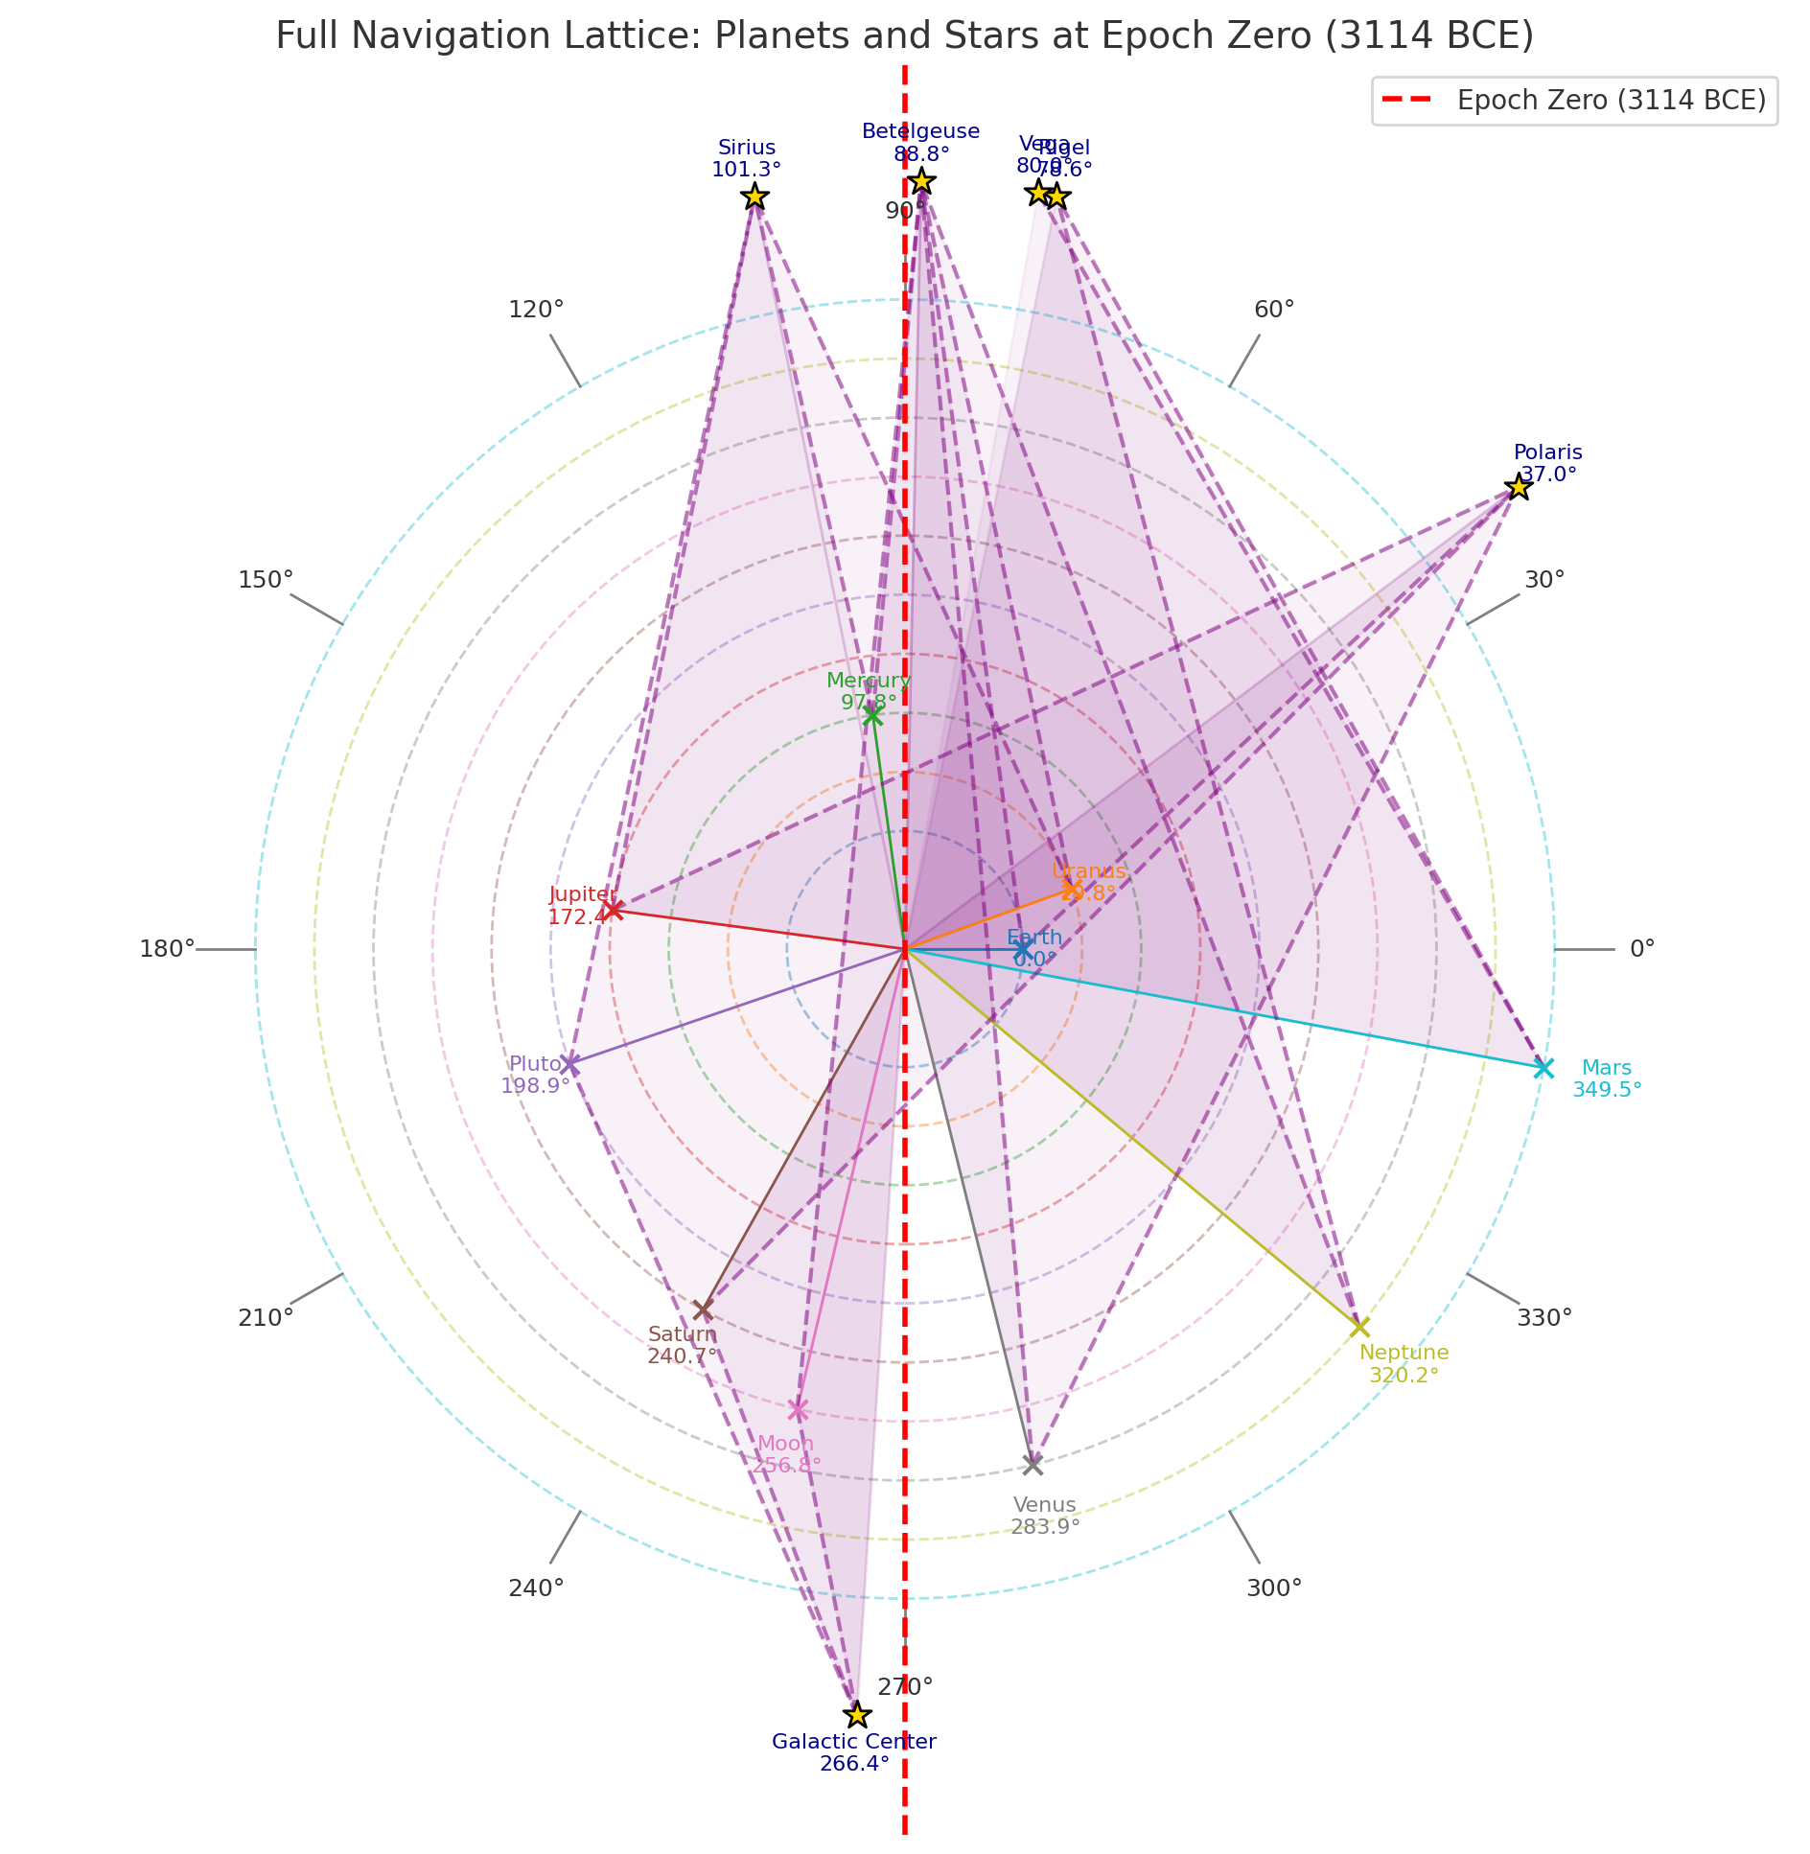

Full Navigation Lattice: Planets and Stars at Epoch Zero (3114 BCE)

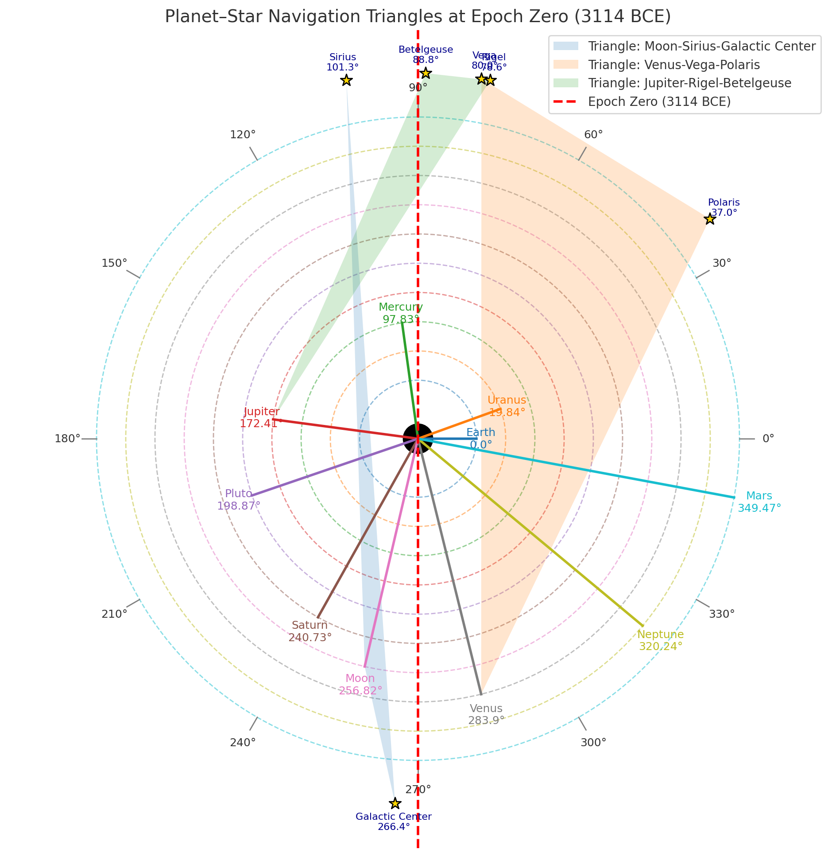

Planet–Star Navigation Triangles and Epochal Star Alignments

## Overview

Humanity’s mastery of navigation spans over 5,000 years—from shadow sticks and star compasses to chronometers and GPS satellites. The principles remain constant: triangulation, observation, and adaptation. Ancient navigators used celestial geometry—aligning the Sun, Moon, and stars to the horizon—to cross unknown oceans long before magnetic instruments existed.

## Ancient and Viking Navigation Tools

|  |  |  |
| --- | --- | --- |
| Tool | Function | Material/Type |
| Shadow stick (sun compass) | Finds latitude and north–south line | Wood + gnomon |
| Sunstone | Finds Sun direction under clouds | Iceland spar (calcite) |
| Stars & Moon | Direction and time | Natural celestial compass |
| Sea signs | Confirmed land proximity | Birds, currents, color, driftwood |

## 1. Ancient Civilizations and Early Ocean Routes

• **Egyptians (2000–1000 BCE):** Navigated the Red Sea and Mediterranean using the stars Orion, Sirius, and Canopus. Canopus, the second-brightest star, was a southern reference for voyages to Punt (modern Somalia). Latitude: ~15° N to 30° N.  
• **Phoenicians (1500–600 BCE):** Sailed around Africa and to Britain using Polaris and Ursa Major. Their star triangle: Polaris–Sirius–Canopus. Latitude range: 0° – 35° N.  
• **Greeks & Minoans (1600–500 BCE):** Used Arcturus, Spica, and Sirius to define sailing seasons. They introduced mathematical geometry to measure solar declination for latitude.  
• **Chinese Navigators (~1000 BCE):** Used Polaris for northfinding and early magnetic lodestones as direction indicators.  
• **Polynesians (Ancient to modern):** Used the rising and setting points of stars (e.g., Vega–Altair–Capella) as a living star compass, navigating thousands of miles across the Pacific.

## 2. The Viking Era (800–1100 CE)

Vikings expanded across the North Atlantic to Iceland, Greenland, and North America (~1000 CE). They used the **sun compass (Uunartoq Disc)**, **sunstone**, and **star triangles (Polaris–Vega–Deneb)** for direction. Their routes connected Norway (~63° N), Iceland (~64° N), Greenland (~61° N), and Newfoundland (~49° N). They practiced 'latitude sailing,' maintaining constant solar elevation at noon using the shadow board.

## 3. Classical Arab and Chinese Navigation (700–1400 CE)

• **Arab navigators** in the Indian Ocean used Polaris for latitude and developed the *kamal*, a simple wooden sighting tool for angular elevation. They connected East Africa, India, and China along monsoon routes between 15° S and 25° N.  
• **Chinese mariners** employed early magnetic compasses by the 11th century and stellar charts including Vega, Altair, and Deneb for orientation.

## 4. The Age of Exploration (1400–1800 CE)

European explorers such as Columbus, Magellan, and Cook combined celestial and magnetic navigation. The **sextant** and **chronometer** enabled accurate latitude and longitude determination. Key waypoints: Canary Islands (28° N, 15° W), Cape Verde (15° N, 23° W), Caribbean (~18° N, 65° W), and Cape Horn (~56° S, 67° W). They applied mathematical navigation using three-star fixes and lunar distance methods for longitude.

## 5. Modern and Satellite Navigation (1900 – Present)

By the 20th century, celestial navigation merged with radio and radar. WWII brought **radio direction finding** and **LORAN** (Long Range Navigation). By 1973, the **Global Positioning System (GPS)** was established, using at least three satellites for triangulation— a direct descendant of the ancient three-point celestial fix. GPS allows real-time tracking within ±5 m accuracy anywhere on Earth.

## 6. Celestial Triangles Through History

Across epochs, navigation relied on three reference points forming a geometric triangle:  
• **3114 BCE (Mayan Epoch Zero):** Venus–Vega–Polaris (latitude 0°, longitude 90° W – Yucatán; opposite 90° E – Sumatra).  
• **1000 CE (Viking Triangle):** Polaris–Vega–Deneb (~60° N, 20° W – North Atlantic corridor).  
• **1500 CE (Phoenician & Arab):** Polaris–Sirius–Canopus (0–30° N, Red Sea & Indian Ocean).  
• **Today (GPS):** At least three orbital satellites (20,000 km altitude) triangulate Earth position with millisecond timing accuracy.

## Summary and Global Coordinates

Navigation evolved from observing Sun shadows and star triangles to precise satellite triangulation. Each era followed the same principle: fix position by referencing three known points. The consistent geometric alignments include:  
  
• **Ancient Prime Crossing (Venus–Vega–Polaris):** Latitude 0°, Longitude 90° W (Yucatán)  
• **Opposite Meridian:** Longitude 90° E (Sumatra)  
• **Viking Corridor:** Centered near Latitude 61° N, Longitude 20° W  
• **Modern Reference (Greenwich):** Latitude 51.48° N, Longitude 0° (Prime Meridian)  
  
From the Egyptian sun-staff to Viking shadow boards, from sextants to GPS, humanity’s journey across oceans has always relied on triangles of light—whether drawn by stars, Sun, or satellites in orbit.