Transwarp Beaming and CST Navigation Stability

# 1. Adding Space Volume into the Navigation Model

In Alcubierre-style warp metrics, the metric tensor is modified:  
  
ds² = -c² dt² + (dx - vₛ(t) f(rₛ) dt)² + dy² + dz²  
  
Here f(rₛ) is a shape function describing the bubble. We explicitly parameterize the space volume inside the bubble:  
  
V_bubble(t) = ∫ sqrt(det(gᵢⱼ)) d³x  
  
This is the amount of space being 'carried'. It can be added to CST navigation equations as a space mass term:  
  
S(t) = ρ_space × V_bubble(t)

# 2. Incorporating Tunnel Curvature into CST Time Sync

CST time synchronizes clocks across the tunnel. If the tunnel's cross-section or curvature changes, the light-path length inside the bubble changes:  
  
Δt_CST = L_path(t) / c_eff(t)  
  
where L_path(t) = ∫ sqrt(gᵢⱼ dxⁱ dxʲ).

# 3. Space Usage Fraction

For a circle warp tunnel:  
  
A_circle = πR² (total cross-sectional area)  
A_bubble(t) = cross-section of actual curved space  
  
η(t) = A_bubble(t) / A_circle  
  
If η fluctuates, instabilities occur. Stable tunnels require η ≈ constant.

# 4. Relativistic / Transwarp Regime

In relativistic physics, speed is limited locally by c, but space shaping allows effective speeds beyond c. The warp factor depends on the bubble shape derivative:  
  
v_eff(t) = v_ship(t) + ẋ_bubble(t).

# 5. Suggested Combined Equation for CST Nav

Define a combined state vector:  
  
Ω(t) = [x(t), v_ship(t), V_bubble(t), η(t), Δt_CST(t)]ᵀ  
  
with dynamics:  
  
dΩ/dt = F(Ω, warp controls).

# 6. Stability Criterion

Require:  
  
|dη/dt| < ε, |dV_bubble/dt| < ε_V  
  
This ensures CST clocks and tunnel curves remain aligned and stable.

# Diagram

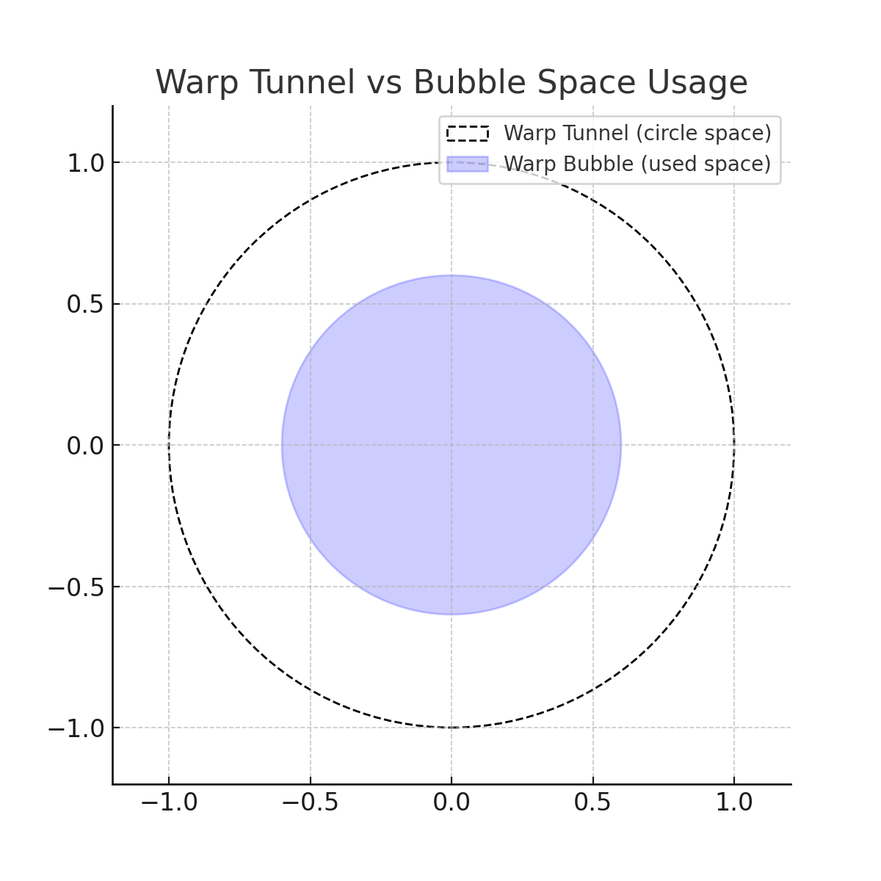

# Diagram (Labeled)

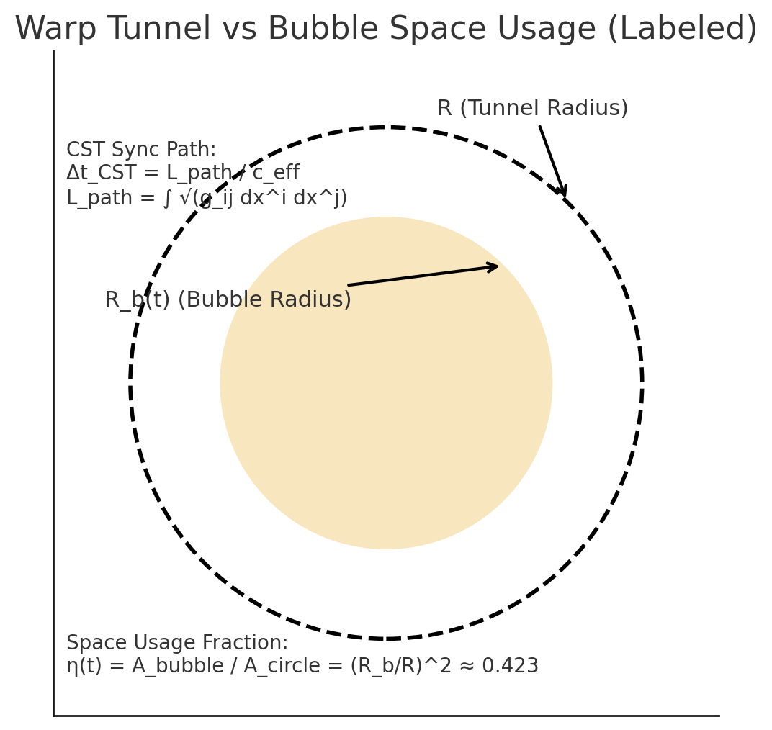

Figure 1. Warp Tunnel (outer circle, radius R) and Warp Bubble (inner disk, radius R_b). The shaded region is the ‘used space’ carried by the bubble. Stability requires η(t) = A_bubble/A_circle to remain ~constant, and CST sync uses Δt_CST = L_path/c_eff.