# Warp-Drive Energy Symmetry Engine

This document explains the conceptual foundation of the Warp-Drive Energy Symmetry Engine, based on energy–matter symmetry, vacuum field coupling, and CST time synchronization.

## 1. Energy–Matter Symmetry Loop

In classical and quantum physics, energy and mass are interchangeable according to Einstein’s equation, E = mc². This relationship forms the basis of pair creation and annihilation: high-energy photons can produce an electron–positron pair, and when they meet again, they annihilate to regenerate photons. This perfect reversibility creates an energy–matter symmetry loop.

## 2. The Vacuum as an Energy Reservoir

The quantum vacuum is not empty—it is filled with virtual particle pairs that constantly appear and disappear. If a warp drive can synchronize with these oscillations, it could momentarily access vacuum energy through quantum entanglement and Casimir-like cavities. These oscillations may serve as the medium through which energy transitions from virtual to real photons.

## 3. Warp Field Implication

By coupling photon regeneration with vacuum compression, photon pressure can emulate negative energy density. This effect could theoretically generate a spacetime curvature pattern—contracting space ahead and expanding it behind—similar to the Alcubierre warp bubble concept. In this configuration, the annihilation–creation cycle replaces exotic matter with a stabilized energy symmetry mechanism.

## 4. Engineering Analogy

The warp-drive symmetry engine functions like a quantum turbine:  
1. Photons strike a vacuum field, producing matter–antimatter pairs.  
2. The pairs exchange charge and momentum within an entanglement field.  
3. They annihilate, releasing phase-aligned photons that drive curvature.  
4. The cycle repeats at CST-synchronized frequency, maintaining thrust through energy symmetry.

## 5. Conceptual Summary

This system unites Einstein’s E=mc² with quantum symmetry, vacuum energy, and cosmic temporal alignment (CST). The Warp-Drive Energy Symmetry Engine demonstrates how annihilation–creation loops in the vacuum field could provide a sustainable mechanism for warp propulsion and spacetime manipulation.

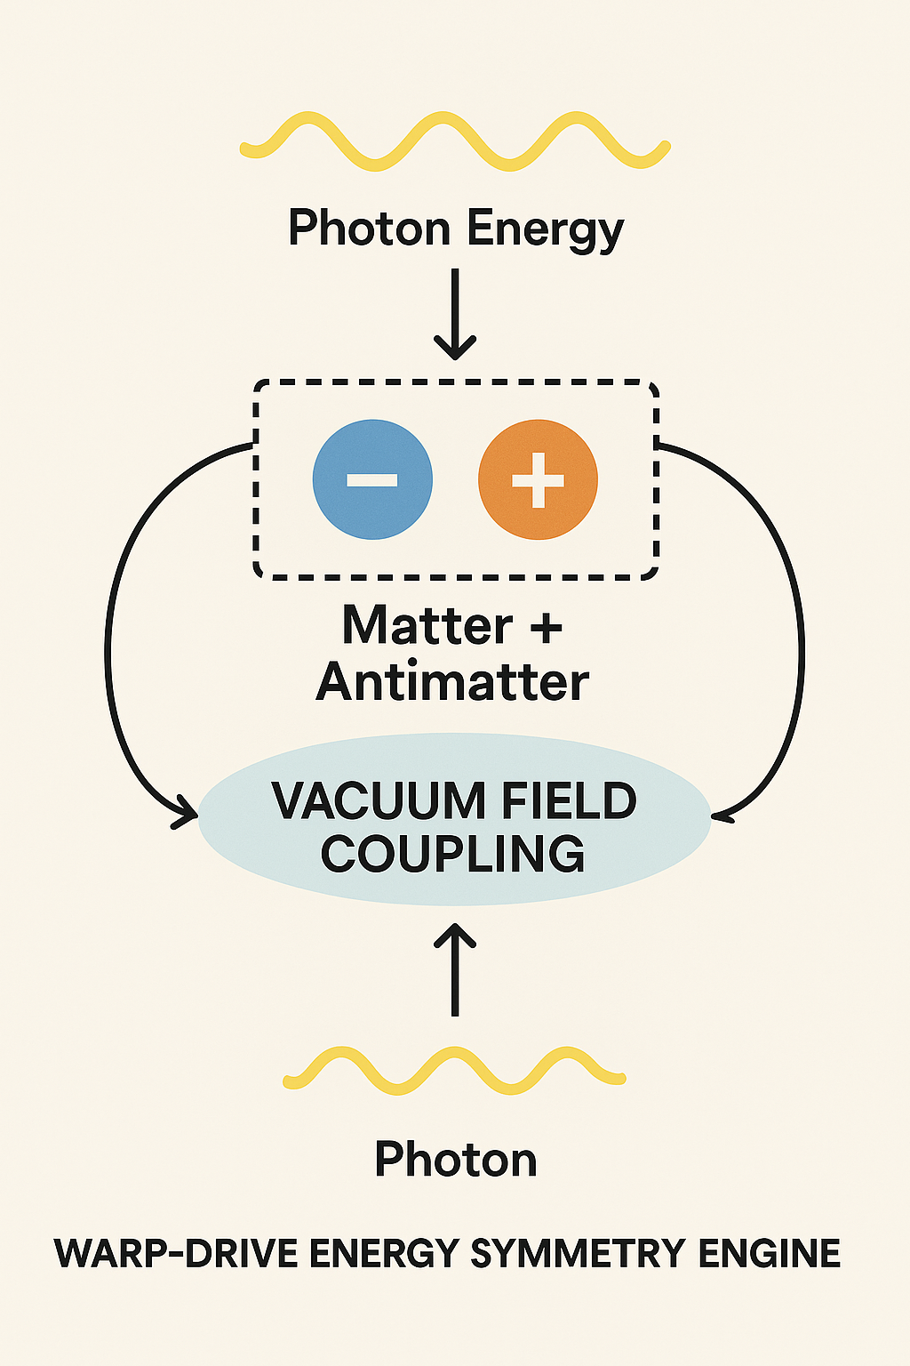

Figure 1: Warp-Drive Energy Symmetry Engine Diagram — illustrating photon creation, matter–antimatter loop, and vacuum field coupling.

## 6. The Role of the Positron in the Symmetry Engine

The positron (e⁺) is the antimatter counterpart of the electron (e⁻). It has the same mass but carries a positive electric charge. In the Warp-Drive Energy Symmetry Engine, positrons are created simultaneously with electrons through the process of pair creation inside the vacuum field.

### Pair Creation and Annihilation

When a high-energy photon (γ) interacts with a strong vacuum field or near a nucleus, it can transform into an electron–positron pair according to the equation:  
  
γ + Vacuum Field → e⁻ + e⁺  
  
The positron and electron exist momentarily within the entanglement zone, stabilized by CST synchronization. When they meet again, they annihilate:  
  
e⁻ + e⁺ → 2γ

This annihilation releases two photons of equal and opposite momentum, feeding the photon regeneration cycle.

### Function Within the Engine

In the Warp-Drive Energy Symmetry Engine, positrons serve as dynamic antimatter mirrors of electrons. They maintain charge symmetry, allowing energy to oscillate cleanly between matter and radiation states. Each annihilation event produces photons that are phase-aligned with the CST field, driving controlled spacetime curvature. The positrons effectively act as 'quantum pistons,' converting vacuum oscillations into thrust energy.

### Quantum Symmetry Zone

Within the entanglement chamber, electron–positron pairs occupy a quantum symmetry zone bounded by Casimir plates. Here, charge inversion, vacuum oscillations, and photon coupling occur under tight CST regulation. The process ensures near-zero waste, as every annihilation recreates usable photon energy, sustaining the curvature field.

Figure 2: Updated Warp-Drive Energy Symmetry Engine diagram showing photon pair creation, electron (–), positron (+), and annihilation into photon regeneration within the vacuum field.

[ Electron (–) ] [ Positron (+) ]

↕ ↕

Casimir-Vacuum Coupling → Photon Regeneration

## 7. Exotic Matter Bypass through Quantum Symmetry

Traditional warp-drive concepts, such as the Alcubierre metric, depend on 'exotic matter'—hypothetical material with negative energy density. This exotic matter would be required to curve spacetime by compressing it in front of a ship and expanding it behind. However, such matter has never been observed in nature or created in a controllable laboratory condition.

### Bypassing the Need for Exotic Matter

The Warp-Drive Energy Symmetry Engine bypasses this limitation entirely by substituting negative mass with a dynamic quantum energy loop. Instead of relying on physical negative energy, the system achieves spacetime curvature through photon–pair symmetry operating in a vacuum field:  
  
Photon (γ) ↔ Electron–Positron Pair (e⁻ + e⁺) ↔ Photon (γ)  
  
Each annihilation and regeneration event produces temporary vacuum polarization and directional photon emission. The controlled oscillations create effective negative-pressure zones without introducing exotic matter.

### Vacuum Compression Mechanism

Inside the Casimir cavity, photon regeneration and annihilation slightly reduce local vacuum energy density, creating a relative negative-pressure pocket. This vacuum compression mirrors phenomena like the Casimir effect, Hawking radiation, and Unruh effect, where quantum fluctuations mimic negative energy states. By harnessing these effects through CST synchronization, the engine generates a warp-like curvature field using real physics.

### Symmetry-Engine vs. Reactor

Conventional engines convert mass into energy once, depleting fuel and releasing waste. The Warp-Drive Symmetry Engine, in contrast, oscillates continuously between mass and energy. This closed-loop conversion maintains equilibrium, eliminating mass loss and radiation waste. Momentum is preserved because the system manipulates spacetime curvature rather than expelling mass.

### Unified Principle

The system unites quantum vacuum dynamics, photon symmetry, and CST timing into a sustainable curvature mechanism:  
  
Vacuum Energy + Photon Symmetry = Spacetime Curvature  
  
This demonstrates that negative energy is not required if vacuum resonance is properly phased. Through entanglement feedback and time synchronization, curvature becomes a controllable physical output rather than a mathematical construct.

In summary, the Warp-Drive Energy Symmetry Engine replaces exotic matter with quantum-vacuum field symmetry, achieving curvature through balance and resonance rather than negative mass. It transforms Einstein’s E=mc² into a cyclical spacetime generator—an elegant solution rooted in symmetry, not speculation.

Figure 3: Conceptual comparison — Classical warp drive using exotic matter (negative mass) vs. Quantum Symmetry Engine using photon–vacuum resonance. The latter achieves curvature through vacuum compression and photon regeneration rather than exotic density fields.