# Warp-Drive Energy Symmetry Engine

This document explains the conceptual foundation of the Warp-Drive Energy Symmetry Engine, based on energy–matter symmetry, vacuum field coupling, and CST time synchronization.

## 1. Energy–Matter Symmetry Loop

In classical and quantum physics, energy and mass are interchangeable according to Einstein’s equation, E = mc². This relationship forms the basis of pair creation and annihilation: high-energy photons can produce an electron–positron pair, and when they meet again, they annihilate to regenerate photons. This perfect reversibility creates an energy–matter symmetry loop.

## 2. The Vacuum as an Energy Reservoir

The quantum vacuum is not empty—it is filled with virtual particle pairs that constantly appear and disappear. If a warp drive can synchronize with these oscillations, it could momentarily access vacuum energy through quantum entanglement and Casimir-like cavities. These oscillations may serve as the medium through which energy transitions from virtual to real photons.

## 3. Warp Field Implication

By coupling photon regeneration with vacuum compression, photon pressure can emulate negative energy density. This effect could theoretically generate a spacetime curvature pattern—contracting space ahead and expanding it behind—similar to the Alcubierre warp bubble concept. In this configuration, the annihilation–creation cycle replaces exotic matter with a stabilized energy symmetry mechanism.

## 4. Engineering Analogy

The warp-drive symmetry engine functions like a quantum turbine:  
1. Photons strike a vacuum field, producing matter–antimatter pairs.  
2. The pairs exchange charge and momentum within an entanglement field.  
3. They annihilate, releasing phase-aligned photons that drive curvature.  
4. The cycle repeats at CST-synchronized frequency, maintaining thrust through energy symmetry.

## 5. Conceptual Summary

This system unites Einstein’s E=mc² with quantum symmetry, vacuum energy, and cosmic temporal alignment (CST). The Warp-Drive Energy Symmetry Engine demonstrates how annihilation–creation loops in the vacuum field could provide a sustainable mechanism for warp propulsion and spacetime manipulation.

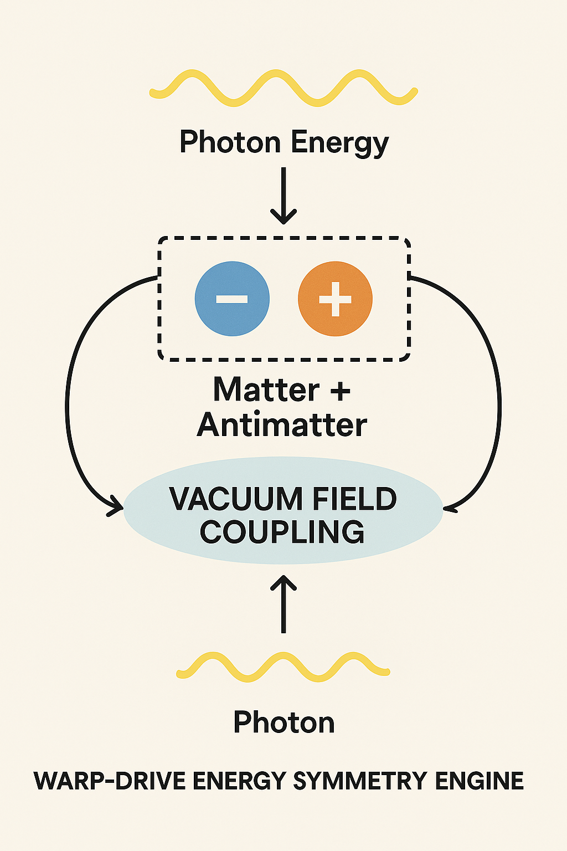

Figure 1: Warp-Drive Energy Symmetry Engine Diagram — illustrating photon creation, matter–antimatter loop, and vacuum field coupling.