**Semester Project Report:**

**Centralizing community water management in Costa Rica.**

Submitted by:

Gabriela T. Sancho Juárez

gabriela.sancho@usu.edu

Instructor: Dr. David Rosenberg

Course: CEE 6410, Water Resources Systems Analysis

Date: December 7th, 2024

Contents

Abstract 3

**1.** **Introduction** 4

**2.** **Background** 5

**3.** **Literature review** 7

**4.** **Model formulation** 8

**5.** **Results** 10

**6.** **Conclusions** 11

# Abstract

Centralizing allocation of water can potentially benefit community water service. Water managers need robust data, modeling, and decision support tools to best allocate water. This report studies optimization modeling as a potential solution to reduce the amount of community water service systems (ASADAS) in Alajuela Costa Rica. Currently there are numerous ASADAS, which represents a challenge for management and adequate governmental support. Three systems are used as an example. The objectives of this project are: (a) Create an optimization model to improve water delivery in decentralized community water systems in Alajuela, Costa Rica. (b) Integrate environmental water constraints in optimization model. This model can be used by decision makers to join ASADAS and best allocate water among them, including ways of balancing the environmental and human water requirements. This model identified 5 links between water sources and communities; governmental accompaniment is needed to facilitate the systems joins within communities.

1. **Introduction**

In Latin America, 70 million people receive water from 145,000 Community Water Service and Sanitation Organizations. In general, these organizations are created under a local collective initiative and have a concession to use water and operate under internal democratic principles (Nicolas-Artero, 2016). In Costa Rica, these organizations are named Community Aqueduct and Sewer System Administrative Associations (ASADAS). The Costa Rican Institute of Aqueducts and Sewers (AyA), a centralized government institution, delegates water supply service to ASADAS, who provide water to approximately 30% of Costa Rica’s population, around 1.5 million people (AyA, 2016). By the end of 2017, 1436 ASADAS existed in the country (see Figure 1.); however, the sheer number of community water providers exceeds the AyA's capacity to assist them (AyA, 2015; Contraloría General de la República, 2013).

**Figure 1**. National distribution of ASADAS in Costa Rica (Hidrogeotecnia, 2019).

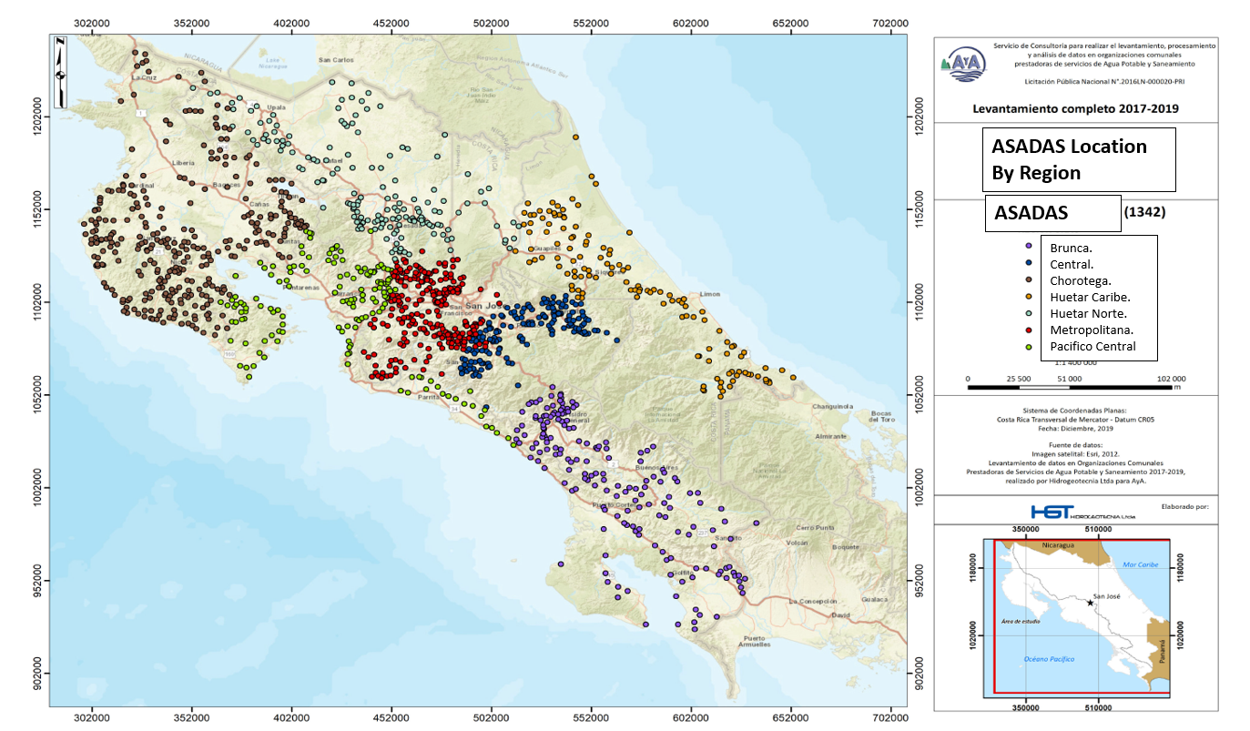

Since so many ASADAS exist, they face management difficulties and do not receive appropriate support. Ongoing efforts seek to alleviate the situation, from ASADAS self-initiatives to government approaches to reduce the number of ASADAS by integrating systems to strengthen management and to facilitate governmental support.

A fundamental problem with Costa Rica’s ASADAS is efficient management of a decentralized water system. To improve water supply management and improve reliability in decentralized systems, optimization models can be useful(Brown et al., 2015; Lund, 2012) . Optimization techniques can quickly evaluate efficient use of resources in water supply systems (Newman et al., 2014). This report proposes an optimization model for joining systems, using 3 ASADAS as an example. Mixed integer programming is implemented to solve the model. Results and conclusions are also included.

1. **Background**

One of the biggest problems with ASADAS is their small size, 72% of them are categorized as “very small” (with less than 100 connections) or “small” (with less than 300 connections). Most of them are unsustainable (see Figure 2) (AyA, 2018; Contraloría General de la República, 2013) because they do not have the financial stability required to guarantee services in terms of quality, quantity and continuity (AyA, 2018). Since 1991, 10% of the flow for all water concessions, including the water allocated for ASADAS, should be bypassed or left instream for environmental flows in Costa Rica (MINAE & Poder Ejecutivo, 2021), a value that sometimes represents an unsustainable model for the proper management of the water resource (Watson-Hernández et al., 2021).

**Figure 2**. Percentage distribution of ASADAS according to number of connections and average monthly billing (in Colones), (Hidrogeotecnia, 2019).

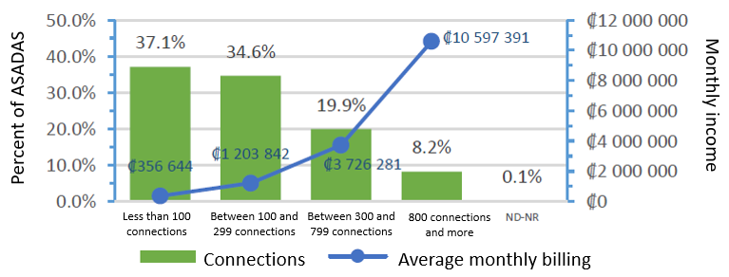

Some documentation exists on how to integrate these systems, the “Protocol for Integration or Fusion of ASADAS” (AyA & PNUD, 2017), explains the main and broad steps to follow. However, there is not a systematic process nor a model that defines the optimal integration of aqueducts. Therefore, it provides inactionable guidance.

I developed a model to minimize the number of ASADAS that currently provide water service. By minimizing the amount of systems, I expect the number of *very small* and *small* systems to be reduced. The model considers human consumption requirements and environmental deliveries represented as a constraint. For this project environmental deliveries are considered as water that won’t be diverted or captured for human uses. I will not consider instream flow requirements (flows dedicated to sustain aquatic ecosystems), since no model has been developed to identify this requirement in Costa Rica, or the study area. Even though 10% of water designated by law, has been used as a general rule for the environment, no research has been undertaken to understand if joining ASADAs could use water more efficiently to increase deliveries to the environment or human requirements.

For this model I included 3 ASADAS located in Naranjo, Alajuela: (1) San Juan-1170 (2) Concepcion Este-4200 and (3) Calle Porosal-4611 (see Figure 3.). In this area there are some collaboration processes where some ASADAS have been implementing joint work in recent years. For this project my objectives are:

* Create an optimization model to improve water delivery in decentralized community water systems in Alajuela, Costa Rica.
* Integrate environmental water constraints in optimization model.

I expect the model to be reproducible to include more ASADAS in other parts of the country or adapted to be used as a reference to join systems.

**Figure 3**. Location of water sources and communities.

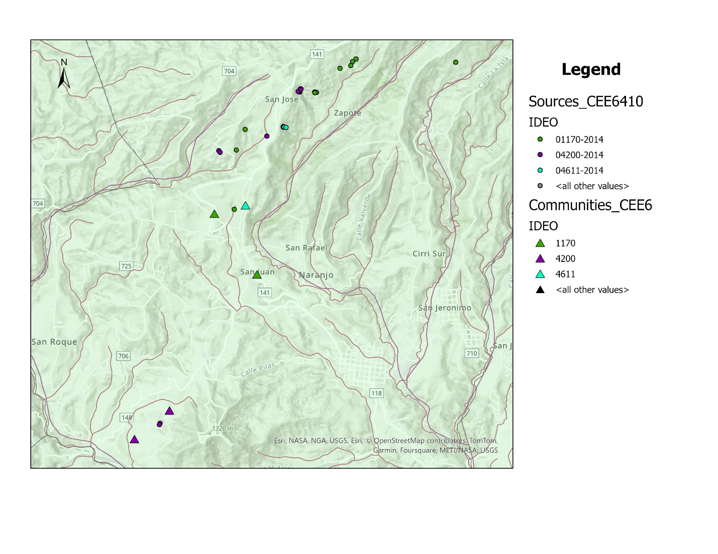

1. **Literature review**

Centralizing water supply systems is a potential solution to improve community water management in Costa Rica. Optimization models can be a convenient approach to improve reliability in decentralized systems (Brown et al., 2015; Lund, 2012). Planning and design of integrated urban water systems, through multi-objective optimization modeling has been studied (Newman et al., 2014). Finding that combination of subsystems into integrated clusters is cost-efficient, however environmental flow constraints or system joining by the model are not included by Newman et al. Optimization applied for water distribution systems has also been applied considering topological characteristics and water quality targets (Ko & Choi, 2022). The model developed by Ko and Choi, satisfies constraints related to hydraulic performance and residual chlorine concentration, ensuring network efficiency and water safety. Their emphasis is on network optimization, the study does not address pre-existing distribution systems or offer broader water management insights, such as environmental uses.

Other centralizing studies include environmental aspects, Xiong et al. (2020) examine cost-effective strategies to enhance the sustainability of urban water systems, accounting for legislated targets and ecosystem impacts. They include wastewater, rainwater, and pollution reduction, and also findings on trade-offs between cost minimization and ecosystem impact reduction.

In Costa Rica, in 2015 The Costa Rican Institute of Aqueducts and Sewers’ (AyA, 2015) released the *Policy for the Organization and Strengthening of Community Management of Drinking Water and Sanitation Services*. This policy highlights the operational and financial challenges faced by community water providers (ASADAS), and promotes the integration of smaller ASADAS into larger entities, to improve management capacity and service reliability. However, these are general guidelines and specific modeling is lacking.

An audit report by the General Comptroller of the Republic (Contraloría General de la República, 2013) explains that AyA does not have the capacity to provide adequate support to the numerous ASADAS. It also points out the need to reduce the amount of community systems, but this report does not provide modeling guidance on joining systems either. In 2017 a protocol was co-developed by AyA and the United Nations Development Program (AyA & PNUD, 2017), it outlines broad steps for ASADAS integration. It identifies systems joining benefits like: enhanced service delivery, improved management capacity, and financial sustainability. However, its lack of a systematic or modeling approach limits its practical utility. In this context, it is relevant to propose an optimization approach that can provide more actionable guidance on joining systems, and reduce the amount that currently operate independently.

1. **Model formulation**

The model formulation was developed considering 3 variables: a binary decision variable to join or not the systems, the volume of water to send and a variable that quantifies the number of systems joined. The objective of this model is to minimize the number of systems (ASADAS). ASADAS usually operate capturing water from different sources and conveying water to communities. From water available, 10% must be allocated for the environment, the rest is for human consumptions. The model is constrained to meet both the human and environment requirements; other constraints like flow capacity and joining feasibility/connection between links are also included. By implementing Mixed integer programing to solve for the objective given the constraints, we can solve applying code in GAMS.

* 1. **Sets, variables and parameters:**

The sets, parameters and variables are defined below.

**Sets:**

* **Sources (*i*):** Water sources (water springs), listed in the model data input spreadsheet. For the 3 ASADAS included in this model the number of sources varies.
* **Human deliveries sites (*d*):** Demand sites, communities that currently receive water supply.
  1. **Parameters:**
* **Existent connections (*ci,d*)**: Currently existing connections between water and deliveries sites. A matrix of *i* and *d* can be found in the input dataset, value of 1 or 0 if a connection exists or not.
* **Potential links (**li,d**)**: Considering the location of *i* and *d*, we can identify which systems could be better integrated due to their proximity. A table in the spreadsheet assigns a value of 1 or 0 if a link could exist between *i* and *d*. This assumption of the model is created by visual assessment of the location of points in the map.
* **Water available (*qi*)**: Water available to be delivered per source. Flows are in L/sec.
* **Human requirement (*qhd*):** Daily water requirements per person: According to AyA the estimated average water used in CR is 800L/day per house (for a family of 4 people). The total human requirement is estimated by multiplying per the number of connections per ASADA and reported in L/sec.
* **Environmental requirement (*qe i*):** estimated as 10% of *qi*, in L/sec.
* **Flow capacity (q_capi,d)**: Describes the capacity of *qi* from *i* to *d*, in L/sec.
* **Systems joined (ji,d):** Two systems are joined if link from source *i* to demand site *d*, then *j* is built.
  1. **Decision variables:**

**Binary variables:**

* **Join (JIi,d)**: feasible joint or not (1 =yes, 0=no)

**Positive variables:**

* **Volume of water (Xi,d):** volume of water to send along each link in L/sec.
* **Number of ASADAS (A):** statevariable,resulting number of ASADAS, after joints.
  1. **Objective function**

Minimize the number of systems, the objective function value will be the total number of ASADAS that result from joining systems.

* 1. **Equations and constraints**
* **Meet Human requirement:**

The total water received at each demand site should meet the human water requirements.

* **Environment requirement:**

The total water sent from *i* to *d* should not exceed the available water minus the environmental requirement (10% of q).

* **Flow capacity:**

The water flow along each link does not exceed the links capacity and only occurs if the link is active:

* **Water deliver feasibility:**

The water that can be delivered from *i* to *d* if a connection is possible between them.

* **Joining feasibility:**

Joining ASADAS will be possible if the water available from sources and deliveries (QH and QE) are feasible.

The complete data input is stored in a excel spreadsheet, code file is written for GAMS. All files can be found on GitHub repository: [CEE6410-GabiSanchoJuarez/Semester_project at main · gabisanju/CEE6410-GabiSanchoJuarez · GitHub](https://github.com/gabisanju/CEE6410-GabiSanchoJuarez/tree/main/Semester_project)

1. **Results**

The model was solved implementing mixed integer programming, and a solution was found. The model indicates that the 5 links that can be built, between sources and deliveries sites. From the output data, these 5 links are between sources and deliveries sites that already have connections. Further revision of the model can be done to identify if a model re-formulation needs to be done.

As more data can be gathered, from literature or consulting with local managers, future model data input improvements can be made. An additional constraint that was not included is costs. This can be later added and then run the model including operation costs of flows along each link. Further research needs to be done to properly estimate them. Currently data for the annual operation cost of the entire ASADA can be obtained from (Salazar Guzmán & Sierra Cerdas, 2022). The annual costs by ASADA’s size are: Small: ₡ 19,955,167.04 (Colonones) and Medium: ₡ 35,890,806.96 (Colones).Due to lack of time I could not estimate costs of flows along each links.

As research continues, more flows data could be estimated to include time as a set and use monthly *q* (water available), therefore run the model at monthly steps.

1. **Conclusions**

The model solves to identify the links that can be made between sources and deliveries sites. 3 systems were used to test the model including 29 water sources and 3 deliveries sites (communities). And 5 potential links were identified by the model. The optimization model does not take into account social and community aspects, like willingness to work together. Even when a model can identify optimal solutions to join systems, water managers and communities can have potential difficulties due to a sense of belonging of water to their community. Optimization models offer insights for potential systems joining, a necessity identified by policies and reports in the country. Water in Costa Rica is considered a public domain good and is managed by the Government. Water authorities most work closely with managers and communities to successfully join systems.

**Repository**

“[CEE6410-GabiSanchoJuarez/Semester_project at main · gabisanju/CEE6410-GabiSanchoJuarez · GitHub](https://github.com/gabisanju/CEE6410-GabiSanchoJuarez/tree/main/Semester_project)”. December, 2024. https://github.com/gabisanju/CEE6410-GabiSanchoJuarez/tree/main/Semester_project

**References**

AyA. (2015). *Política de Organización y Fortalecimiento de la Gestión Comunitaria de los Servicios de Agua Potable y Saneamiento*. https://www.aya.go.cr/ASADAS/documentacionAsadas/Pol%C3%ADtica%20de%20ASADAS.pdf

AyA. (2016). *Política Nacional de Agua Potable de Costa Rica 2017 – 2030*. https://www.aya.go.cr/Noticias/Documents/AyA%20Pol%C3%ADtica%20Nacional%20de%20Agua%20Potable%20de%20Costa%20Rica%202017-2030.pdf

AyA. (2018). *Estrategia para el Ordenamiento de la Gestión Comunitaria de los Servicios de Agua Potable y Saneamiento*. https://investiga.uned.ac.cr/obsas/wp-content/uploads/sites/25/2019/01/Estrategia-para-el-ordenamiento-de-ASADAS-27032018-1.pdf

AyA, & PNUD. (2017). *Protocolo para la integración o fusión de ASADAS*. https://www.undp.org/es/costa-rica/publications/protocolo-para-la-integracion-o-fusion-de-asadas

Brown, C. M., Lund, J. R., Cai, X., Reed, P. M., Zagona, E. A., Ostfeld, A., Hall, J., Characklis, G. W., Yu, W., & Brekke, L. (2015). The future of water resources systems analysis: Toward a scientific framework for sustainable water management. *Water Resources Research*, *51*(8), 6110–6124. https://doi.org/10.1002/2015WR017114

Contraloría General de la República. (2013). *Informe de la auditoría de carácter especial sobre la razonabilidad del control ejercido por el Instituto Costarricense de Acueductos y Alcantarillados sobre la gestión de las Asociaciones Administradoras de Acueductos y Alcantarillados Comunales* (DFOE-AE-IF-07-2013). https://cgrfiles.cgr.go.cr/publico/docs_cgr/2013/SIGYD_D_2013016235.pdf

Hidrogeotecnia. (2019). *Diagnostico nacional de entes operadores*. AyA. https://www.aya.go.cr/ASADAS/Documents/Diagn%C3%B3stico%20Nacional%20de%20Entes%20Operadores%20(Levantamiento%202017-2020).pdf

Ko, M. J., & Choi, Y. H. (2022). Optimal Design of Water Distribution Systems Considering Topological Characteristics and Residual Chlorine Concentration. *Mathematics*, *10*(24), Article 24. https://doi.org/10.3390/math10244721

Lund, J. R. (2012). Provoking More Productive Discussion of Wicked Problems. *Journal of Water Resources Planning and Management*, *138*(3), 193–195. https://doi.org/10.1061/(ASCE)WR.1943-5452.0000190

MINAE, & Poder Ejecutivo. (2021, December 15). *Reglamento para la selección de la metodología para el cálculo del caudal ambiental y evaluación del impacto hídrico acumulado N° 43242-MINAE*. Sistema Costarricense de Informacion Juridica. http://www.pgrweb.go.cr/scij/Busqueda/Normativa/Normas/nrm_texto_completo.aspx?param1=NRTC&nValor1=1&nValor2=95920&nValor3=128208&strTipM=TC

Newman, J. P., Dandy, G. C., & Maier, H. R. (2014). Multiobjective optimization of cluster-scale urban water systems investigating alternative water sources and level of decentralization. *Water Resources Research*, *50*(10), 7915–7938. https://doi.org/10.1002/2013WR015233

Nicolas-Artero, C. (2016). Las organizaciones comunitarias de agua potable rural en América Latina: Un ejemplo de economía substantiva. *Polis. Revista Latinoamericana*, *45*, Article 45. https://journals.openedition.org/polis/12107

Salazar Guzmán, A. de J., & Sierra Cerdas, J. F. (2022). *Análisis de estructura de costos operativos y de mantenimiento de los sistemas de acueducto de la Región Chorotega, Costa Rica*. http://hdl.handle.net/11056/23220

Watson-Hernández, F., Chavarría-Pizarro, L., Quesada-Alvarado, F., Guzmán-Arias, I., Watson-Hernández, F., Chavarría-Pizarro, L., Quesada-Alvarado, F., & Guzmán-Arias, I. (2021). Determinación del caudal ambiental mediante una metodología hidrobiológica, considerando variables de cambio climático en el río Pejibaye, Cartago, Costa Rica. *Revista Tecnología en Marcha*, *34*(4), 118–129. https://doi.org/10.18845/tm.v34i4.5223