# The Great Pizza Test

## Description

It’s an application that allow to different web user to list, create, edit and delete pizzas and also select a variety of toppings in every one, the main goal of the application is to allow to final user manipulate the information related to pizza’s ingredients in order to elaborate the most know pizzas flavors and the new one.

## Requirements

To next there are described the main features of the web application, so we’ll focused on provide these functionalities implemented and tested.

1. Get pizzas
   1. Get a list of the pizzas stored on database.
2. Get single pizza
   1. Display the properties stored of a specific pizza selected.
3. Insert new pizza
   1. Through a web form create a new pizza, populating the respective properties in the form.
4. Delete pizzas
   1. Delete from database a specific pizza selected.
5. Get Toppings
   1. Get a list of toppings stored on database.
6. Insert new topping
   1. Through a web form create a new topping, populating the properties of a topping.
7. Delete topping
   1. Delete from database a specific topping selected.
8. Add topping to pizza
   1. Using a topping and pizza created, add a topping on the pizza, the toppings can be associated to different pizzas and also can be removed from this.
9. Get toppings from a pizza
   1. From a selected pizza, get the list of toppings that are part of the pizza choose.

## Tech Stack

The architecture of the application it’s separated in two layers, frontend and backend. Both it will be developed using JavaScript technologies such as Angular for frontend and NodeJS for backend side. Regarding to the database, in this initial phase it will be used SQLite data management, in order to have an easy and fast deploy after clone the code, this could be changed in the future based on the requirements of functionality or demand of the users or reviewers.

Below you can find a small diagram of the application architecture based on the requirements defined in the document provided.

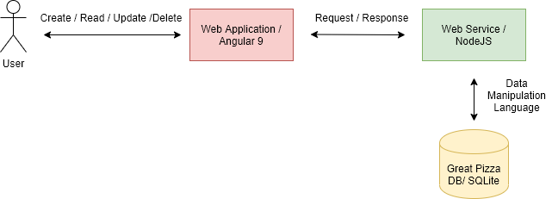

The high-level tech stack is described to next, where basically the application it will be separated in two layers, frontend and backend every layer has a specific role to handle the application data.

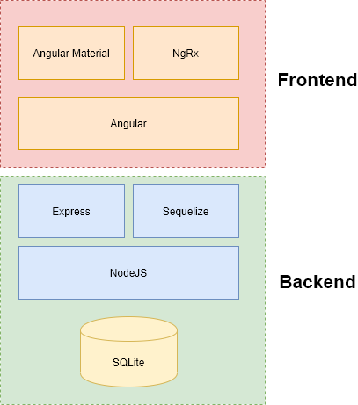

## The User Interface

The user interface defined for the functionality to list the pizzas and toppings are displayed to next, in this screenshot you can see how the pizza can be created with the respective toppings.

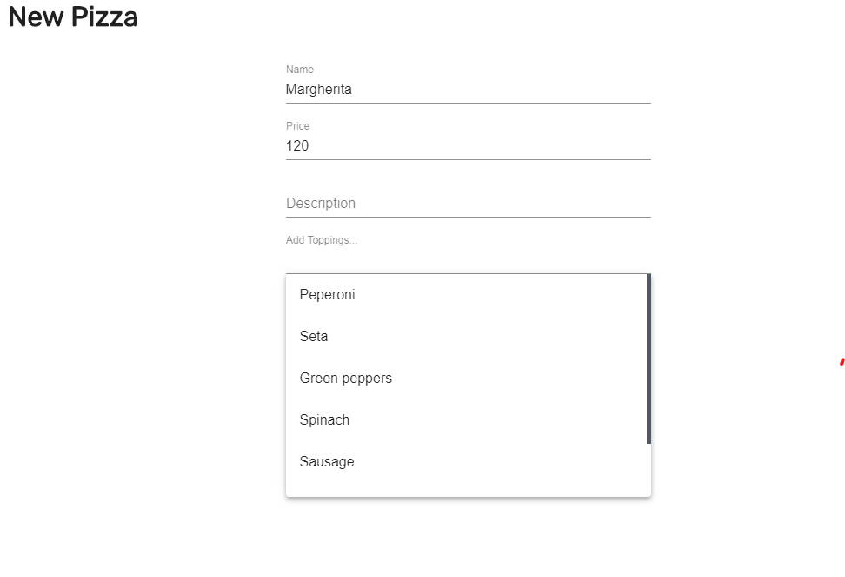

In this screenshot we can see how the toppings can be selected, also we can select many toppings in our pizza creation.

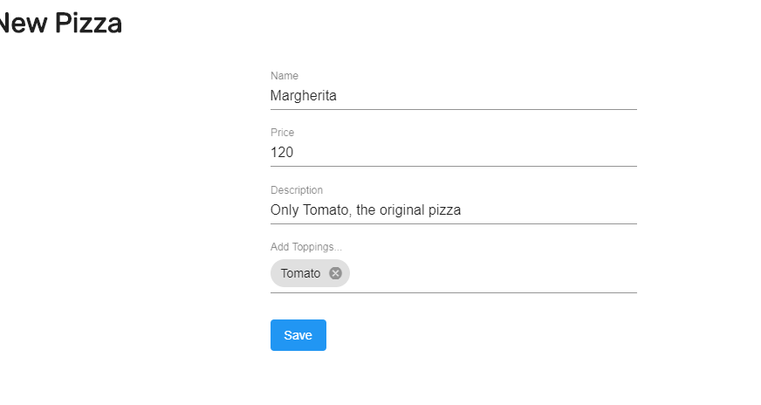

The topping has a similar UI for the creation of this, but in this case just we can set the name, price and description for a topping. If we want to select different toppings on out Pizza creation UI it’s necessary in first instance to create a couple of topping in order to have a better experience with the interaction between these features application.

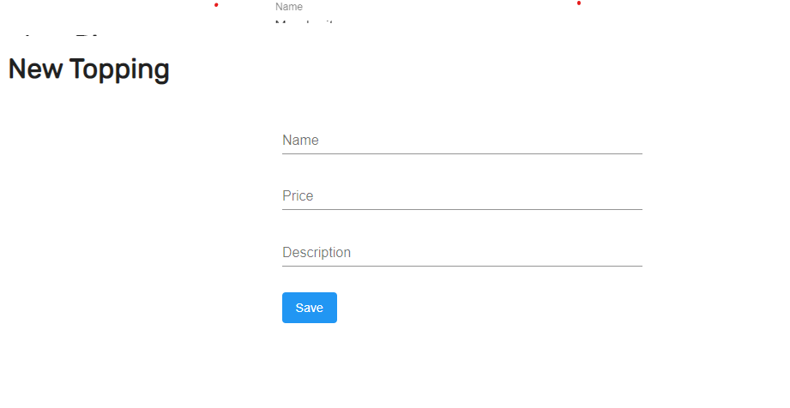

In the List screen we can delete the elements that we consider unnecessary just we need to select the specific items and press the delete button. Currently there is a bug with the select all button this mark the items, but the delete operation is not performed, so you need to select one by one in order to delete properly the items.

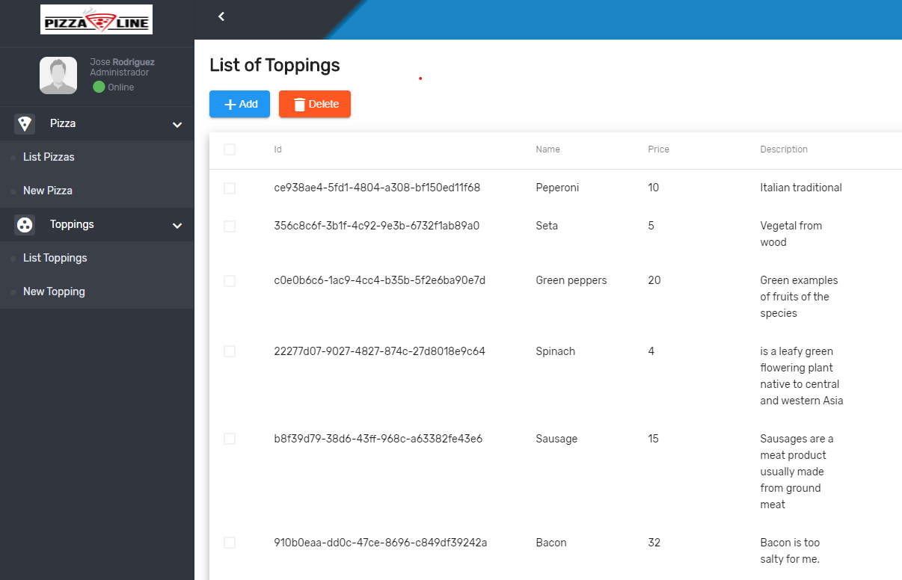

The Pizza UI has the same features of topping UI, but in this case, we can use the pencil icon to display the different topping added for a specific pizza.

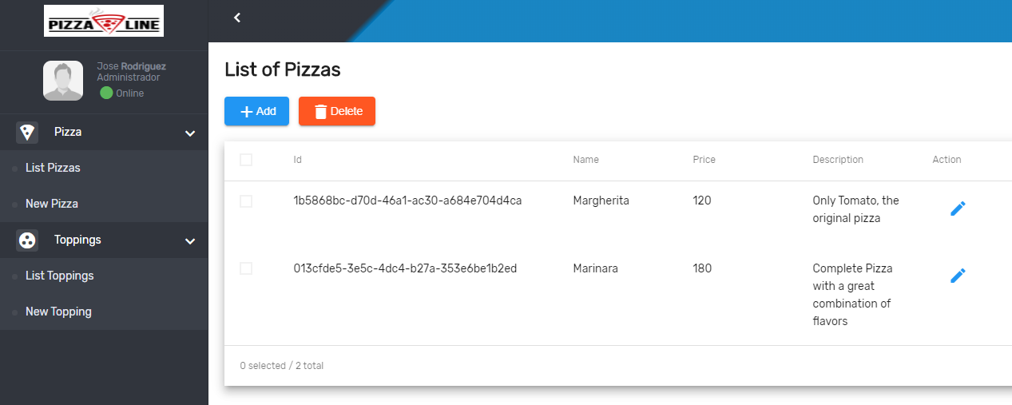

In this screen we can identify the different toppings used and also the properties of this.

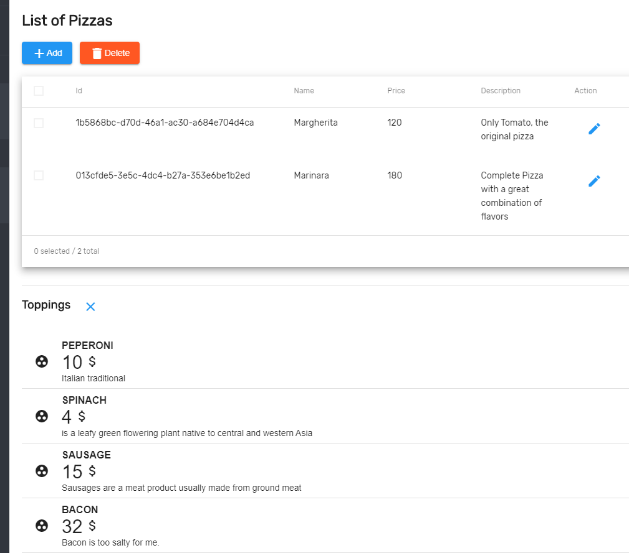

## Database Design

This application it was developed using the next database design, where the main tables are: pizza, topping and pizza_topping which represent the relationship many to many between both tables.

