Hi _______________,

My name is Schuyler. I am the research assistant for your scan at MIT. This email is to confirm your fMRI appointment at MIT. Your brain scan is scheduled for:

Day:______

Time:______

Please arrive 15 minutes prior to your appointment to get ready to be scanned on time.

Please notify us at least **3 days** ahead of time if you need to cancel or reschedule this appointment.

**Vision - please wear contacts:**

If you wear glasses/contacts, please wear your contacts. If you don’t have contacts, please email us your prescription strength beforehand and also make sure that you know your prescription when you arrive for the scan.

**Clothing & jewelry:**

Because the MRI machine contains a large magnet, no metal is allowed near the scanner, including jewelry and metal on clothing. If you would like to wear your own clothes, please bring pajamas or other comfortable clothing with no metal (e.g. no buckles, zippers, etc.). If you would prefer, you can borrow a clean pair of scrubs from us. We will ask you to remove any jewelry before scanning.

**Location & access:**

Martinos Imaging Center at The McGovern Institute for Brain Research

Massachusetts Institute of Technology (MIT)

Building 46

550 Main Street

Cambridge, MA 02139

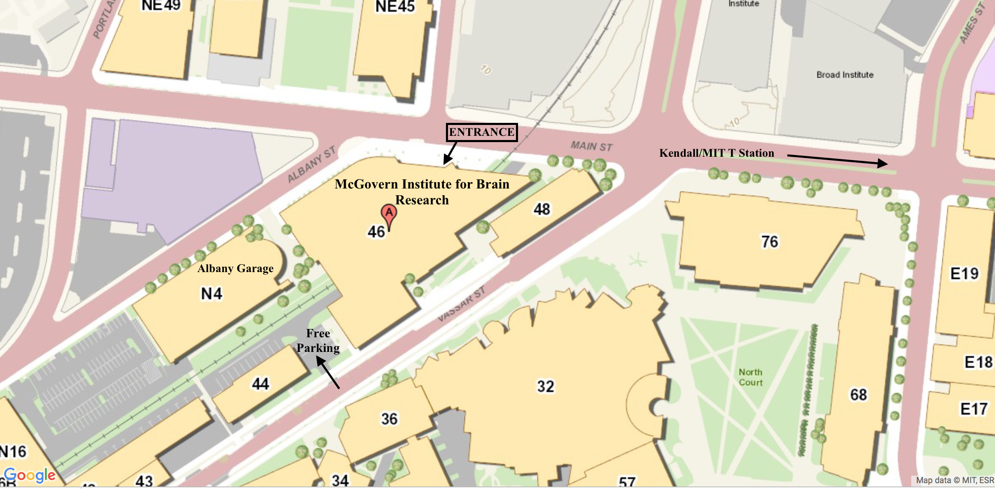

The building in between Vassar Street and Albany Street (see map). The nearest T station is **Kendall/MIT** (see map). We have **free parking** near our building (see map). Another option is the nearest garage, which is the **Albany Garage** (see map) with a flat rate of $6 to a maximum of $22 per day.

For detailed driving instructions, please visit <http://mcgovern.mit.edu/contact-us>

**Contact information:**

Please email any questions to [schuyler@mit.edu](mailto:schuyler@mit.edu)

When you arrive on your scan day, please call my cell at 301-767-6403