VHS FILTER

Component: Add Noise

Brief explanation:

Add noise to image by multiplying noise mask to original image.

For “multiplying”, refer to: [Multiply_and_Screen](https://en.wikipedia.org/wiki/Blend_modes#Multiply_and_Screen)

For others, Refer to images below.

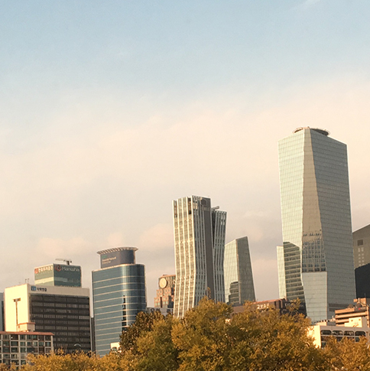

This is the original image.

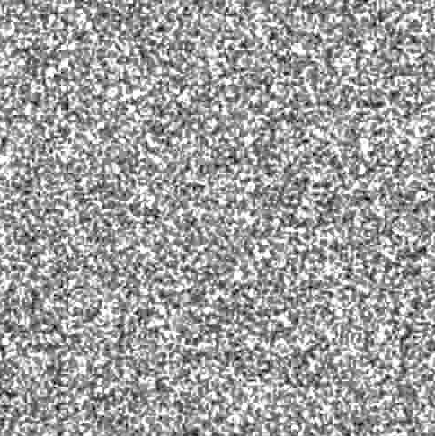

This is the noise mask used for this example.

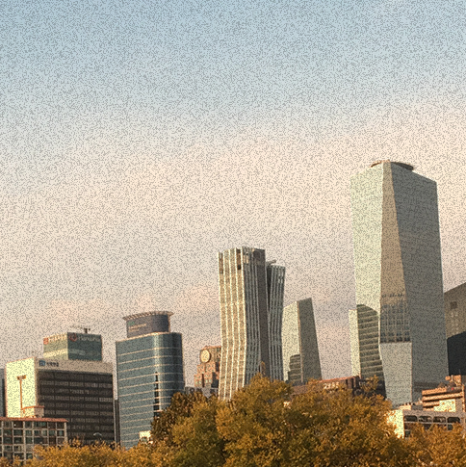

This is the expected result.

Things to think about:

The size of noise mask might not fit the image well, so we will have to account for these situations. Refer to the image below.

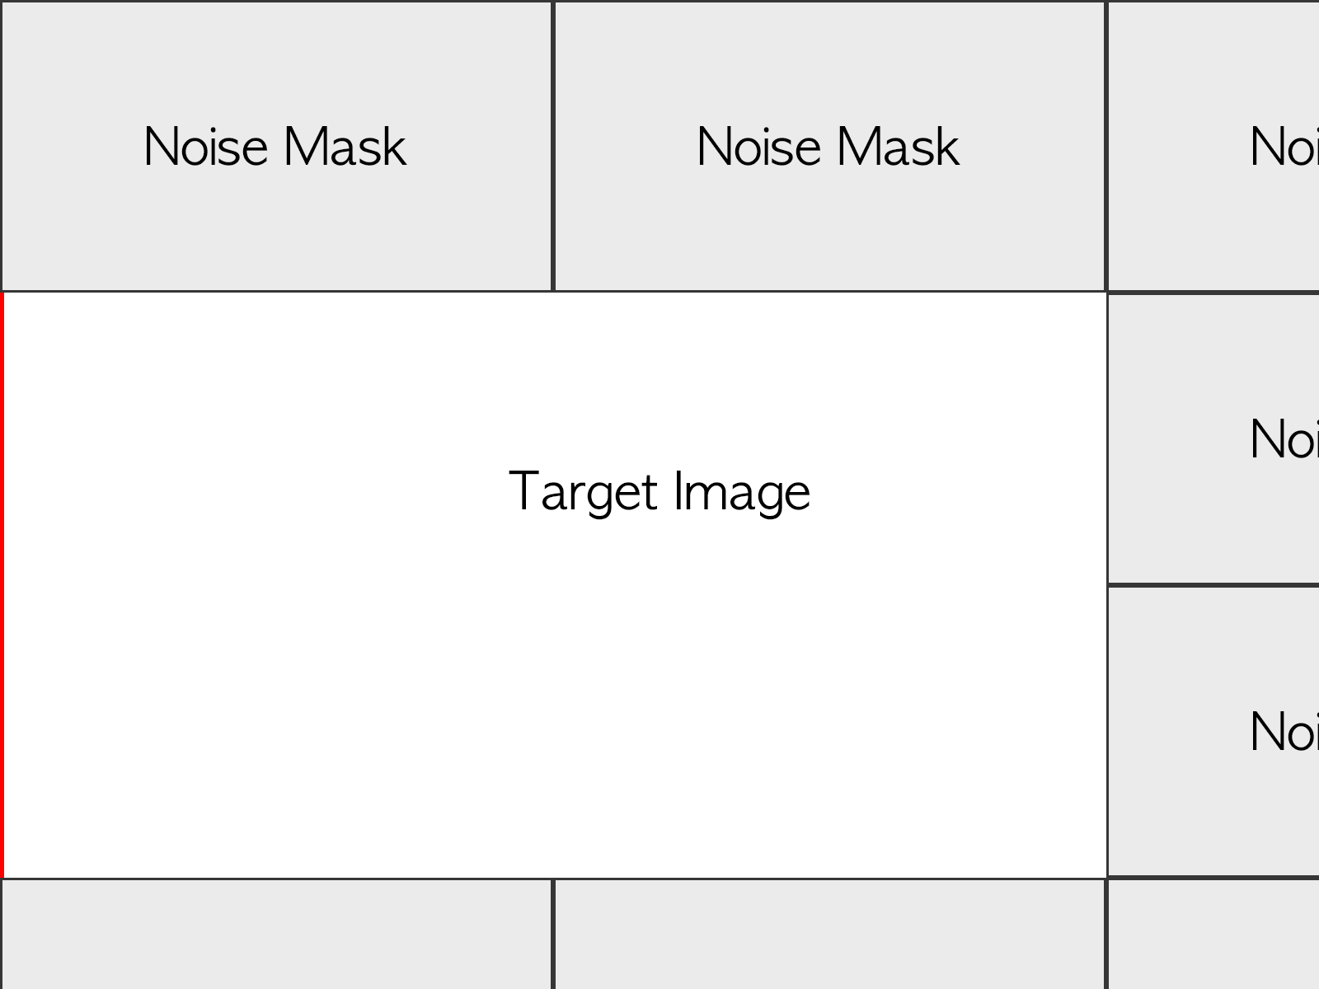

Case 1: Original image is bigger but noise mask does not fit well.

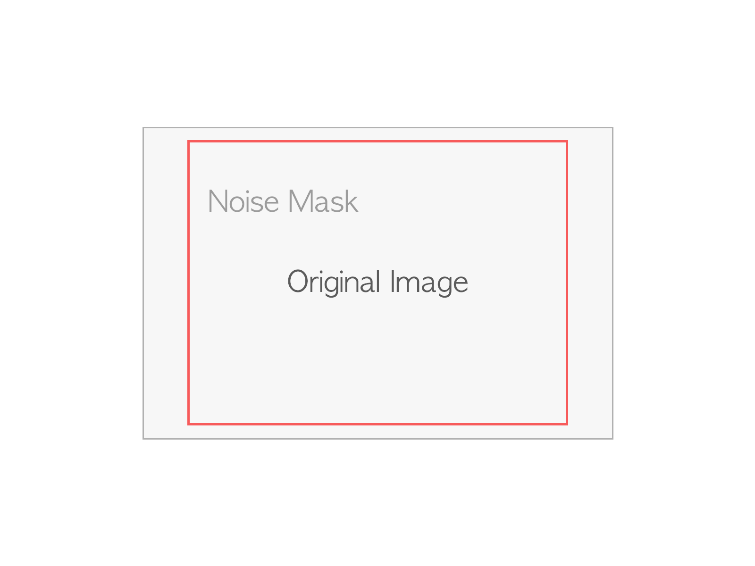

Case 2: Noise mask is bigger.