VHS FILTER

Component: Add Time Stamp

Brief explanation:

Add a time stamp like old camcorders use to do. Refer to images below. You can use the font include in this folder.



This is the original image.

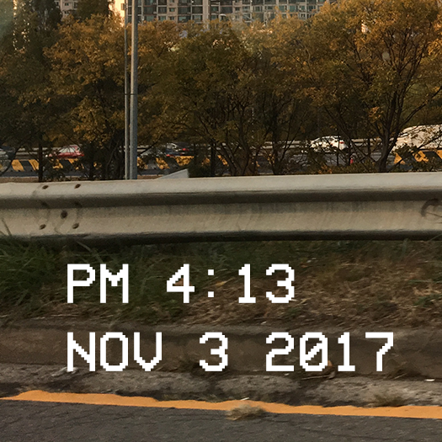

This is the expected result.

Things to think about:

Calculate font size and position according to the size of image, since image size can differ image to image.

Get the actual time and date, and format it as above.

\*For this one, I am not sure how to implement it without using libraries. However, if you choose to implement this, please try it on your own before using libraries.