VHS FILTER

Component: Distort Colors

Brief explanation:

Distort the color to get a retro look. Refer to images below.

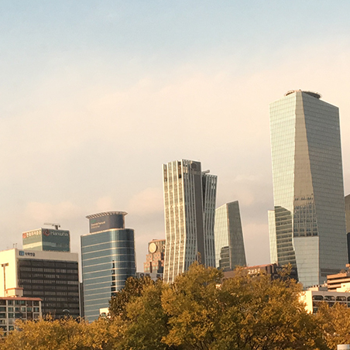

This is the original image.

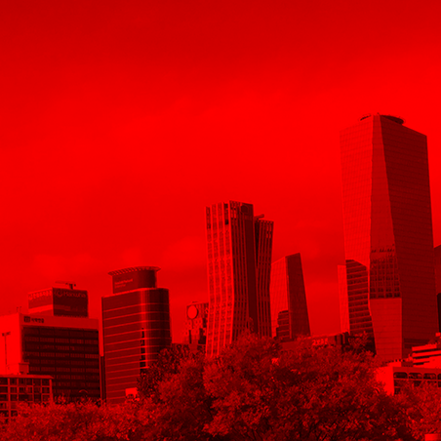

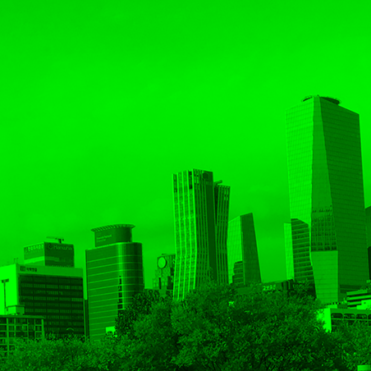

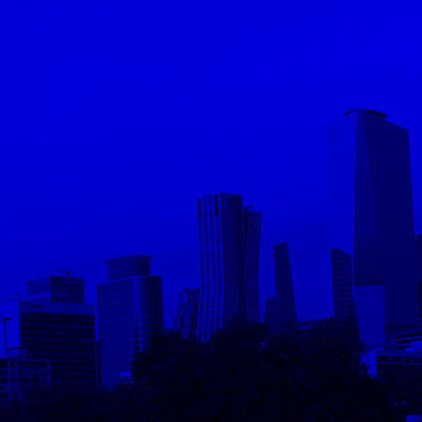

Make 3 images with each RGB channels.

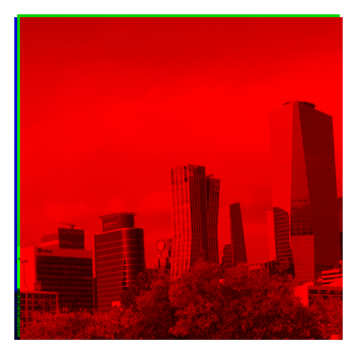

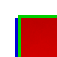

Combine three images with slight offset. Since each layer have each R, G, B we can just combine each R, G, B into one color at a specific coordinate.

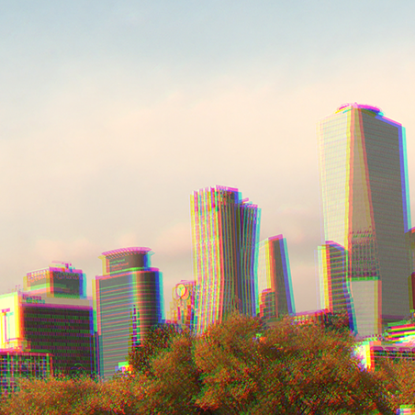

This is the expected result.

Things to think about:

Since we are reassembling the image with slight offset, we will need to trim the edges where not all 3 images are present. Refer to the image below.

You will have to figure out the right amount of offset and direction, or make it effectively random. Please try out different values.

