VHS FILTER

Component: Stretch Pixels

Brief explanation:

Select a row in image, and override random number of rows below with the selected row.

Refer to images below.

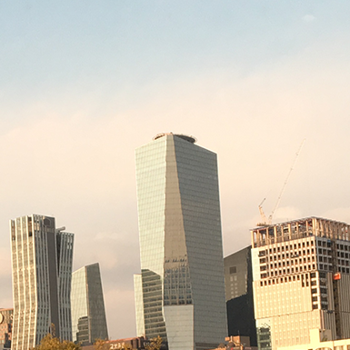

This is the original image.

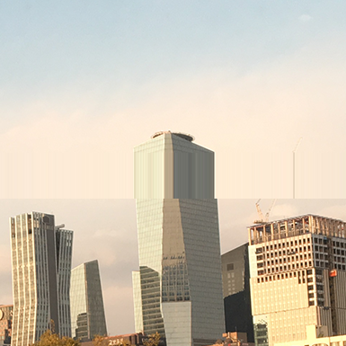

This is the expected result.

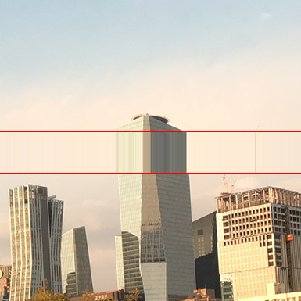

As you can see between the red lines, a single row of pixels in the image is stretched across multiple rows under it.

Things to think about:

The size of stretched area should be visibly random. If you just stretch 0 to random number of rows, some might not be visible because the area is too small, and in other cases it might not be visibly random because the random values you are getting is, for ex) 110, 111, 113. Which in real life, is not a visible difference.

The image will have multiple pixel stretched areas, same as the one above, the number of stretched areas should be visibly random(Random in position and size). Refer to image below.

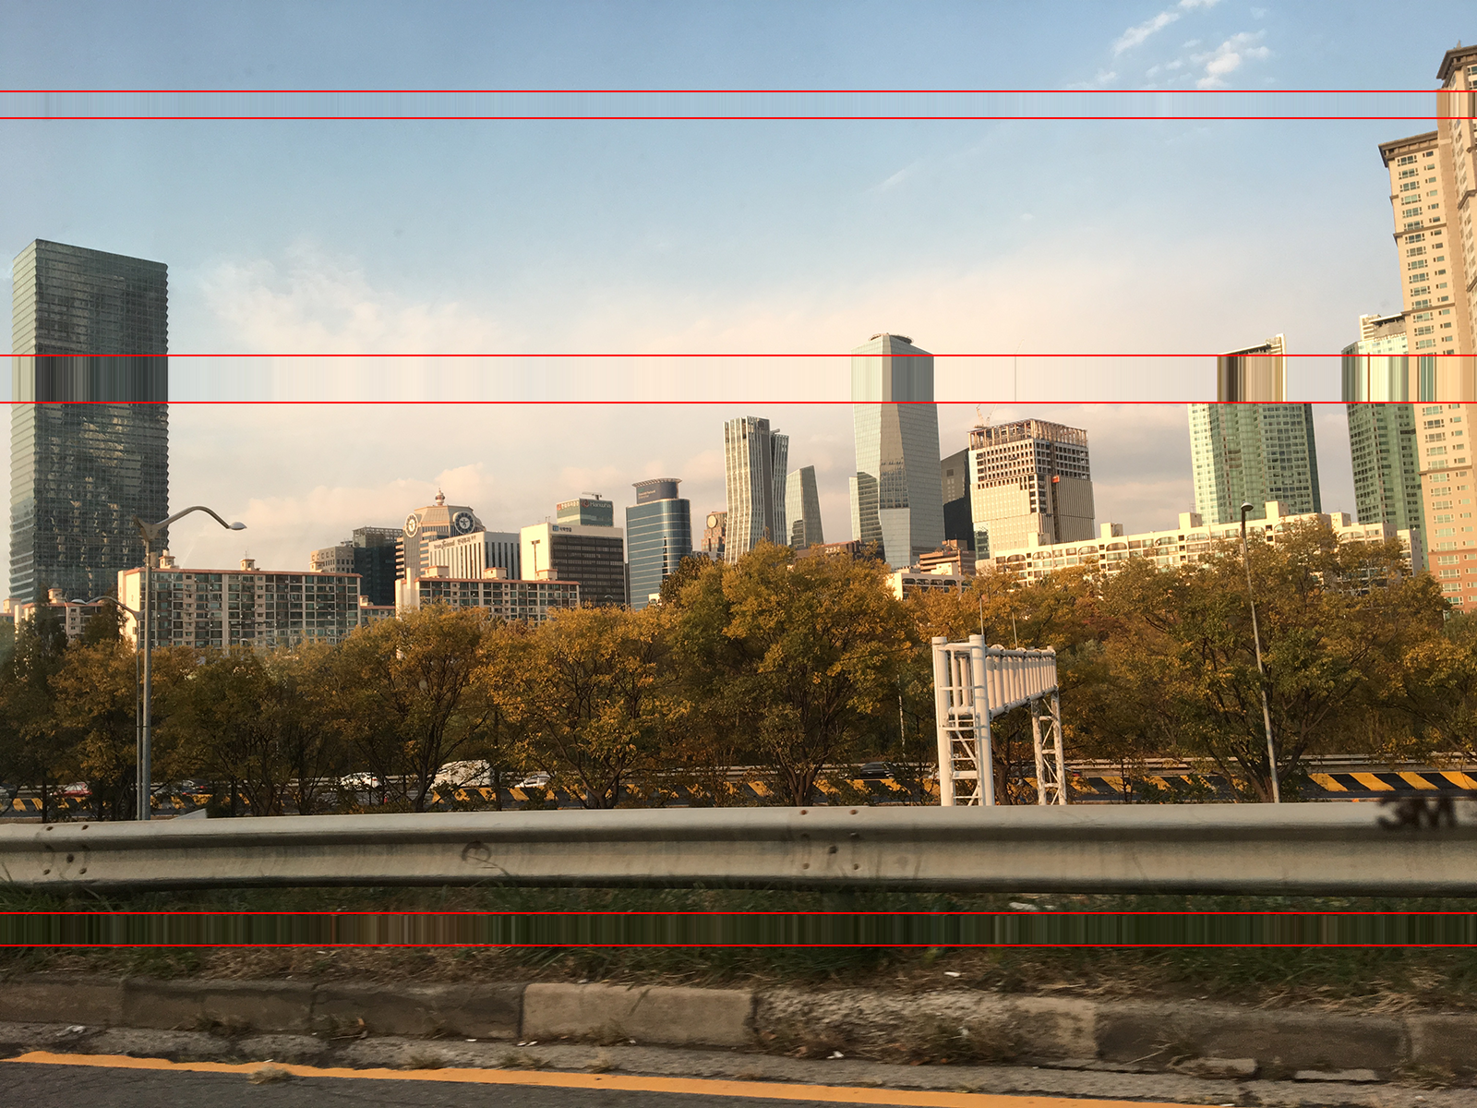

You can see that there are multiple pixel stretched areas with visibly random positions and sizes.